

Web Development Project Skills & Professionalism Software Development Fundamentals

MINI WEBSITE

STUDENT: DIANA CABEZAS. STUDENT #: 2023073. DATE: 14.05.2023

Introduction:

This document is going to be to identify and explain the kind of legal and ethical issues that you can encounter and consider before you decide to publish your site. This also will talk about the most suitable methodology to build a more comprehensive commercial website for your site and will explain the reason why the methodology would be idoneal for the site.

Project Skills & Professionalism:

I have been asked by a friend to create a website for a hotel. Being hosts is one of our biggest hobbies, so we have started it. When our website was ready, we did research into what legal and ethical problems we could be exposed to before publishing it. Our website was designed to show the hotel and be able to make reservations through it. It is important to note that no matter what the nature of your business is, once it turns commercial and is available for the public it will face the same legal and ethical issues.

In this article, we will examine four areas of law that we found that are particularly important to consider for our website:
Legal Issues:
Privacy law.
Different jurisdictions have different privacy laws. We need to do some research to determine which privacy laws apply in the country where we are, and make sure to familiarize ourselves with the laws affecting the website.
- Minimizing data collection. It is good to minimize the amount of data we collect so that users' privacy is not compromised.
- Cookie consent. You can use cookies for advertising and analytics, but they can also invade users' privacy.
- Cookies policies. Explain how and why your website uses cookies.
- Creating a privacy policy. The users will receive a comprehensive overview of how we collect, use, and share their personal information in this document.
- Data security. Our system must be protected from hackers, and users' personal information must be kept secure.

Consumer protection law.
Ecommerce websites are most likely to be impacted by consumer protection law and contract law more generally. Any website can still be subject to consumer protection laws even if they don't sell goods or services through it.
- Creating Terms and Conditions
- Disclaimers
- Returns and refunds.
- Affiliate links

Copyright law.
In case of unauthorized reproduction of copyrighted content, website owners may face legal consequences. It is usually easy to avoid this by refencing or getting the necessary licenses for third party content.

Defamation law.
You should, of course, avoid making any defamatory statements on your website in order to avoid issues with defamation law.

Displaying your legal Notices.
Display Legal Notices prominently on the website to make sure users can access them.

Ethical Issues:
It is still unclear what the ethical issues are relating to web design, but we will discuss the ones we should be aware of.

Hiding information
In many cases, web designers hide important information by using non-prominent links or burying several links from the main page of a website. Sign-up pages usually include all the terms of service, when you look at these, the text is overly long and not very attractive to read. This type of text is typically written in a complex language that can be difficult to comprehend. This is quite unethical the user should be able to access information easily from the main page.

Transfer and use of information
One of the problems that arise in the web design is the transfer and use of information. The information is normally sent to the server through form fields. Almost all the information to fill the form is provided by the user, but in some cases, there are hidden form fields that are filled in by client-side scripting languages and these contain data that was taken from the user’s computer and the page displayed by the browser may not change after a form submission, so the user does not know what has been sent. The simple fact that the user cannot see what happens behind the scenes makes this unethical. It is important for web designers to explicitly describe all data transferred from client to server in their privacy policies. What is being sent, how it will be used, and how long this information will be stored.
Obtaining proper consent
An honest and straightforward approach should be taken when collecting consent from a website's visitors. On Web pages, consent can be obtained in four ways:
- The policy is stated, and consent is assumed. Accepting the policy automatically gives them permission to use your information.
- Opt-out. Is when they add you to their mailing list and give you the option not to receive their emails.
- Opt-in. You ask for someone’s consent or permission before you use their data for marketing. This is considered one of the must ethical ways to obtain consent.
- Opt-in for the initial consent for each secondary use, disclosure, or transfer of data.
While some of them are good options for obtaining user consent, they are often used to trick users into doing something they don't really want or need. Keeping ethical standards is our responsibility, this is why we think it is better to use opt-in to obtain consent from the users, since this will allow the user to decide whether or not to share their data.

Maintaining privacy
Web site designers should stress the importance of protecting privacy when storing and transferring personal information on Web sites. For the user to be aware of any stored information, the web page designer must prominently display information that makes them aware through a well-designed web page, where the user will be able to see which information is being stored and can also delete it if they do not wish it to be kept.

Challenges encountered while developing a website:
- Competition: Now a day there is a wide range of website that advertise hotels or even companies like Airbnb that allows people to rent their homes for a short period of time like a hotel, as a hotel you must guarantee trough the website what make your place so special and different from the others. Starting with ethic and letting the user know all our policies, respecting their data and privacy could be a good start.

- User expectations: The internet has a wide variety of websites that advertise hotels and even companies like Airbnb that allow people to rent their homes for a short period of time, just as hotels do. Using your website, you need to be able to describe what makes your hotel stand out from the competition.

Software Development Fundamentals:

Plan-based approach vs Agile development

Plan-based approach. In a plan-driven development process, all activities are planned in advance, and progress is measured against the plan. Thus, as the term suggests, it is always planned, and results are reported at the end.

In agile development. the plan is always incremental, and it can be altered based on customer needs. The term 'agile development' suggests a process-based method in which things and planning can be altered and replaced with more suitable ones.
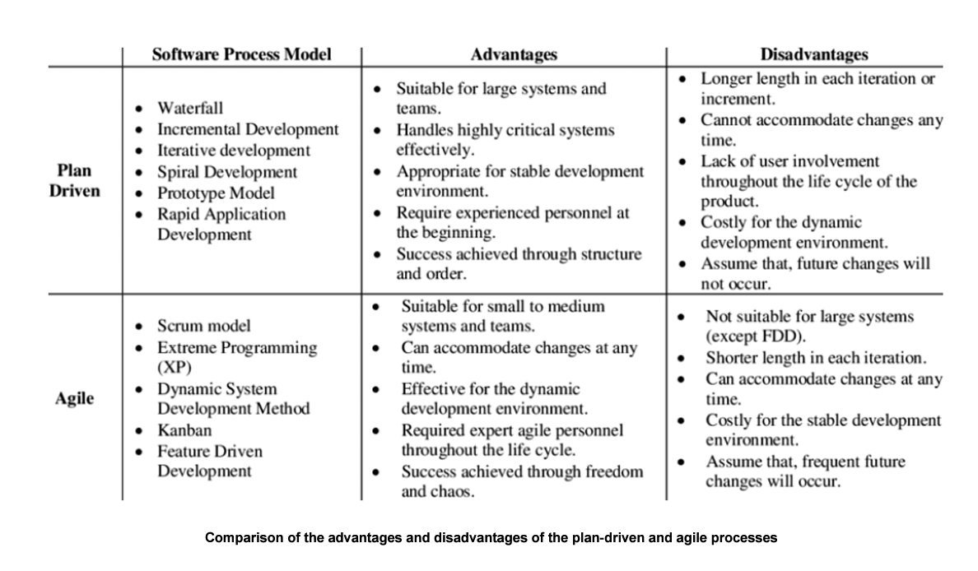
Difference between Plan-based and Agile approach:

As part of the agile approach to software development, design and implementation are seen as the central activities. In addition to requirements elicitation and testing, they incorporate other activities into design and implementation. Plan-based software engineering, on the other hand, identifies separate stages with outputs associated with each stage. During the next process activity, the outputs from one stage are used as a basis for planning.

With a plan-based approach, iteration occurs within activities, and formal documents are used to communicate between stages. (Every project manager should create a small core of formal documents defining the project's objectives, how they are to be achieved, who will achieve them, when they will be achieved, and how much it will cost. In Agile approaches, iteration occurs across activities, so these documents can also reveal inconsistencies you might not otherwise notice. As a result, requirements and designs are developed together rather than separately.

Which one to pick and why?
Considering our Web Development project, I believe that agile is the best approach to our project because it is an incremental delivery strategy in which the software engineer delivers the software to the customer and receives feedback quickly from them. Our project is small and requires small teams that will communicate informally, so it wouldn't be a good fit for a plan-based approach, but it would be perfect for larger systems that require bigger teams.

Based on our choice of Agile approach we have picked Scrum software process model as our agile framework for project management.

How did I apply scrum in my web development project?
- Indication phase. This phase involves creating a vision for the project, essentially outlining its main objectives, goals, and deliverables. Furthermore, they will identify all stakeholders, assign team members to each role, and determine epics to form the backlog of the project.
- Planning and estimates phase. It's rare that product epics are completed with just one task or feature. To complete a product epic, the Scrum team has to do several things. User stories are what they're called.
The format of user stories is similar to that of product epics. They are, however, usually easier to implement.
PROJECT | EPIC | USER STORIES
Website development for a hotel | Through this feature, you'll be able to showcase your hotel's services and facilities to prospective guests. | As a user, I want to see every corner of the hotel so I can imagine what it looks like without having to visit it in person
- Implementation phase. The implementation phase is about completing project deliverables and accomplishing product goals. The daily standup meeting and burndown chart monitoring are key to this phase because there is when you get the chance to share the following: What tasks he/she did yesterday? What tasks he/she plans to work on next today? What issues he/she faced (if any)?
- Review and retrospective phase. This phase constitutes the following Scrum processes: Sprint review, Sprint retrospective, Product backlog grooming Project retrospective (when the project ends).

