ADTA 5770: Generative AI with LLMs
Semester Project – Group Final Report

Thuan L Nguyen, Ph.D.

Group 2:
- Ramzy Idris
- Otto Prado
- Diana Chubb

Overview

The semester project aims to develop a knowledge-based Question-Answer and Search System. The project is done using the Cloud Integrated Development Environment (IDE) System (CIDES) provided by Google Cloud Platform (GCP) Vertex AI services.

Students work on the project in groups throughout the semester to complete all the project assignments. At the end of the semester, each group must submit the semester project group report as part of the group submission portfolio.

Semester Project: Introduction

INSTRUCTOR’S NOTES:
--) Provide a brief introduction to the semester project, including the selected domain field

We are Intelligence Architects. Shaping the future of knowledge management and visibility across our clients’ internal ecosystem. Our AI system development group is being contracted to create a generative AI Q&A search system for a nutrition counseling clinic. This system would not completely replace professional services like medical nutrition therapy or diet planning. However, it provides a place for potential patients and current patients to enhance personal education on nutrition. Using a sample of Nutrition data, we will provide a sample of how this could be achieved for this business. It would be a system that is completely operational 24/7, running off domain knowledge widely approved by licensed nutritionists or by the nutritionists employed at the clinic.

Semester Project: Knowledge Base

INSTRUCTOR’S NOTES:
--) Provide information about the PDF files included in the knowledge base
--) Provide information about HOW the PDF files were collected
--) Provide a general description of the contents of the files

The knowledge based is comprised of 150 pdfs, which 100 are dedicated to information about nutrition, and the other 50 are related to general health. The PDFs were collected through personal research and web-crawling capabilities. Each document was scanned and verified for domain reliability and substance. The knowledge base of Nutrition documents contains a wide variety of research papers and large non-profit corporate artifacts. The documents range from general nutrition tips to avoiding nutrition deficits. The health files are an extreme range of health artifacts and contains a wide variety of topics.

Semester Project: Business and Technical Requirements

INSTRUCTOR’S NOTES:
--) Provide a summary of the business and technical requirements of the semester project

The RAG system we plan to build will be able to retrieve vetted, credible, and evidence-based information from our knowledge base of 100 pdfs to help patients with nutritional guidance. Whenever the system reaches the limit of its knowledge base, it will communicate effectively and escalate to a registered dietitian for advising.

The some KPIs we will measure for success are:

- Usefulness and Relevance
- Retrieval Accuracy
- Clarity, Coherence, and understanding
- Completeness and depth
- Overall satisfaction

Semester Project: System Analysis

INSTRUCTOR’S NOTES:
--) Provide a summary of the system analysis of the semester project

…

Semester Project: System Design: High-Level Design

INSTRUCTOR’S NOTES:
--) Provide a summary of the high-level design of the semester project, including at least one image

The high-level design provides insight into the retrieval & response loop based on a use input query. The User Query is submitted and processed via Python which becomes processed and translated against the Vertex Search Index. This semantic search is then used to assemble the context in locating correct information within the context assembly container, using vector similarity search and Top-K to retrieve the correct components of information. From there, the Gemini Pro LLM provides a grounded response relevant to the user query input. 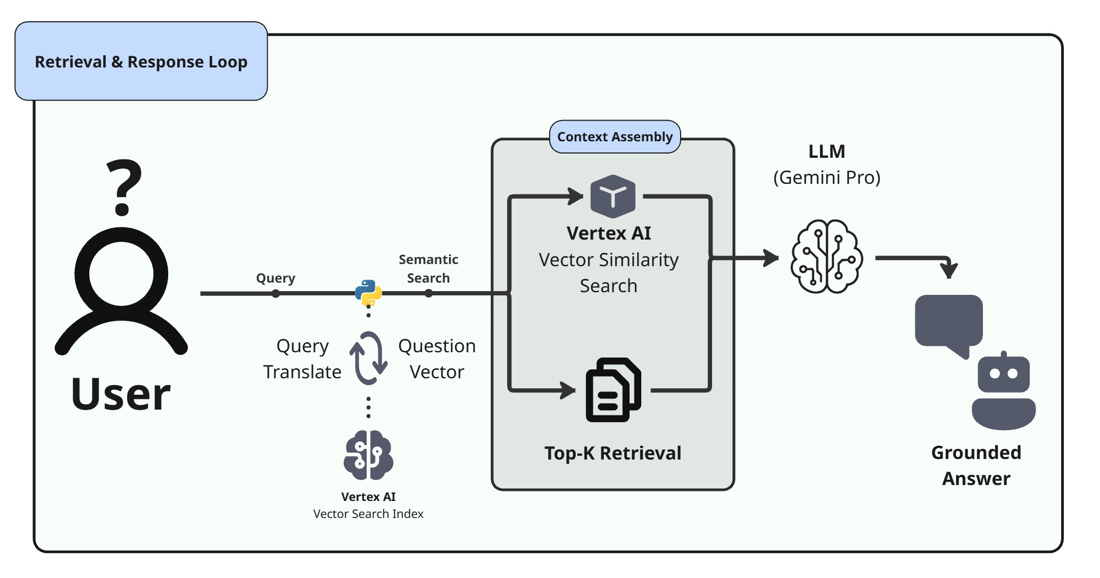

Semester Project: System Design: Detailed Design (Optional)

INSTRUCTOR’S NOTES:
--) Provide a summary of the detailed design of the semester project, including at least one image

The detailed design provides insight into the retriever assembly that allows for queries to be searched against for information related to the input query. The Ingestion & Indexing pipeline begins with the data engineers responsibility of uploading all relevant artifacts to a Google Cloud bucket. This bucket is called upon by Python using Google libraries and processes the knowledge base into machine ready components. This data is processed through the retriever assembly, where the documents are chunked and embedded using Vertex AI. This process allows the data from each document to be retrievable by the system based on a user's query, also called a question. 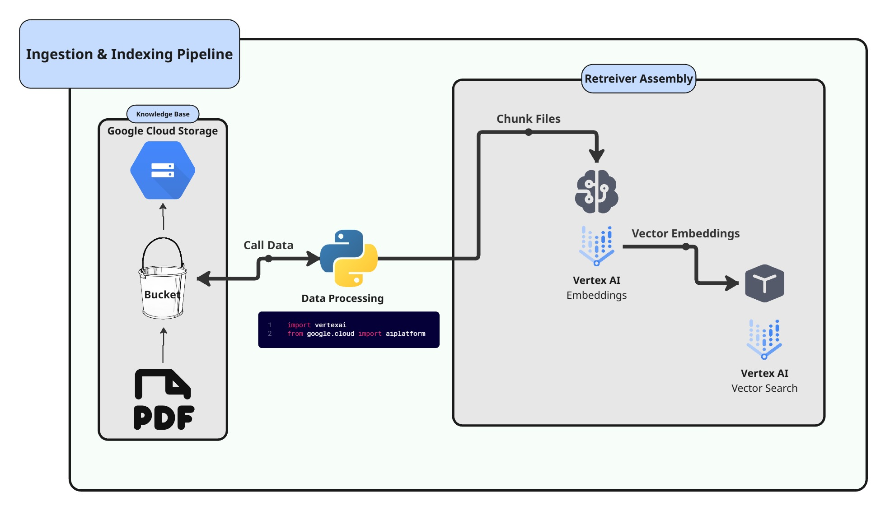

Semester Project: System Development: Coding

INSTRUCTOR’S NOTES:
--) Provide a report about how the Q&A Search system has been developed.
--) Include the information about PHASES (1 – 10) …
--) Include information about the LLM model, i.e., Gemini, used for the project

The Q&A system is built in 10 phases. These Phases are split across two major components: Ingestion & Indexing Pipeline, and Retrieval & Response loop.

The Ingestion & Indexing Pipeline component is made up of 6 major phases. The first phase if the PDF knowledge base, which is a collection of document artifacts that are uploaded to a cloud based storage system. In this project, the Google Cloud product is utilized for storage. The second phase processes the documents which involves ingesting and parsing the PDF documents into what is called chunks. These chunks are split components of the documents which prepare it for a vector store within google cloud. This leads into the third phase which stages an empty Vector Search environment to prepare for phase four. Phase 4 takes the next step in configuring the matching engine which is the vector search by preparing the vector database which is created in the google cloud bucket. Next, phase 5 initializes the instance integration with LangChain. Finally, phase 6 processes the transformed chunks into embeddings in the Vertex AI model which completes the ingestion & indexing pipeline.

The next major component is the retrieval & response loop. Phases 7 and 8 are prepared in succession by creating the LLM objecting which uses the gemini-2.5-pro model, and then configures the LangChain RAG system. In this phase, the prompt template for the LLM retriever is also created. Phase 9 then tests the Q&A end-to-end system by using the ask function to send natural language queries to the RAG system. These queries are ingested to the system to retrieve relevant documents from the vector store and feeds them to the LLM to generate an answer. Lastly, in phase 10, the system is undeployed and deletes all indexes and endpoints. This step would not be necessary in a deployed system.

Semester Project: Testing and Operationalization

INSTRUCTOR’S NOTES:
--) Provide a report about how the Q&A Search system has been tested
--) Provide a brief description of the prompts and how to get responses

The Q&A search system was tested by prompting the system with 10 questions based on our domain knowledge of Nutritional papers and articles. The questions were picked with a pre-conceived understanding of what the correct answer should be.

The prompts are structured to inform the system that it is an intelligent assistant helping users with their questions on nutrition and dietary information and for it to use our specific knowledge base for every question of input we put into the system.

Semester Project: Q&A Search System: Prompts and Responses

INSTRUCTOR’S NOTES:
--) Provide a summary of WHAT/HOW of running 10 prompts to get responses using the Q&A Search system

When running our 10 questions through our Q&A system, we created 8 questions we knew the answer to, so one criteria of the performance of the response would be whether the answer was correct. We then observed the responses' specific output format and used that as another criteria to grade the responses on. When testing the Q&A System, we saw that all questions were answered correctly, but some of the response outputs were well structured and formatted while others were not formatted in a traditional LLM response template.

