# Bike-Share Data Analysis Project Report

## 1. Introduction

This project explores bike-share usage patterns between member and casual users by analyzing Divvy trip data from 2019 Q1 to 2020 Q1. The analysis was conducted using R, with data visualizations created in both R and Tableau. Key insights focus on ride duration, usage distribution by day of week, and weekend preferences.

## 2. Data Cleaning and Preparation

Using R, datasets from different quarters were standardized by renaming columns and converting data types. Irrelevant columns were removed and missing or invalid entries were filtered out. All trips were then combined into a single dataframe with consistent structure.

## 3. Summary of R Code Steps

- Loaded and cleaned individual quarterly CSV files using `read_csv()` and `rename()`.  
- Standardized column names and types across datasets.  
- Combined the datasets using `bind_rows()`.  
- Extracted date, time, and weekday components from timestamps.  
- Created new columns such as `ride_length` and `day_of_week`.  
- Filtered data to remove erroneous entries and HQ QR rides.  
- Aggregated data using `group_by()` and `summarise()` to compute key statistics.

## 4. Key Findings

- **Ride Duration: ** Casual users averaged 3,553 seconds per ride, while members averaged 850 seconds.

- **Weekend Usage: ** 37% of casual rides occurred on weekends, compared to only 24% for members.

- **Day of Week Trends: ** Casual users ride most on weekends, while members ride consistently on weekdays.

## 5. Visualizations

Below are selected visualizations comparing usage trends between casual and member riders.

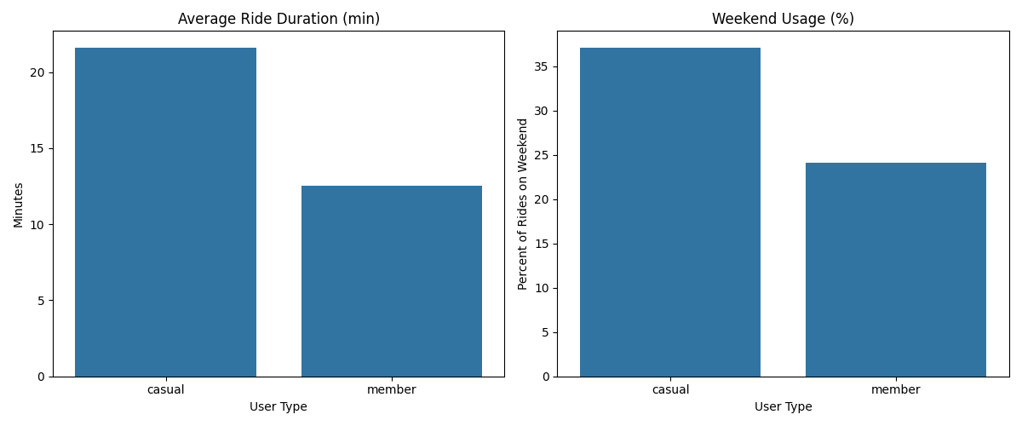

Figure 1: Comparison of Average Ride Duration and Weekend Usage by User Type (Pyhon).

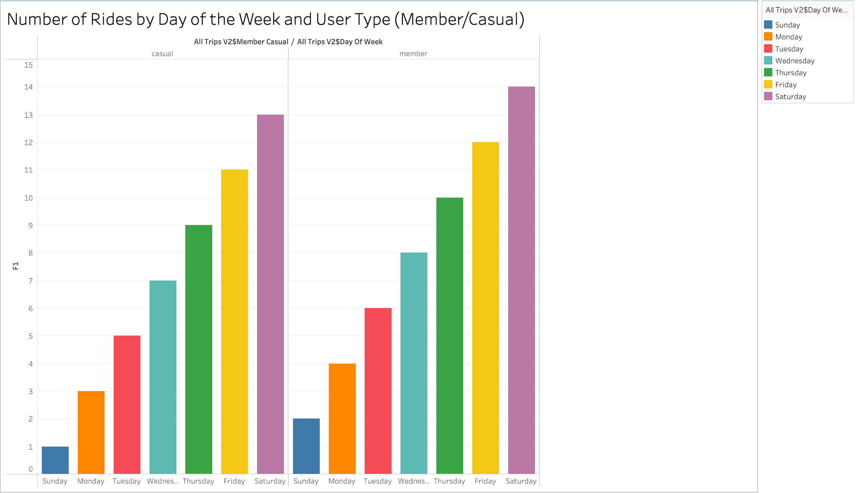

Figure 2: Number of Rides by Day of the Week and User Type (Tableau).

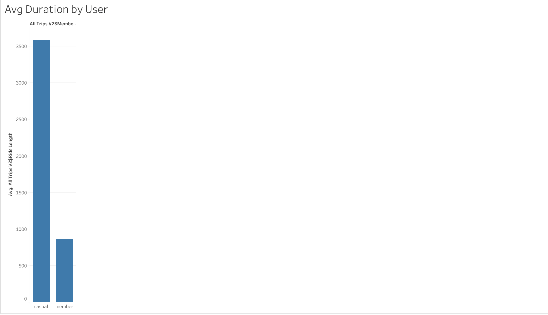

Figure 3: Average Ride Duration by User Type (Tableau).

## 6. Conclusion

This analysis revealed clear differences in behavior between casual and member riders. Casual riders take longer rides and are more active on weekends, while members exhibit consistent weekday usage. These patterns can help inform strategies to increase membership conversions by targeting casual users with tailored promotions.