Development of a Personal Responsive Portfolio Website
CISC3003 Web Programming | DC325411 LIN CHO KIO | 2026.3.1

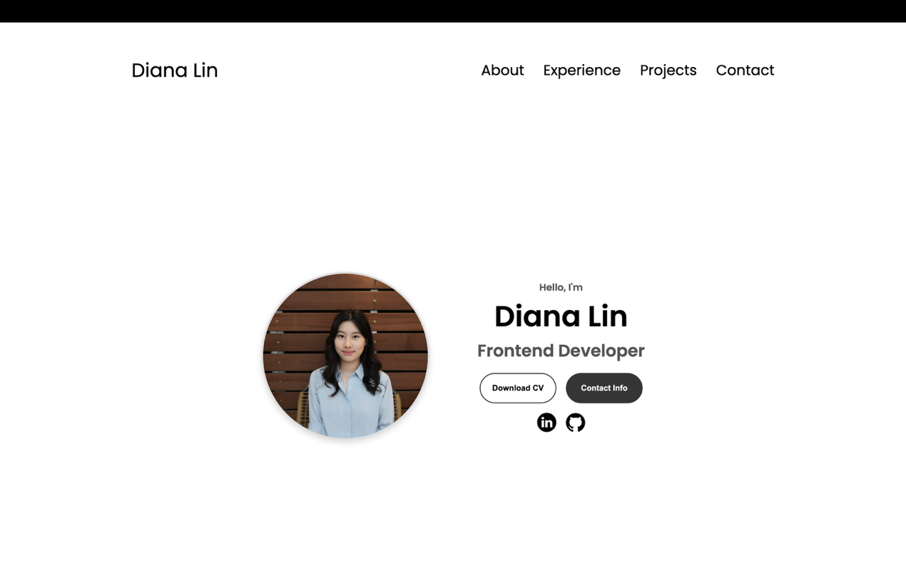

Project Question:
How can I design and develop a modern, responsive personal portfolio website using HTML, CSS, and JavaScript that includes Home, About Me, Experience, Projects, and Contact sections?

CISC3003 Individual Assignment – Development of a Personal Responsive Portfolio Website 1
Project Question: 1
1. Project Purpose 3
1.1 Outcomes 3
1.2 Skills 4
Technical Skills 4
Software Development Skills 5
UI/UX Design Skills 5
1.3 Knowledge 5
2. Project Tasks 6
Phase 1 – Planning and Design 6
Phase 2 – HTML Structure Development 6
Phase 3 – CSS Styling and Layout 7
Phase 4 – JavaScript Interactivity 7
Phase 5 – Projects Integration 7
Phase 6 – Testing and Deployment 8
3. Project Criteria for Success 9
Functional Requirements 9
Design Requirements 9
Technical Requirements 9
Deployment Requirement 10
4. Project Related References 11

1. Project Purpose

The purpose of this project is to design and develop a fully functional personal portfolio website that showcases my background, technical skills, and web development projects.

The website will consist of five major sections:
- Home – Introduction and profile overview
- About Me – Personal background and education
- Experience – Technical skills and development experience
- Projects – Demonstration of completed web projects
- Contact Me – Contact information and social links

The website will be implemented as a responsive single-page application using HTML5, CSS3, and JavaScript.

This project demonstrates practical application of web programming concepts learned in CISC3003 and reflects real-world frontend development practices.

1.1 Outcomes

This project aligns with the learning outcomes of CISC3003 Web Programming:
- Apply HTML, CSS, and JavaScript to build interactive web pages
- Implement responsive web design techniques
- Structure web content using semantic HTML elements
- Implement client-side interactivity
- Develop and deploy a web application

This project also supports the Computer Science programme outcome of applying computing knowledge to create practical solutions.

The final portfolio website can be used for:
- Internship applications
- Job applications
- Academic opportunities
- Personal branding

1.2 Skills

Through this project, I will strengthen the following skills:

Technical Skills
- Semantic HTML structure design
- CSS layout techniques (Flexbox and Grid)
- Responsive web design using media queries
- Mobile-first development approach
- JavaScript DOM manipulation
- Event handling (e.g., navigation toggle)

Software Development Skills
- Code organization and project structuring
- Version control using Git
- Debugging using browser developer tools
- Cross-browser testing

UI/UX Design Skills
- Typography and visual hierarchy
- Navigation flow design
- Responsive navigation (hamburger menu)
- Professional layout and spacing

1.3 Knowledge

This project deepens understanding of:
- HTML5 semantic elements
- CSS styling and layout systems
- Responsive design principles
- Client-side scripting fundamentals
- Single-page website structure
- Basic accessibility practices (alt attributes, headings hierarchy)
- Deployment of static websites

2. Project Tasks

The project will be completed in the following stages:

Phase 1 – Planning and Design
- Research examples of professional portfolio websites
- Define website structure and section layout
- Design navigation structure
- Plan color scheme and typography

Deliverable: Wireframe and structure planning

Phase 2 – HTML Structure Development
- Create the main HTML file
- Implement five main sections:
  - Home
  - About Me
  - Experience
  - Projects
  - Contact
- Implement navigation bar and anchor linking

Deliverable: Structured HTML page

Phase 3 – CSS Styling and Layout
- Apply styling using external CSS files
- Implement Flexbox and Grid layouts
- Ensure consistent typography and spacing
- Apply responsive breakpoints for mobile and desktop
- Design responsive navigation (desktop + hamburger menu)

Deliverable: Fully styled and responsive layout

Phase 4 – JavaScript Interactivity
- Implement hamburger menu toggle functionality
- Implement smooth navigation between sections
- Improve user interaction behavior

Deliverable: Functional JavaScript file

Phase 5 – Projects Integration

The Projects section will showcase web projects including:
- E-commerce demo homepage
- Product detail page

Each project will include:
- Screenshot preview
- GitHub link
- Live demo link

Deliverable: Fully working project section

Phase 6 – Testing and Deployment
- Test responsiveness across screen sizes
- Test on multiple browsers
- Fix layout issues
- Ensure no console errors
- Deploy to hosting platform (e.g., GitHub Pages)

Deliverable:
- Live website URL
- Complete project source code

3. Project Criteria for Success

The project will be considered successful if:

Functional Requirements
- All five sections are clearly structured
- Navigation links correctly scroll to sections
- Hamburger menu works properly
- Project demo links function correctly

Design Requirements
- Fully responsive layout
- No horizontal scrolling issues
- Professional and clean design
- Consistent typography and spacing

Technical Requirements
- Semantic HTML structure
- No console errors
- Optimized images
- Page loads efficiently

Deployment Requirement
- Successfully hosted website
- Properly structured project repository

4. Project Related References
How to Become a Developer. (1 Apr 2023). Responsive Portfolio Website From Scratch.
https://www.youtube.com/watch?v=ldwlOzRvYOU&t=369s

GreatStack. (8 Jul 2020). How To Make Ecommerce Website Using HTML And CSS Step By Step | Create e-Commerce Website
https://www.youtube.com/watch?v=yQimoqo0-7g&list=PLjwm_8O3suyM_2Lo9aAIw3HqjOPor8j9g

GreatStack. (18 Jul 2020). Part 3 Ecommerce Website Design In HTML & CSS | Create eCommerce Site Product Details Page
https://www.youtube.com/watch?v=ENyk_W-Eleo

