|  |
| --- |
| Bird |
| - timer : QTimer |
| <<constructor>>+Bird(x:float , y:float , radius float , timer:QTimer *, pixmap :QPixmap, world: b2World *, scene:QGraphicsScene *)  +setLinearVelocity(velocity: b2Vec2):void |

|  |
| --- |
| Bird2 |
|  |
| <<constructor>>+Bird2(x:float , y:float , radius float , timer:QTimer *, pixmap :QPixmap, world: b2World *, scene:QGraphicsScene *)  +setLinearVelocity(velocity: b2Vec2):void |

|  |
| --- |
| Bird3 |
|  |
| <<constructor>>+Bird3(x:float , y:float , radius float , timer:QTimer *, pixmap :QPixmap, world: b2World *, scene:QGraphicsScene *)  +setLinearVelocity(velocity: b2Vec2):void |

|  |
| --- |
| Bird4 |
|  |
| <<constructor>>+Bird4(x:float , y:float , radius float , timer:QTimer *, pixmap :QPixmap, world: b2World *, scene:QGraphicsScene *)  +setLinearVelocity(velocity: b2Vec2):void |

|  |
| --- |
| Egg |
| - timer : QTimer |
| <<constructor>>+Egg(x:float , y:float , radius float , timer:QTimer *, pixmap :QPixmap, world: b2World *, scene:QGraphicsScene *)  +setLinearVelocity(velocity: b2Vec2):void |

|  |
| --- |
| Enimy |
| +key : int  +score : int |
| <<constructor>>+ Enimy(x:float ,y:float , radius float , timer:QTimer *, pixmap :QPixmap, world: b2World *, scene:QGraphicsScene *)  + collide(): void |

|  |
| --- |
| Mainwindow |
| -key:int  -key1:int  -key2:int  -key3:int  -key4:int |
| <<constructor>>+MainWindow(*parent: QWidget)  <<destuctor>>+MainWindow()  +calculate ( a: int , b: int ): b2Vec2  +showEvent(QShowEvent *): void  +eventFilter( :QObject *, event: QEvent *): bool  +closeEvent( :QCloseEvent *):void  +quitGame():void  -tick():void  -QUITSLOT():void  -check():void  -time():void |

|  |
| --- |
| Wood |
|  |
| <<constructor>>+Wood(x:float , y:float , radius float , WOOD_DENSITY:float , timer:QTimer *, pixmap :QPixmap, world: b2World *, scene:QGraphicsScene *) |

**Screen shot :**

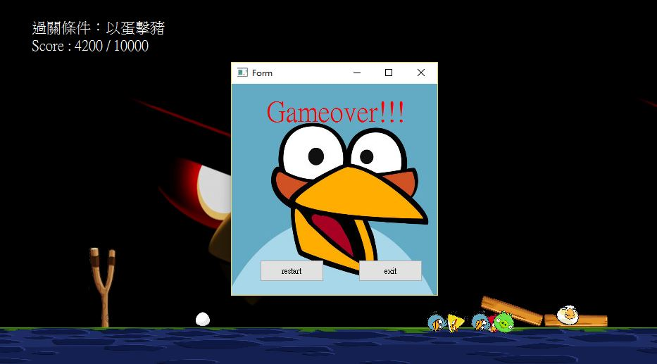

**How to play ?**

沒有任何功能的鳥。

點擊滑鼠分身。

 點擊滑鼠可以下蛋。

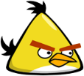點擊滑鼠可以加速。

蛋打中豬時得一萬分。