Creating a GUI
Make a GUI that has a box to input “First Name” and another one to input “Last Name.” When you click the “Ok” button, your full name will display in the label. You will use the grid() function to line your widgets up. Use lecture example and this documentation to help you.
WARNING: Do not use pack() anywhere if you choose to use grid()!

On start up your GUI should look like this:
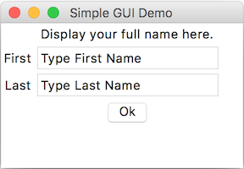

After entering first and last name, and clicking “Ok” button is clicked, it will look like this:

