


TEMPLATE REPORT
REVERSE BINARY




REPORT

Black-box Audit
In this phase, we analyzed the binary using reverse engineering tools and manual fuzzing. List of the tools you used:
- strings
- upx
- caesar-cipher (url: https://cryptii.com/pipes/caesar-cipher/)

- 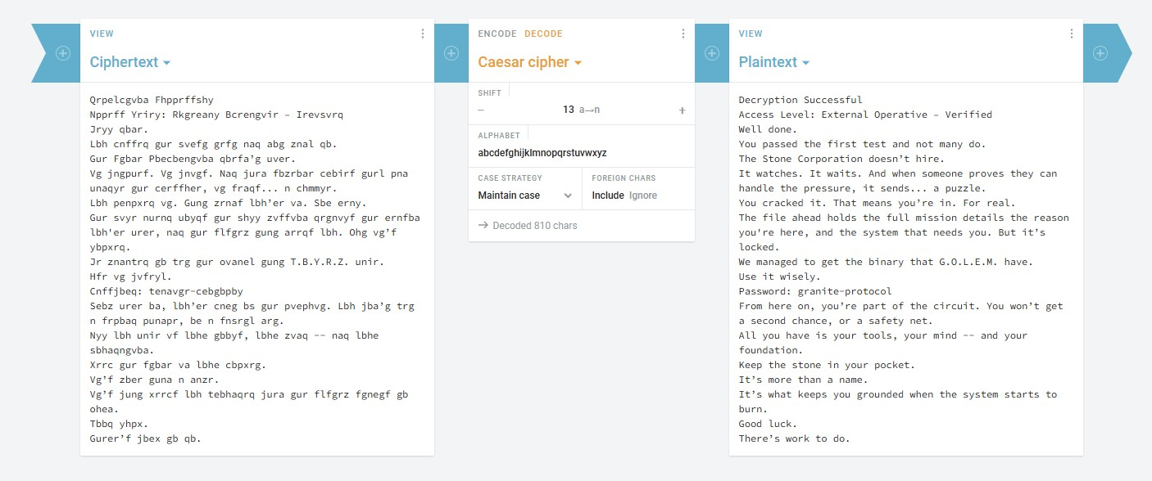
Key discoveries:
- identified that the binary was packed with UPX.
- discovered credentials (password: admin123), enabling unauthorized acces to protected commands
- found that the application leaks data.
- found insecure input handling, identifying a format string vulnerability and a logic flaw regarding negative input values.

2

White-box Audit
With access to source code, we performed a full code review and vulnerability assessment.
Focus area:
- Input validation
- Memory safety
- Privilege escalation paths
List of the tools you used:
- Strings
- C code

Final report
In order to gain access to the last pdf (Obsidian_final.pdf), we decrypted the password, which was encoded using the Braille alphabet, using the following website: https://abcbraille.com/braille.

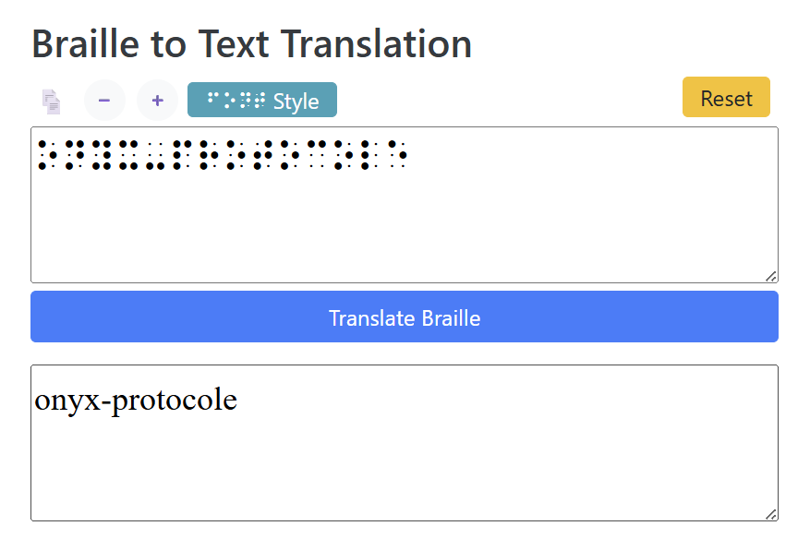

Vulnerability Report
Below is the list of vulnerabilities discovered, ranked by severity:

3


Vulnerability #1: System compromise

Severity: Critical
Type: Privilege Escalation / Bypass Location: activate_emergency_protocols Discovered in: Black-box

Description:
The application hid sensitive information using a binary packing (UPX). Using the utilitary upx, this was easily bypassed. Once the binary was unpacked, the application’s internal strings revealed multiple passwords and flags used to bypass authentication for “Emergency protocols”.
Proof of concept:
  - detection of packing (analysis with strings failed to show readable logic, revealing a header)

  - filter with sensitive keywords
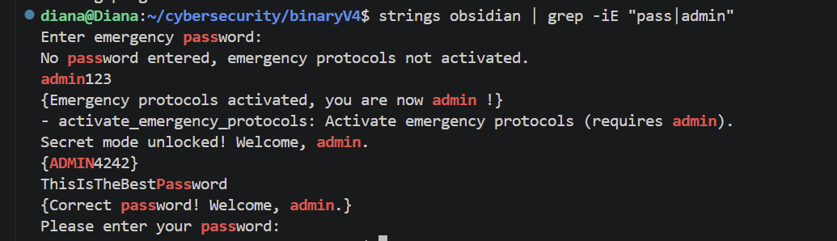
  - exploitation
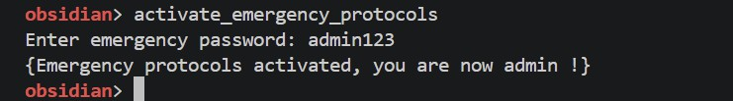
3


Impact:
An attacker can gain admin privileges over the application, managing to bypass all security layers, granting unauthorized access to multiple functions.

4

Vulnerability #2: Unauthorized Access to Functions

Severity: Critical
Type: Priviledge Escalation / Bypass
Location: Secret functions
Discovered in: Black-box

Description:
While exploring the program’s code with the strings tool, I discovered two hidden commands: unlock_secret_mode and trigger_emergency_shutdown. Initially, the application denied execution of these commands, displaying error messages which state that I didn’t have the “required priviledges”. However, by leveraging exploit #1, I escalated my status to admin and was able to successfully execute these hidden commands.

Proof of Concept:
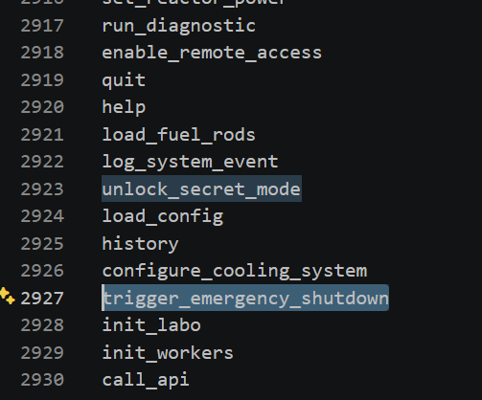

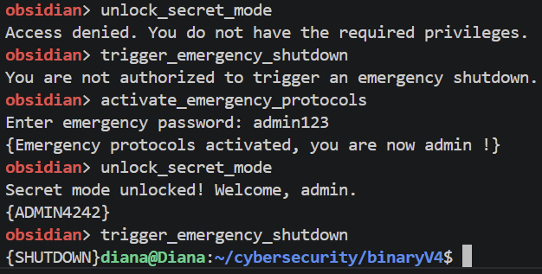

Impact:
Being able to gain admin access can lead to system compromise.
5


Vulnerability #3: Integer Overflow

Severity: Critical
Type: Integer Overflow; Improper Input Validation
Location: obsidian_lib.so, turbine_temperature Discovered in: Black-box

Description:
The function does not validate the upper bounds of the temperature change input. The vulnerability comes from the use of a 32-bit signed integer variable to store the temperature. In C, a signed 32-bit integer has a maximum value of 2³¹ – 1, which is 2.147.483.647. The program adds the provided number to the current temperature (20°C), thus exceeding the storage capacity of the variable. The most significant bit (the sign bit) is flipped and the number is interpreted as negative. The solution is to implement a check for a maximum input threshold before performing the sum.

Proof of Concept:
- Run ./obisidian
- Execute init_steam_turbine
- Execute turbine_temperature
- Input 2147483647
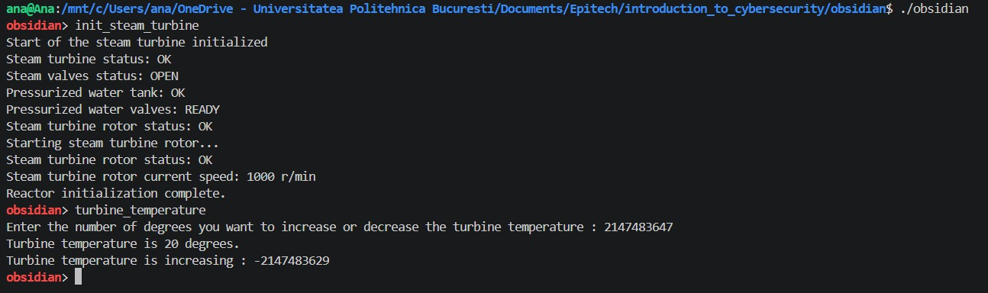

Impact:
- Logic manipulation: unintended negative values can cause unwanted events that affect the operation (in this case the way the turbines work will be altered).
- Safety checks: these kinds of systems usually have a threshold for high temperatures that cause the equipment to stop. An attacker could keep the system running at extremely high temperatures, while the program registers them as negative degrees and preventing the automatic emergency shutdown for that kind of temperature
6
6

Vulnerability #4: Buffer Overflow
7

Severity: Critical
Type: Stack-based Buffer Overflow; Function Pointer Hijacking
Location: obsidian, monitor_radiation_levels Discovered in: Black-box

Description:
The function does not validate user input size before storing it in memory. Providing a string longer than 10 characters causes a segmentation fault. The function allocates a buffer on the stack for this radiation level string and, immediately after, there is a function pointer used by the system. By inputting 11 characters, it overflows its boundaries by overwriting into the first byte of the function pointer.

Proof of Concept:
- Run ./obsidian
- Execute monitor_radiation_levels
- Enter a 11-character number for radiation levels
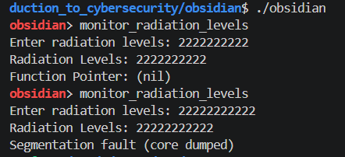
*Note that the first example in the screenshot is for a 10-character string, while the second one is for an 11-character string

Impact:
- Control Flow Hijacking: an attacker can replace the pointer with the memory address of a malicious function or one that requires admin privileges.
7
9


Vulnerability #5: Sensitive Information Disclosure

Severity: High
Type: Information Disclosure Location: log_system_event Discovered in: White-box

Description:
The log_system_event function contains a logic flaw where sensitive information is written to an accessible log file if a specific string is present in the user input. The application uses strstr(input, “leak”) to monitor incoming commands. If a user provides an input containing the word leak, the program displays sensitive information in the Data/system.log file.

Proof of Concept:

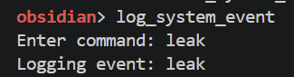

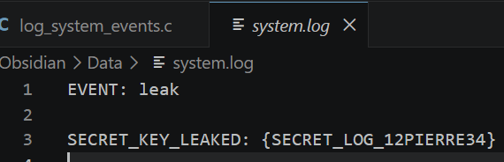

Impact:
By revealing the exact name and location of the log files, the application provides the attacker with essential reconnaissance data. An attacker could attempt to overwrite system logs, making the application unsafe. Moreover, if an attacker does something bad in the system, they can simply delete or modify the file, making it impossible for an admin to see what happened.
8
10


Vulnerability #6: Insecure Log Handling

Severity: High Type: Log injection
Location: read_turbine_config Discovered in: Black-box

Description:
The application leaks path information regarding the folder. By leveraging the path leakage identified in vulnerability #3, an attacker knows the application writes to and reads from Data/system.log. The attacker can manually insert keywords into system.log, tricking the application into executing those strings as internal events if the log file is loaded as a config file.

Proof of Concept:
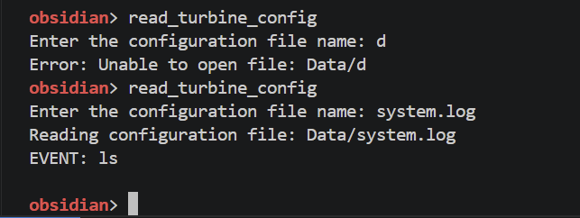
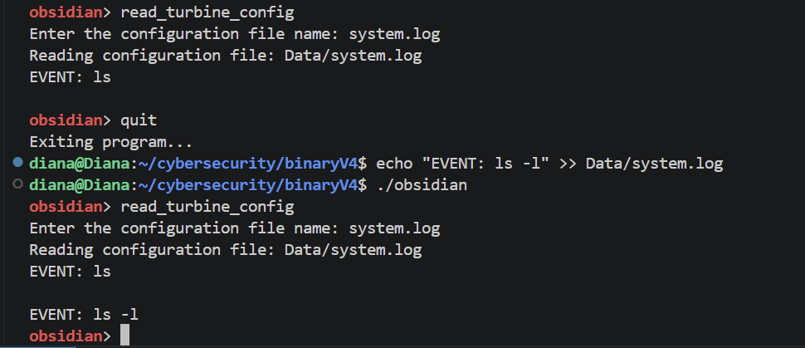

Impact:
This allows an attacker to manipulate the application’s logic. By manipulating the system.log file that the program later uses, an attacker can maybe later trigger unintended events.
9
11


Vulnerability #7: Boundary Logic Flaw

Severity: Medium
Type: Integer Overflow / Improper Input Validation Location: obsidian, set_reactor_power Discovered in: White-box

Description:
The function contains a critical vulnerability regarding the handling of signed integers. The program uses a 32-bit signed integer for the power level. The program contains an explicit check that, instead of rejecting dangerous input, triggers an emergency shutdown if the addition exceeds the maximum capacity of the integer.

Proof of Concept:
- Run ./obsidian
- Execute set_reactor_power
- Enter 2147483647 (maximum value for a signed 32-bit int)
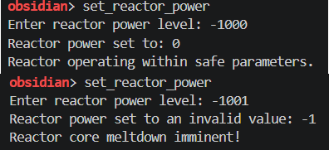
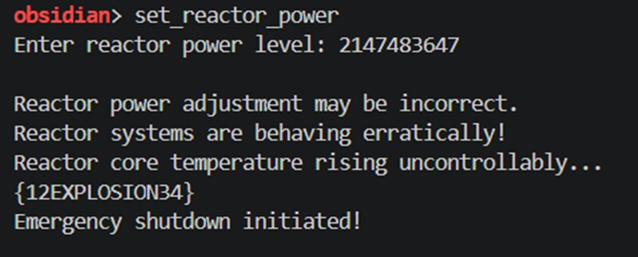

Impact:
- Privilege escalation: an attacker could possibly trigger a dangerous state, such as the meltdown.
- Denial of service: after the meltdown is initiated, the system becomes unusable.
12

10

Vulnerability #8: Uncontrolled Format String

Severity: High
Type: Format string
Location: alchemy command
Discovered in: Black-box

Description:
The vulnerability exists in the way the alchemy function handles user input for the password prompt. Specifically, the application passes user-supplied data directly to an output function (such as printf()) without a format string. This allows an attacker to write format specifiers, which the application then interprets as instructions to read from the stack.

Proof of Concept:

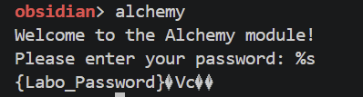

Impact:
The exploitation of this format string vulnerability can lead to critical security compromise, such as information disclosure. An attacker can use specifiers like “%s” to leak sensitive data from the stack.

11

Vulnerability #9: Improper Handling of Negative Input

Severity: high
Type: Improper Input Validation
Location: run_turbine command
Discovered in: Black-box

Description:
The run_turbine command contains a logic flaw in its input validation. The application explicitly states that it only accepts values between 0 and 15. For a higher value, the program displays a proper error message. However, the application fails to properly handle negative values. For the value -1, the check (which is likely if value <= 15) is bypassed and the program enters an infinite loop.

Proof of Concept:

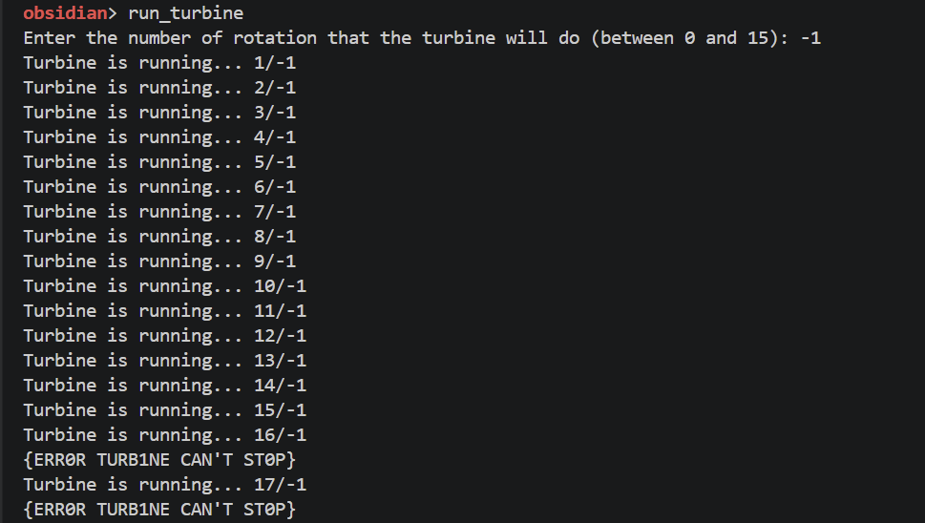

Impact:
The main impact is that an attacker can crash the program or make it freeze by forcing it into an infinite loop. Since the program is busy running the turbine forever, it cannot process other commands. Also, this shows that the program has improper input validation, meaning we can bypass the rules set by the developers.

12

Vulnerability #10: Insecure Temporary File Storage

Severity: Medium
Type: Information Disclosure
Location: turbine_remote_access
Discovered in: Black-box

Description:
When the turbine_remote_access runs, the program creates a temporary file in the Data/ folder. Although it is a temporary file and the application deletes it after the command ends, the file is still viewable while the function runs.

Proof of Concept:

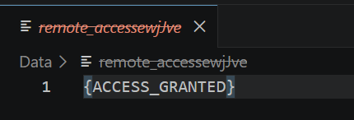

Impact:
The impact is information disclosure. Any sensitive information stored in temporary files is easy to access.

13

Vulnerability #11: Sensitive Data Leakage via Type Confusion

Severity: Medium
Type: Improper Access Control / Type Confusion
Location: run_diagnostic command
Discovered in: White-box

Description:
The run_diagnostic command provides an integrated diagnostic interface. While the advanced mode operates correctly by assigning an integer address to the integer pointer (data = &diagnostic_code), the debug mode introduces a Type Confusion vulnerability. In this mode, the program forces the memory address of a character array (sensitive_data) into the same data pointer. Because the application fails to implement authorization checks and re-casts the pointer back to a string during output, it leaks hardcoded information when debug keyword is typed.

Proof of Concept:

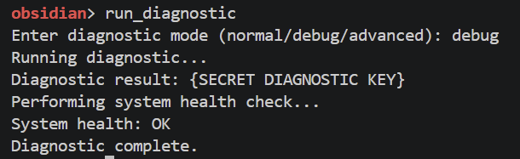

Impact:
The impact is information disclosure. Unauthorized users can extract internal data by exploiting the type mismatch.

14

Vulnerability #12: UAF leading to Data Exposure

Severity: High
Type: Use-After-Free (UAF)
Location: check_cooling_pressure command
Discovered in: White-box

Description:
The check_cooling_pressure function suffers from a Use-After-Free vulnerability. The pointer data, which initially contains the string “Pressure OK”, is released with free(). Because the application does not nullify the pointer, it creates a dangling pointer that the application uses to perform logic checks. When the program reaches if (strcmp(data, “Pressure OK”)) statement, it performs a comparison using overwritten memory. Since the memory at the data address is corrupted after being freed, the comparison with “Pressure OK” fails and return non-zero. Since any non-zero is considered true, the application displays sensitive information.

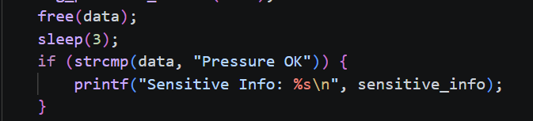

Proof of Concept:

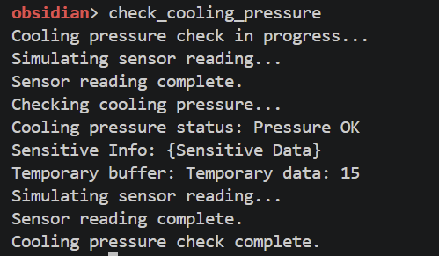

Impact:
The impact is information disclosure, by allowing unauthorized access to sensitive data. Moreover, accessing freed memory is undefined behavior which may lead to crashes or further memory corruption if the pointer is used for write operations.

15

Vulnerability #13: Sensitive Data Exposure

Severity: Medium
Type: Information Disclosure
Location: simulate_meltdown command
Discovered in: White-box

Description:
The simulate_meltdown function contains a logical flow that leaks sensitive information when the system enters a meltdown state. The vulnerability resides in the error-handling logic: when a random_number variable is smaller than 5, the application triggers a “Critical Error” message. The program prints the hardcoded secret_code directly to the standard output.

Proof of Concept:

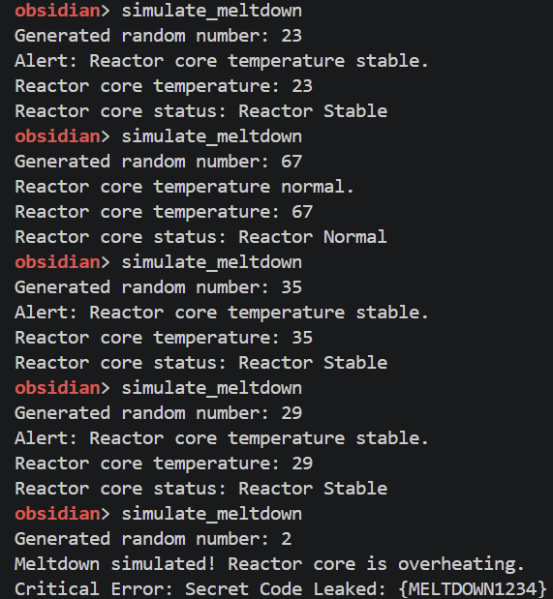

Impact:
The data exposure provides an attacker with a credential which may be used in order to bypass future security checks.

16

Vulnerability #14: Logical Gap in Input Validation

Severity: Medium
Type: Information Disclosure
Location: load_fuel_rods command
Discovered in: White-box

Description:
The load_fuel_rods function has an incomplete conditional flaw. The input validation uses an if / else if statement that explicitly handles cases where the input is greater than 10 or between 1 and 9. However, it fails to account for the values of 0, 10 and negative integers. When the user input is 0/10/-2, the program bypasses the if / else if statements and displays hardcoded sensitive code.

Proof of Concept:

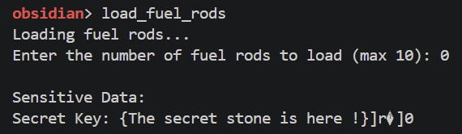

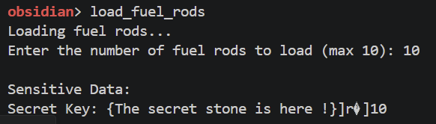

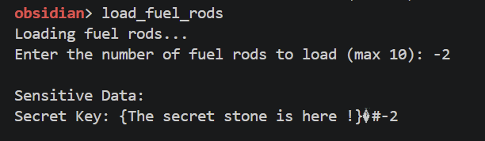

Impact:
The data exposure provides an attacker with a credential which may be used in order to bypass future security checks. By identifying gaps in the program’s logic, an attacker can access sensitive code that was indented to be protected.

Fix summary:
Fixed the input validation logic by strictly accepting values between 0 and 10, rejecting negative numbers, as well as numbers higher than 10.
- Patch File: Obsidian/load_fuel_rods.patch

Vulnerability #15: Race Condition
17

Severity: Medium
Type: Race Condition
Location: init_workers command
Discovered in: White-box

Description:
When multiple worker threads are initialized simultaneously, the system fails to implement proper synchronization methods to avoid race condition between them. This could cause inconsistencies or unpredictable behaviour if multiple threads attempt to modify the same resources.

Proof of Concept:
- Run init_workers
- Input the number of workers

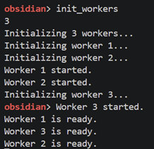

Impact:

System instability: can lead to zombie processes, making the interface unresponsive to emergency commands.
Memory corruption: concurrent writes to shared memory areas can corrupt data, leading to segmentation fault or other errors.
Denial of Service: if the race results in a deadlock where threads are waiting on resources held by each other, the workers may never start.

v 1.O

