


REPORT
REVERSE BINARY




REPORT

Black-box Audit
In this phase, we analyzed the binary using reverse engineering tools and manual fuzzing. List of the tools you used:
- strings
- upx
- caesar-cipher (url: https://cryptii.com/pipes/caesar-cipher/)

- 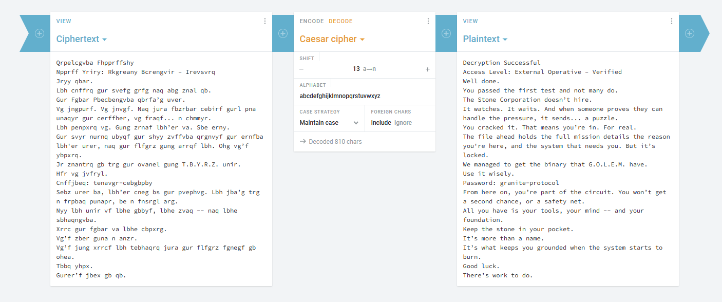

Key discoveries:
- identified that the binary was packed with UPX.
- discovered credentials (password: admin123).
- discovered vulnerability in the .obsidianrc, allowing for command injection.
- found that the application leaks data.

Vulnerability Report
Below is the list of vulnerabilities discovered, ranked by severity:

Vulnerability #1: System compromise

Severity: Critical
Type: Privilege Escalation / Bypass
Location: activate_emergency_protocols
Discovered in: Black-box

Description:
The application hid sensitive information using a binary packing (UPX). Using the utilitary upx, this was easily bypassed. Once the binary was unpacked, the application’s internal strings revealed multiple passwords and flags used to bypass authentication for “Emergency protocols”.

Proof of concept:
- detection of packing (analysis with strings failed to show readable logic, revealing a header)

- filter with sensitive keywords

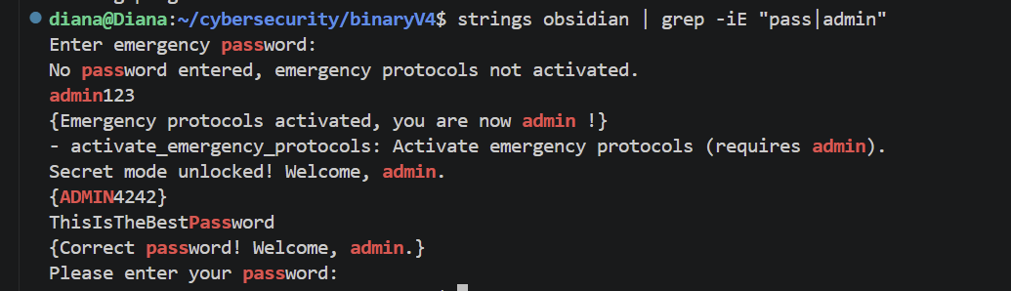

- exploitation

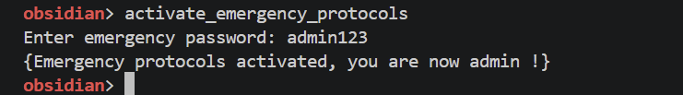

Impact:
An attacker can gain admin privileges over the application, managing to bypass all security layers, granting unauthorized access to multiple functions.

Vulnerabity #2: Command Injection via .obsidianrc

Severity: Critical
Type: Command Injection
Location: .obsidianrc
Discovered in: Black-box

Description:
The application includes a feature that allows users to create a configuration file named .obsidianrc. According to the application’s own help command, this file is used to “automatically execute command at startup” using the syntax “exec <command>”.
The application doesn’t restrict which commands can be used.

Proof of Concept:

- output from the help command:

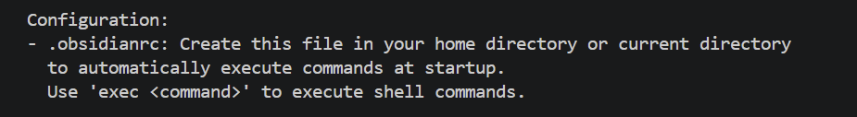

Impact:
This is a critical vulnerability because the application runs any command the user puts in the .obsidianrc file, which is why an attacker is able to execute malicious commands on the system. Since these commands run automatically as soon as the program starts, an attacker can take full control of the computer the moment the application is launched.

Vulnerability #3: Information Disclosure via Error Messages

Severity: High
Type: Information Disclosure
Location: log_system_event
Discovered in: Black-box

Description:
The application leaks sensitive path information by outputting direct system error messages when failing to access files. Specifically, when the directory Data is missing, the application reveals the location of its log file (Data/system.log). Because the program doesn’t use generic error messages, the application allows any user to see the internal folder structure that the program expects to find.

Proof of Concept:

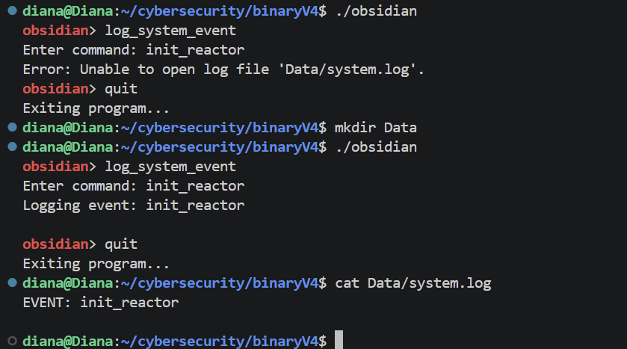

Impact:
By revealing the exact name and location of the log files, the application provides the attacker with essential reconnaissance data. An attacker could attempt to overwrite system logs, making the application unsafe. Moreover, if an attacker does something bad in the system, they can simply delete or modify the file, making it impossible for an admin to see what happened.

Vulnerability #4: Insecure Log Handling

Severity: High
Type: Log injection
Location: read_turbine_config
Discovered in: Black-box

Description:
The application leaks path information regarding the folder. By leveraging the path leakage identified in vulnerability #3, an attacker knows the application writes to and reads from Data/system.log. The attacker can manually insert keywords into system.log, tricking the application into executing those strings as internal events if the log file is loaded as a config file.

Proof of Concept:

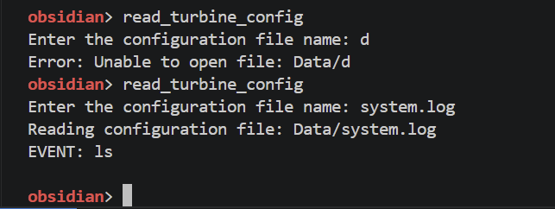

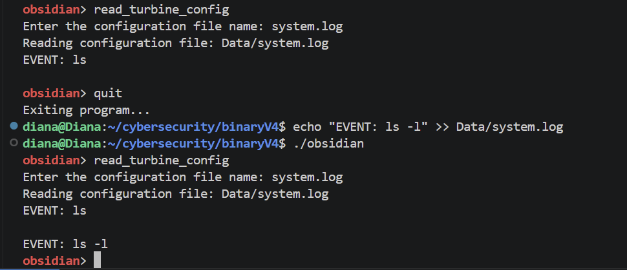

Impact:
This allows an attacker to manipulate the application’s logic. By manipulating the system.log file that the program later uses, an attacker can maybe later trigger unintended events.


v 1.O

