An analysis of the ‘community involvement statements’ published in *Autism*

Diana Tan

2023-10-13

## Preliminary analysis

#### This report provides an overview of results generated from a preliminary analysis. This dataset includes information obtained from 283 journal articles (excluding Perspectives, Commentaries and Editorials; n = 16) published in Autism in the year 2019 (two years before community involvement statements were made mandatory) or 2022 (two years after statements were made mandatory).

##### **1) Frequency of reporting**

Between 1 Jan 2019 and 31 Dec 2019, *Autism* published 116 research papers. 12 of which (10.3%) included information on community involvement activity. Between 1 Jan 2022 and 31 Dec 2022, following the introduction of the mandatory reporting of community involvement policy in Jan 2021, *Autism* published 167 research papers. 90 of which (53.9%) included information on community involvement activity.

yearCommInv <- fulldata %>%  
 select("yearPub", "commInvPresence")  
  
pubCountTotal <- yearCommInv %>%   
 group_by(yearPub) %>%  
 count()  
  
pubByCommInv <- yearCommInv %>%   
 group_by(yearPub) %>%  
 filter(commInvPresence == "Yes") %>%  
 count()  
  
yearCommInv <- as.data.frame(table(yearCommInv))  
  
freqBarChart <- ggplot(yearCommInv, aes(x = fct_relevel(yearPub, c("2022", "2019")), y = Freq, fill = fct_relevel(commInvPresence, c("No", "Yes")))) +  
 geom_col() +  
 labs(x = "Year",  
 y = "Number of articles",  
 fill = "Presence of community involvement") +  
 scale_fill_brewer(palette = "Set2") +  
 theme(legend.position = "bottom") +  
 coord_flip()  
  
freqBarChart

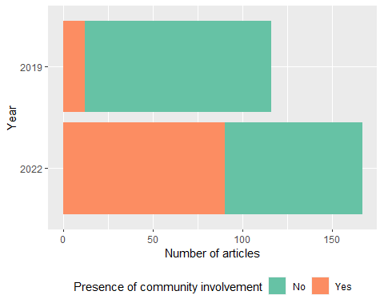

##### **2) Type of community involvement report**

partdata <- fulldata %>%  
 filter(commInvPresence == "Yes") %>%  
 select("levelOfPart", "yearPub")  
  
partdata <- as.data.frame(table(partdata))  
  
partBarChart <- ggplot(partdata, aes(fill = yearPub, x = fct_relevel(levelOfPart, c("Insufficient information", "Informing", "Consulting", "Engaging", "Co-producing", "Community led", "Community controlled")), y = Freq)) +  
 geom_col(position = "stack") +  
 labs(x = "Level of Participation",  
 y = "Number of articles",  
 fill = "Year") +  
 coord_flip()  
  
partBarChart

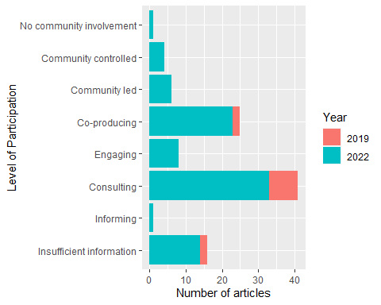

##### **3) Breadth of Community Involvement**

breadthdata <- fulldata %>%  
 select(PMID, c("Developing community-based theories of the research":"Insufficient information"))  
  
#pivot wide to long  
  
breadthdatalong <- breadthdata %>%  
 pivot_longer(cols = c("Developing community-based theories of the research",   
 "Grant proposal writing",   
 "Background research",   
 "Designing study (added)",   
 "Choosing research methods",   
 "Developing sampling procedures",   
 "Recruiting study participants",   
 "Developing intervention",   
 "Implementing the intervention",   
 "Designing/Modifying interview and/or survey questions",  
 "Providing inputs on public-facing materials",   
 "Collecting primary data",   
 "Analysing data",   
 "Interpreting study findings",   
 "Writing reports/journal articles",   
 "Giving presentations at meetings/conferences",  
 "Disseminating findings (approach unspecified)",  
 "Providing endorsement on project",   
 "All aspects of research",   
 "Insufficient information"),  
 names_to = "Breadth of Involvement",  
 values_to = "Level of Participation")   
  
#create cross table to calculate number of articles for each breadth of involvement broken down by level of participation  
breadthparttab <- crosstable(breadthdatalong, "Breadth of Involvement", by = "Level of Participation",  
 percent_pattern = "{n}")   
breadthparttab <- as.data.frame(breadthparttab)  
  
breathpartlong <- breadthparttab %>%  
 pivot_longer(cols = c("No involvement", "Informing", "Consulting", "Engaging", "Co-producing", "Community led", "Community controlled", "Insufficient information"),  
 names_to = "levelOfPart",  
 values_to = "Count") %>%  
 select(c("variable", "levelOfPart", "Count")) %>%  
 rename("breadthOfPart" = "variable")  
  
breathpartlong$Count <- as.numeric(breathpartlong$Count)  
  
#create stacked percent bar chart  
breadthBarChart <- ggplot(breathpartlong, aes(x = fct_relevel(breadthOfPart, c("Insufficient information", "All aspects of research", "Providing endorsement on project", "Disseminating findings (approach unspecified)", "Giving presentations at meetings/conferences", "Writing reports/journal articles", "Interpreting study findings", "Analysing data", "Collecting primary data", "Providing inputs on public-facing materials", "Designing/Modifying interview and/or survey questions", "Implementing the intervention", "Developing intervention", "Recruiting study participants", "Developing sampling procedures", "Choosing research methods", "Designing study (added)", "Background research", "Grant proposal writing", "Developing community-based theories of the research")), y = Count, fill = fct_relevel(levelOfPart, c("Insufficient information", "No involvement", "Informing", "Consulting", "Engaging", "Co-producing", "Community led", "Community controlled")))) +  
 geom_bar(position = "fill", stat = "identity") +  
 theme(legend.position = "bottom",   
 legend.text = element_text(size = 7),  
 legend.key.size = unit(.2, "cm"),  
 axis.text.y = element_text(size = 8),  
 axis.text.x = element_text(size = 8)) +  
 labs(x = "Breadth of involvement",  
 y = "Percentage of published studies",  
 fill = "") +  
 scale_y_continuous(labels = scales::percent) +  
 scale_fill_brewer(palette = "Set2") +  
 coord_flip()  
  
breadthBarChart

