DOKUMEN ALUR PENGERJAAN PROYEK
Campus Facility System
Sistem Informasi Peminjaman & Pelaporan Fasilitas Kampus
Laravel 12 | PHP 8.2 | Branch: feature/person-1-backend
Tanggal dokumen: 07 September 2026
Tim: Person 1 (Backend/Auth - selesai) | Person 2 (Frontend) | Person 3 (Reservasi) | Person 4 (Laporan)

DAFTAR ISI (panduan baca)
- Bab 1 - Gambaran umum & kontrak enum (WAJIB semua person)
- Bab 2 - Yang sudah dikerjakan Person 1 (detail per file)
- Bab 3 - ERD & struktur tabel (diagram + rincian kolom)
- Bab 4 - Diagram alur auth & rencana reservasi/laporan
- Bab 5 - Tugas Person 2 (Frontend) - detail anti-miskom
- Bab 6 - Tugas Person 3 (Reservasi) - detail anti-miskom
- Bab 7 - Tugas Person 4 (Laporan) - detail anti-miskom
- Bab 8 - Aturan kerja bersama
- Lampiran - akun, route, cara jalan

Bab 1 - Gambaran Umum & Kontrak Tim
Aplikasi web kampus untuk (a) peminjaman fasilitas dan (b) pelaporan kerusakan. Empat aktor dengan hak berbeda.
Role | Hak akses
ADMIN | Kelola fasilitas (CRUD + nonaktifkan/INACTIVE). Kelola akun (buat STAFF/USER langsung ACTIVE, verifikasi PENDING -> ACTIVE/REJECTED).
STAFF | Kelola antrean reservasi + laporan (modul Person 3/4). Dibuatkan admin, TIDAK boleh registrasi mandiri.
USER | Registrasi mandiri -> PENDING -> diverifikasi -> login -> pinjam + lapor.
Pengunjung | Lihat daftar & detail fasilitas tanpa login. Tanpa data pemohon.

Kontrak enum - NILAI AKTUAL DI DATABASE (jangan dikarang, lihat migrasi):
Kolom | Nilai aktual (akurat per migrasi) | Keterangan
users.role | ADMIN | STAFF | USER | Huruf kapital.
users.status | PENDING | ACTIVE | REJECTED | Migrasi 2026_09_07_000001. Default PENDING.
facilities.status | AVAILABLE | MAINTENANCE | INACTIVE | Awalnya 2 nilai, INACTIVE ditambah via 2026_09_07_000002.
reservations.status | PENDING | APPROVED | REJECTED | CANCELLED | Migrasi 2026_09_05_085148. Default PENDING. Tanpa DONE.
reports.status | NEW | PROCESSING | COMPLETED | REJECTED | Migrasi 2026_09_05_090227. Default NEW. BUKAN PENDING/RESOLVED.

PERINGATAN ANTI-MISKOM: Person 3/4 WAJIB pakai nilai di atas. Jika ingin nama berbeda (mis. DONE/RESOLVED), buat migrasi baru + diskusi tim. Jangan hardcode string lain di controller.

Bab 2 - Yang Sudah Dikerjakan (Person 1)

2.1 Kronologi
- Initial Commit: Laravel standar.
- Commit 3088998 (5 Sep 2026): Models User/Facility/Reservation/Report, migrasi facilities/reservations/reports, FacilityController v1, RoleMiddleware lama, DatabaseSeeder awal.
- Kerja berjalan (branch feature/person-1-backend, belum di-commit): AuthController, DashboardController, CheckRole + EnsureUserActive (gantikan RoleMiddleware), perombakan FacilityController, Admin/UserController, blade auth/facilities/admin/layouts, 2 migrasi status, seeder + routes final.

2.2 Middleware (jangan dihapus)
bootstrap/app.php mendaftarkan alias 'role' -> CheckRole dan 'active' -> EnsureUserActive. Pola baku: ['auth','active'] untuk user login; ['auth','active','role:ADMIN'] untuk admin; ['auth','active','role:STAFF,ADMIN'] untuk petugas (Person 3/4 tinggal pakai). CheckRole: belum login -> /login; role salah -> 403. EnsureUserActive: tendang session yang statusnya bukan ACTIVE (PENDING/REJECTED).

2.3 Auth (Story 15)
- GET/POST /register (guest): validasi name/email-unique/password-min6-confirmed; PAKSA role=USER status=PENDING; redirect /login + pesan verifikasi.
- GET/POST /login: Auth::attempt; PENDING -> logout + 'menunggu verifikasi'; REJECTED -> logout + 'ditolak admin'; ACTIVE -> redirect dashboard.
- POST /logout (auth): invalidate session. Harus POST + @csrf.

2.4 Dashboard pengarah role
GET /dashboard (auth,active) -> DashboardController@index: ADMIN -> admin.users.index; STAFF/USER -> facilities.index (sementara). AuthController selalu redirect ke dashboard, jadi Person 3/4 cukup ubah 2 baris ini setelah halaman mereka jadi, tanpa menyentuh auth.

2.5 Fasilitas (Story 1, 2, 16)
- index GET /facilities (publik): non-admin otomatis where status != INACTIVE; filter ?type=&location=&min_capacity=; kirim $facilities, $types (distinct), $filters. View HANYA info umum.
- show GET /facilities/{facility} (publik): INACTIVE + non-admin -> 404.
- create/store/edit/update (role:ADMIN): validasi name/type/location required, capacity int>=1, status in AVAILABLE,MAINTENANCE,INACTIVE.
- destroy (role:ADMIN): soft-delete -> update status INACTIVE (riwayat aman). BUKAN delete permanen.
- Route ganda: ->only(index,show) publik + ->except(index,show) admin.

2.6 Admin akun (Story 13, 14, 15)
- GET /admin/users (?status=): urut PENDING,ACTIVE,REJECTED lalu terbaru.
- GET/POST /admin/users/create: buat STAFF/USER langsung ACTIVE (role in STAFF,USER).
- PATCH /admin/users/{user}/verify (action=approve/reject): -> ACTIVE / REJECTED.

2.7 Seeder & cara jalan
Role | Email | Password
ADMIN | dianberlian@undip.ac.id | dian123
STAFF | marchell@undip.ac.id | marsel123
USER | kayla@students.undip.ac.id | kayla123
USER | argifari@students.undip.ac.id | argi123

Fasilitas contoh: Ruang A301/A302/A303/A305 (Classroom, 40) + Lab B/C/D (Computer Laboratory, 35), semua AVAILABLE.
cd "D:\XAMPP\htdocs\PROYEK PPK\campus-facility-system"
composer install
php artisan key:generate
php artisan migrate --seed
php artisan serve # http://127.0.0.1:8000

Bab 3 - ERD & Struktur Tabel
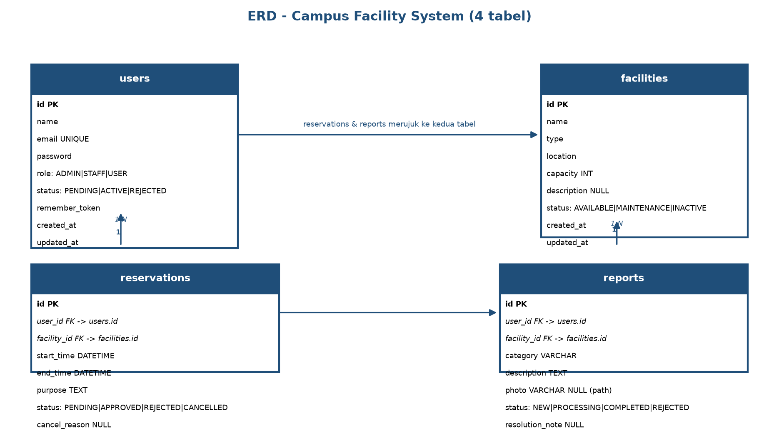
Gambar 1 - Entity Relationship Diagram. reservations & reports masing-masing berelasi N-1 ke users dan facilities.
Rincian kolom per tabel (sesuai migrasi):
Tabel | Kolom kunci
users | id PK, name, email UNIQUE, password (hash), role, status (PENDING|ACTIVE|REJECTED, default PENDING), remember_token, timestamps
facilities | id PK, name, type, location, capacity INT, description NULL, status (AVAILABLE|MAINTENANCE|INACTIVE, default AVAILABLE), timestamps
reservations | id PK, user_id FK->users (cascade), facility_id FK->facilities (cascade), start_time, end_time, purpose TEXT, status (PENDING|APPROVED|REJECTED|CANCELLED, default PENDING), cancel_reason NULL, timestamps
reports | id PK, user_id FK->users (cascade), facility_id FK->facilities (restrict), category, description TEXT, photo NULL (path file), status (NEW|PROCESSING|COMPLETED|REJECTED, default NEW), resolution_note NULL, timestamps

Catatan: facilities INACTIVE disembunyikan dari non-admin di query (bukan di DB). reports.photo menyimpan path (mis. reports/abc.jpg), bukan binary. reports.facility_id restrictOnDelete agar laporan tidak ikut hilang.

Bab 4 - Diagram Alur

4.1 Alur auth & verifikasi (sudah jadi)
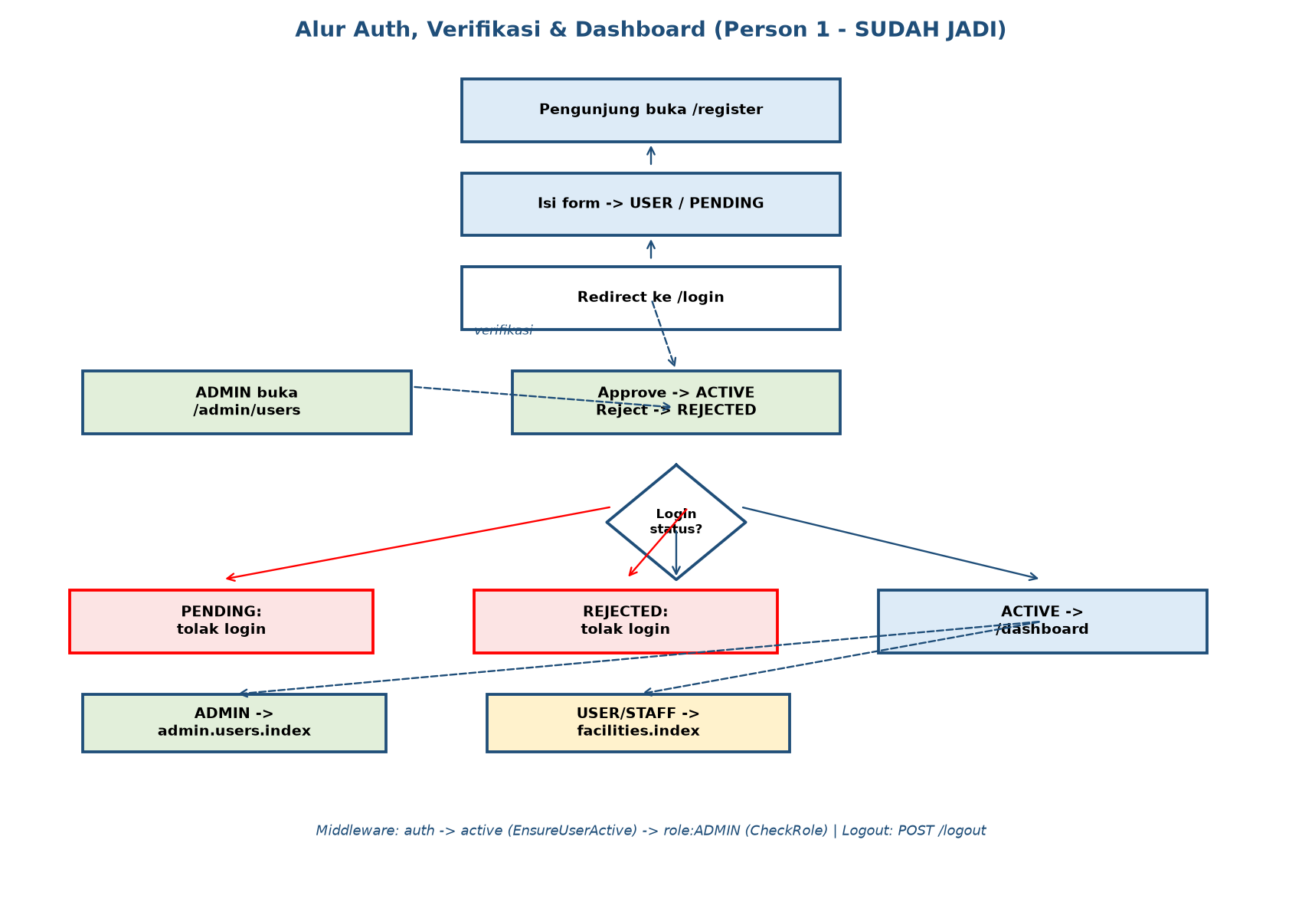
Gambar 2 - Register USER->PENDING, verifikasi admin di /admin/users, login bercabang per status, dashboard bercabang per role. Garis putus-putus = redirect/verifikasi.

4.2 Rencana reservasi & laporan (tugas Person 3/4)
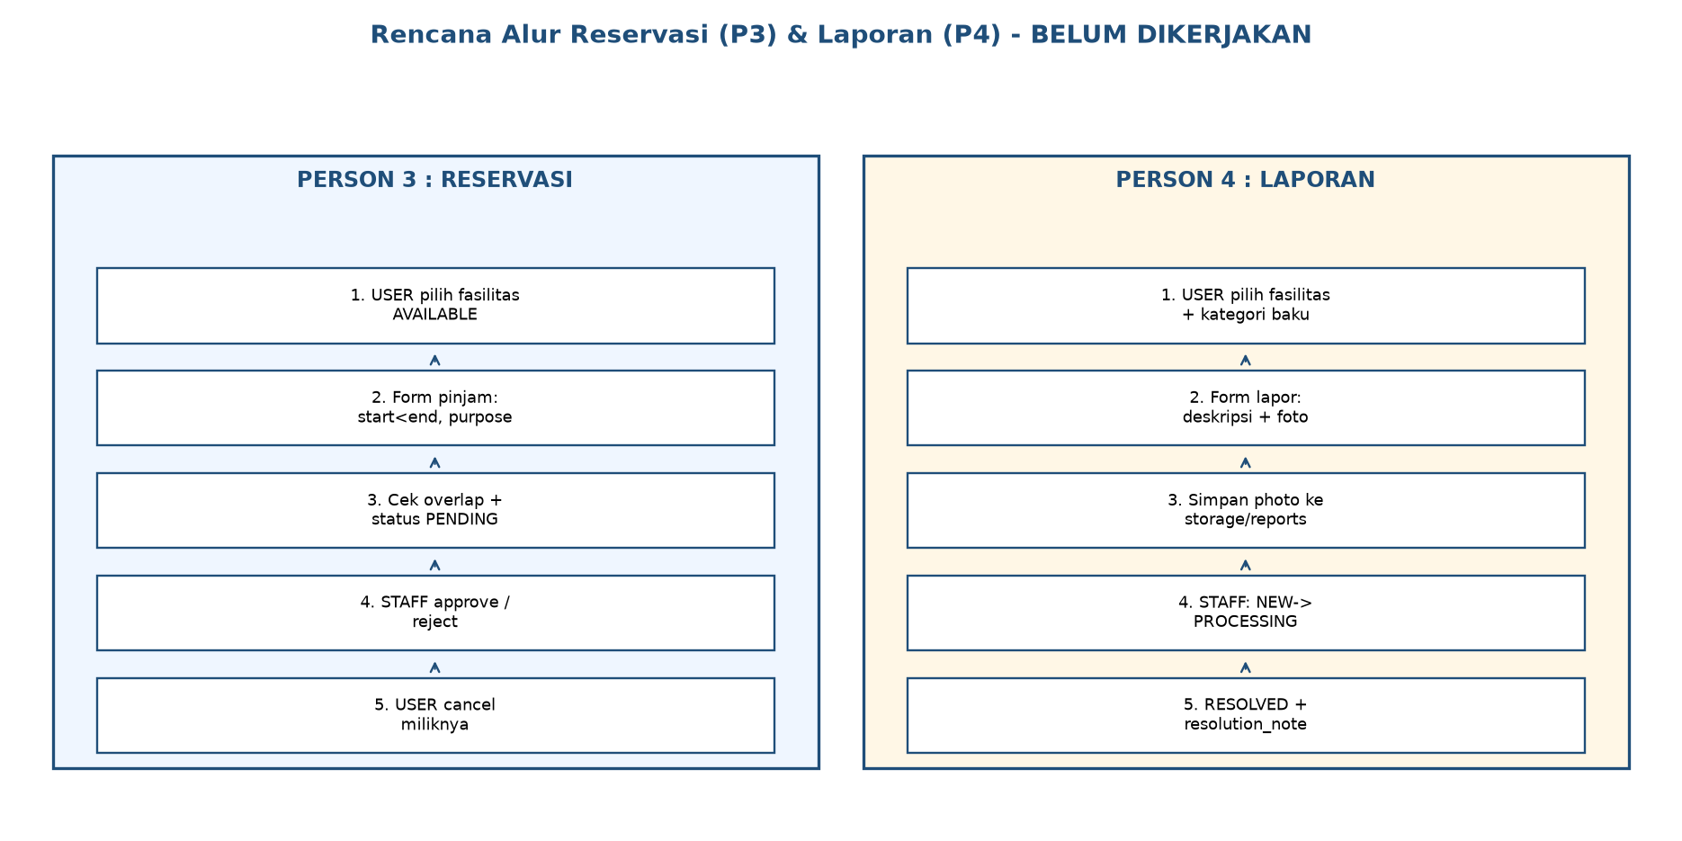
Gambar 3 - Alur yang HARUS dibangun Person 3 (kiri) dan Person 4 (kanan). Detail aturan di Bab 6-7.

Bab 5 - Tugas Person 2 (Frontend/UI)
Tujuan: rapikan tampilan TANPA merusak logika. Boleh ubah: layouts/app.blade.php, welcome.blade.php, dan HTML/CSS blade lain (auth, facilities, admin/users). JANGAN hapus: name attribute, @csrf, @method, variabel controller ($facilities,$types,$filters,$facility,$users,$status). JANGAN ubah: controller/middleware/routes/models/migrasi dan nama route.
- [P2-1] Layout: navbar (Login/Register saat guest; nama+Logout POST saat auth; link Dashboard, Fasilitas, Kelola Akun khusus ADMIN via role check); tampilkan session(success) & @error; Tailwind/Vite konsisten.
- [P2-2] Welcome: hero + tombol Lihat Fasilitas (facilities.index), Login/Register (guest), Dashboard (auth); penjelasan 3 role.
- [P2-3] facilities/index: kartu/tabel + form filter GET (type dropdown dari $types, location text, min_capacity number, pertahankan $filters); badge hijau AVAILABLE / kuning MAINTENANCE / abu INACTIVE (admin saja).
- [P2-4] facilities/show: detail + kembali + Edit (ADMIN saja). JANGAN tambah data pemohon.
- [P2-5] auth/login & register: tampilkan $errors + session(success); tegaskan register khusus USER + verifikasi admin.
- [P2-6] admin/users: tabel + filter ?status= + form PATCH verify (@csrf+@method PATCH+action). JANGAN ubah URL/field.
- [P2-7] Responsif HP + Bahasa Indonesia. Test sebagai guest/USER/ADMIN pakai akun seed.

Bab 6 - Tugas Person 3 (Reservasi)
Dasar sudah ada: tabel + model Reservation. Buat: ReservationController (+ views reservations/*) dan route BARU di bawah route lama (jangan hapus).
- [P3-1] Hanya USER ACTIVE pinjam; guest -> login; cek INACTIVE/MAINTENANCE di controller (jangan hanya di view).
- [P3-2] Validasi: start<end, start tidak lampau, purpose min 10.
- [P3-3] Cegah overlap: tolak jika ada reservasi PENDING/APPROVED di fasilitas sama dengan (start < new_end AND end > new_start).
- [P3-4] Status AWAL PENDING (sesuai enum). USER cancel miliknya (CANCELLED + cancel_reason). STAFF approve (APPROVED) / reject (REJECTED + alasan). Cek kepemilikan user_id vs auth()->id().
- [P3-5] Privasi: USER hanya miliknya; STAFF/ADMIN semua + filter. Middleware: user ['auth','active']; persetujuan ['auth','active','role:STAFF,ADMIN']. JANGAN hard-delete.
- [P3-6] Setelah jadi, tambah link Reservasi Saya + arahkan STAFF ke antrean via DashboardController.
- Usulan route: GET/POST /facilities/{facility}/reserve (user), GET /reservations (riwayat), PATCH /reservations/{r}/cancel; prefix staff: GET /staff/reservations (antrean), PATCH approve/reject. Nama boleh beda asal konsisten + update Bab 8.
ENUM WAJIB: PENDING|APPROVED|REJECTED|CANCELLED. Tidak ada DONE. Butuh DONE? Buat migrasi + diskusi.

Bab 7 - Tugas Person 4 (Laporan)
- [P4-1] Hanya USER ACTIVE lapor. Field: facility (URL/dropdown), category (TENTUKAN list baku, mis. Kebersihan/Listrik/AC/Furniture/Jaringan/Lainnya, pakai di semua tempat), description min 10, photo opsional image max 2MB.
- [P4-2] Upload: $request->file('photo')->store('reports','public'); simpan path ke kolom photo; tampil via asset('storage/...'); placeholder bila kosong. Jalankan php artisan storage:link sekali per laptop.
- [P4-3] Status AWAL NEW. STAFF: NEW->PROCESSING->COMPLETED (wajib resolution_note) / REJECTED (alasan).
- [P4-4] Privasi: USER hanya miliknya (+resolution_note); STAFF/ADMIN semua + filter status/kategori. INACTIVE sebaiknya tidak bisa dilaporkan; MAINTENANCE boleh.
- Route usulan: GET/POST /facilities/{facility}/report (user), GET /reports (milik saya); prefix staff: GET /staff/reports + PATCH progress/resolve. Folder views/reports (jamak) agar tak bentrok Person 3.
ENUM WAJIB: NEW|PROCESSING|COMPLETED|REJECTED (default NEW). Jangan pakai PENDING/IN_PROGRESS/RESOLVED kecuali buat migrasi + diskusi.

Bab 8 - Aturan Kerja Bersama (Anti-miskom)
- Tanpa diskusi DILARANG: ubah enum/kolom DB, alias middleware, nama route lama (login,register,dashboard,facilities.*,admin.users.*), hapus/rename controller, composer update, force push main.
- Wajib: @csrf di semua form non-GET (+@method), middleware tepat, validasi server, Bahasa Indonesia, tanpa data sensitif di view.
- Branch: feature/person-2-frontend, feature/person-3-reservasi, feature/person-4-laporan -> PR ke main satu per satu.
- Urutan: P2 layout dulu -> P3+P4 paralel (file beda) -> gabung -> ubah DashboardController terakhir.
- Test wajib sebelum 'selesai': migrate:fresh --seed; guest tak bisa /dashboard; PENDING tak bisa login; USER tak bisa /admin/* (403); INACTIVE hilang di publik; approve/reject berefek.
- Lapor error sertakan: route, file:baris, langkah reproduksi + pesan/screenshot.

Lampiran - Daftar Route Aktif
/ -> welcome
GET/POST /register, GET/POST /login (guest) | POST /logout (auth)
GET /dashboard (auth,active)
GET /facilities, GET /facilities/{facility} (publik)
GET /facilities/create, POST /facilities, GET /facilities/{f}/edit, PUT/PATCH /facilities/{f}, DELETE /facilities/{f} (auth,active,role:ADMIN)
GET /admin/users, GET /admin/users/create, POST /admin/users, PATCH /admin/users/{user}/verify (auth,active,role:ADMIN)

