HCCS™
Human Capital Control Standard™
Template Library
HCCS-T-1.0
Aligned to HCCS-1.0 Core Standard + HCCS-IG-1.0 Implementation Guide
Version 1.0 | March 2026

Document Information
Document ID | HCCS-T-1.0
Title | Human Capital Control Standard™: Template Library
Aligned To | HCCS-1.0 + HCCS-IG-1.0 (March 2026)
Version | 1.0
Date | March 2026
Author | Diane Malefyt
Copyright | © 2026 IngenuityCo LLC. All rights reserved.

Table of Contents

1. Purpose and Usage
1.1 Template Index
T-01: Role Definition Worksheet
T-02: Evaluation Criteria Design
T-03: Candidate Evaluation Scorecard
T-04: Structured Debrief Record
T-05: Hiring Decision Rationale
T-06: ADT Inventory Entry
T-07: ADT Human Review Record
T-08: Process Classification Record
T-09: Compensable Factor Analysis
T-10: Maturity Self-Assessment Instrument

1. Purpose and Usage
This library provides fillable templates for implementing HCCS™ controls. Each template maps to specific control IDs in the Core Standard and is designed to produce the evidence required for audit.
How to use: Complete the template for each relevant decision event. Retain completed templates as evidence per ER domain requirements (minimum 3 years, contemporaneous, retrievable).

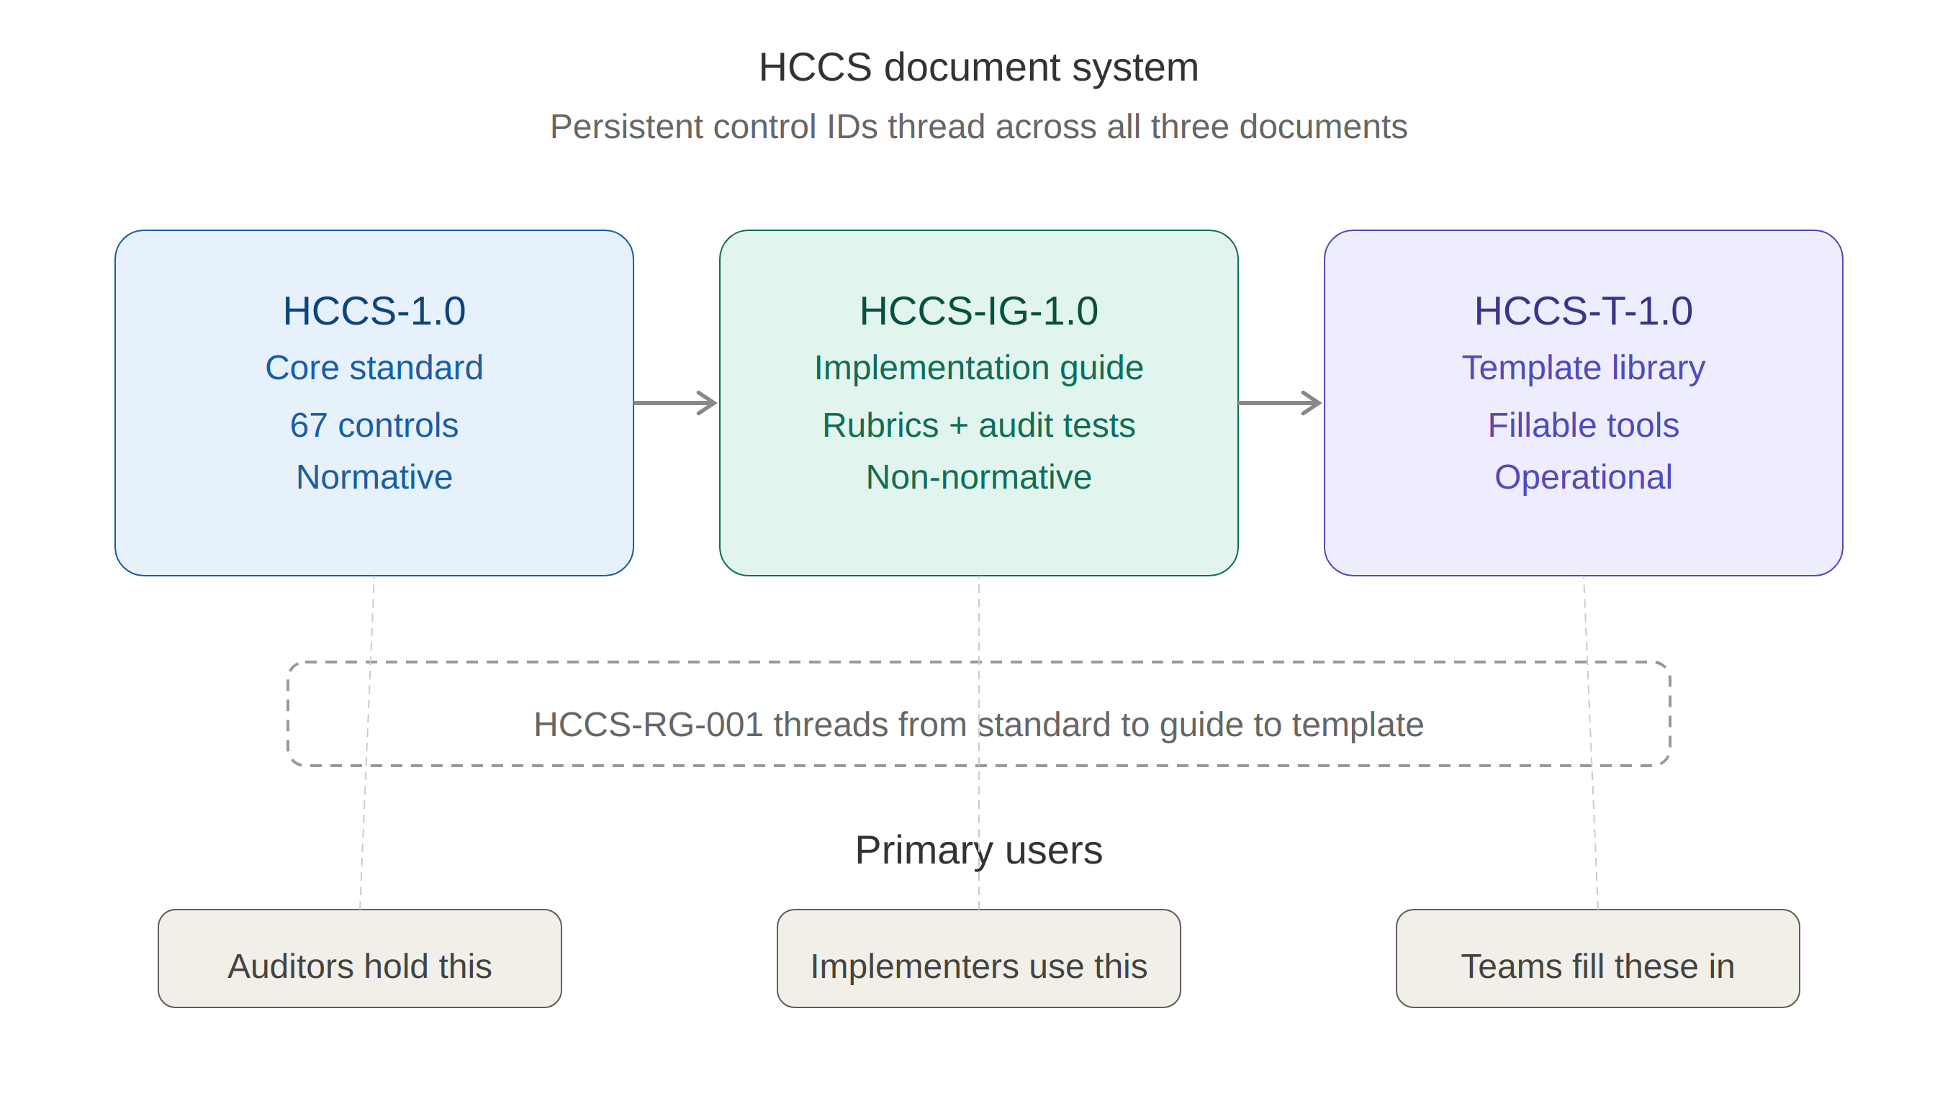

1.1 Template Index

Template | Title | Control IDs | Domain
T-01 | Role Definition Worksheet | RG-001 to RG-007 | Role Governance
T-02 | Evaluation Criteria Design | EI-001, EI-003, EI-010 | Evaluation Integrity
T-03 | Candidate Evaluation Scorecard | EI-002, EI-004, EI-005 | Evaluation Integrity
T-04 | Structured Debrief Record | DG-007, DG-009 | Decision Governance
T-05 | Hiring Decision Rationale | DG-001 to DG-006 | Decision Governance
T-06 | ADT Inventory Entry | AG-001, AG-003, AG-007 | AI Governance
T-07 | ADT Human Review Record | AG-002, AG-006 | AI Governance
T-08 | Process Classification Record | PI-001, PI-002 | Process Integrity
T-09 | Compensable Factor Analysis | CG-001 to CG-003 | Compensation Gov.
T-10 | Maturity Self-Assessment | All domains | Cross-domain

T-01: Role Definition Worksheet
Controls: HCCS-RG-001 through HCCS-RG-007
Instructions: Complete all sections before sourcing begins. Both hiring manager and validator must sign. This document becomes the anchor for evaluation criteria (EI), decision rationale (DG), and compensation alignment (CG).

Role Title
Department / Business Unit
Reporting Line
Date Completed
Requisition ID

Business Outcomes
What results is this role expected to deliver? Be specific and measurable.
Timeframe | Expected Outcomes
30-Day
60-Day
90-Day
Annual

Decision Rights (RG-004)
Authority Level | Decisions
Makes independently
Makes with consultation
Requires approval
Budget authority limit

Scope Indicators (RG-005)
Direct reports
Indirect reports / influence span
Cross-functional exposure
Ambiguity level (low/med/high)
Stakeholder exposure

Capabilities (RG-003)
Distinguish clearly between what the candidate MUST demonstrate at hire vs. what can be developed.
Required at Hire | Learnable Post-Hire

Compensable Factor Alignment (RG-007, linked to T-09)
Factor | Score (1-5) | Rationale
Decision Authority
Scope Complexity
Accountability
Business Impact
Required Expertise

Approval (RG-006)
Role | Name / Signature | Date
Hiring Manager
Validator

T-02: Evaluation Criteria Design
Controls: HCCS-EI-001, EI-003, EI-010
Instructions: Derive 4-6 criteria from the Role Definition (T-01). Define behavioral anchors at 1, 3, and 5. Lock this document before evaluating any candidate. This is the master criteria set used by all evaluators.

Role Title
Linked Role Definition ID
Criteria locked date
Locked by (name)

Criterion 1
Capability assessed
Evaluation method
Construct validity basis (EI-010)

Score | Behavioral Anchor
1 - Does not meet
3 - Meets
5 - Exceptional

Criterion 2
Capability assessed
Evaluation method
Construct validity basis (EI-010)

Score | Behavioral Anchor
1 - Does not meet
3 - Meets
5 - Exceptional

Criterion 3
Capability assessed
Evaluation method
Construct validity basis (EI-010)

Score | Behavioral Anchor
1 - Does not meet
3 - Meets
5 - Exceptional

Criterion 4
Capability assessed
Evaluation method
Construct validity basis (EI-010)

Score | Behavioral Anchor
1 - Does not meet
3 - Meets
5 - Exceptional

Criterion 5
Capability assessed
Evaluation method
Construct validity basis (EI-010)

Score | Behavioral Anchor
1 - Does not meet
3 - Meets
5 - Exceptional

Criterion 6
Capability assessed
Evaluation method
Construct validity basis (EI-010)

Score | Behavioral Anchor
1 - Does not meet
3 - Meets
5 - Exceptional

T-03: Candidate Evaluation Scorecard
Controls: HCCS-EI-002, EI-004, EI-005
Instructions: Complete independently before any group debrief. Score each criterion 1-5 using the anchors from T-02. Document specific evidence for each score. Scores of 4-5 require cited evidence; scores of 1-2 require documented rationale for what was absent.

Role Title
Candidate Name / ID
Evaluator Name
Evaluation Date
Evaluation Method
Start Time / End Time

Criterion 1 | Score (1-5)
Evidence / Rationale for Score

Criterion 2 | Score (1-5)
Evidence / Rationale for Score

Criterion 3 | Score (1-5)
Evidence / Rationale for Score

Criterion 4 | Score (1-5)
Evidence / Rationale for Score

Criterion 5 | Score (1-5)
Evidence / Rationale for Score

Criterion 6 | Score (1-5)
Evidence / Rationale for Score

Overall Assessment
Do NOT complete this section until all criteria are scored individually.
Structured synthesis (reference criteria scores, not overall impression)

Recommendation (advance / hold / reject)
Evaluator signature
Timestamp submitted

T-04: Structured Debrief Record
Controls: HCCS-DG-007, DG-009
Instructions: Follow the 5-step debrief protocol. All individual scorecards (T-03) MUST be submitted before this meeting begins. Document the sequence and any score changes.

Role Title
Candidate Name / ID
Debrief Date / Time
Facilitator

Participating Evaluators
Evaluator Name | Scorecard Submitted | Timestamp

Step 2: Evidence Presentation (criterion by criterion)
Criterion | Score Range | Key Evidence Discussed
Criterion 1
Criterion 2
Criterion 3
Criterion 4
Criterion 5
Criterion 6

Step 3-4: Calibration and Re-scoring
Evaluator | Scores Changed | Rationale for Change

Step 5: Decision
Decision (advance / reject)
Decision-maker name and authority
Rationale (reference criteria)

Post-Decision Rationalization Check (DG-009)
Indicator | Present? Y/N
Rationale documented >24 hrs after decision?
Rationale omits reference to specific criteria?
Rationale contradicts documented scores?
Rationale uses subjective language without criteria linkage?
If any indicator = Y, flag for review under DG-005.

T-05: Hiring Decision Rationale
Controls: HCCS-DG-001 through DG-006
Instructions: Complete within 24 hours of the decision. This is the primary decision record for audit. Must reference pre-defined criteria and cite specific evidence.

Role Title
Requisition ID
Decision Date / Time
Decision-Maker Name
Decision-Maker Title
Authority Basis (per matrix)

Decision
Decision (hire / reject / hold)
Selected Candidate Name / ID

Criteria-Referenced Rationale (DG-001, DG-002)
For EACH evaluation criterion, document the selected candidate's score and the specific evidence supporting it.
Criterion | Score | Evidence Cited
Criterion 1
Criterion 2
Criterion 3
Criterion 4
Criterion 5
Criterion 6

Comparative Basis
How did the selected candidate compare to other finalists on the criteria? (cite specific criteria differences, not overall impressions)

Rejection Rationale for Final-Stage Candidates (DG-006)
For each candidate who reached final evaluation but was not selected:
Candidate | Criteria Not Met | Specific Evidence / Gap

Conflict of Interest Disclosure (DG-004)
Disclosure Item | Present? Y/N
Prior personal or professional relationship with any candidate?
Financial interest in the hiring outcome?
Other potential conflicts?

T-06: ADT Inventory Entry
Controls: HCCS-AG-001, AG-003, AG-007
Instructions: Complete one entry per automated decision tool. Review and update at minimum annually.

Tool Name
Vendor
Version
Function (screen/score/rank/recommend/benchmark)
Decision Scope (what decisions does it influence?)
Data Inputs (what data does the tool use?)
Output (what does the tool produce?)
Deployment Date
Last Review Date
Accountable Owner (name, title)
Human Review Point (where does a human review?)

Explainability Documentation (AG-003)
In plain language, how does this tool produce its outputs? What criteria drive its recommendations?

Bias Testing Record (AG-004)
Test Date | Result Summary | Remediation (if needed)

T-07: ADT Human Review Record
Controls: HCCS-AG-002, AG-006
Instructions: Complete for every batch or individual ADT-supported decision. The reviewer MUST have authority to override the ADT. Passive batch approval does not satisfy this requirement.

ADT Name (per T-06 inventory)
Reviewer Name
Reviewer Title / Authority
Review Date
Candidates / Decisions Reviewed
Total ADT Recommendations Reviewed

Review Detail
Candidate / ID | ADT Output | Reviewer Decision | Override Rationale

Total overrides this review
Reviewer signature

T-08: Process Classification Record
Controls: HCCS-PI-001, PI-002
Instructions: Complete BEFORE posting the role. The hiring manager must classify the process and sign. If internal-preference, document the rationale. This is the record that prevents performative posting findings.

Role Title
Requisition ID
Classification Date
Posting Date (must be after classification)
Hiring Manager Name

Process Classification
Classification | Description | Select
Open | No preferred candidate. External and internal evaluated equally on criteria.
Internal-Preference | Internal candidate identified. Documented. External candidates still evaluated on same criteria.
Restricted | Internal transfer/promotion only. Not posted externally.

Internal-Preference Documentation (if applicable)
Internal candidate name / ID
Rationale for internal preference
Will external candidates be evaluated on identical criteria?

Hiring Manager Signature
Date

T-09: Compensable Factor Analysis
Controls: HCCS-CG-001 through CG-003
Instructions: Score each of the five required compensable factors 1-5. Derive the target compensation range from the factor profile. Document the rationale connecting factors to pay. Salary history MUST NOT be used as a determining factor.

Role Title
Linked Role Definition (T-01) ID
Analysis Date
Completed By

Factor Scoring
Factor | Score | Rationale / Evidence
Decision Authority
What decisions can this role make? Financial/strategic impact?
Scope Complexity
Systems, teams, geographies, ambiguity, competing priorities?
Accountability
End-to-end ownership? Consequences of failure?
Business Impact
Revenue, cost, risk, strategic impact? Impact radius?
Required Expertise
Non-trainable skill/knowledge? Market scarcity?

Compensation Determination
Total factor score (sum of 5 factors)
Factor-derived compensation range
Actual offer / compensation amount

If actual offer deviates from factor-derived range, document rationale:

Confirm: Salary history was NOT used as a determining factor

T-10: Maturity Self-Assessment Instrument
Controls: All domains (cross-cutting)
Instructions: Score each domain against the maturity level criteria. Provide evidence references for each claimed level. This instrument supports self-attestation (L1-L2) and forms the basis for validated self-assessment (L3).

Organization Name
Assessment Date
Assessor Name / Title
Assessment Period

Domain-Level Assessment
Domain | Claimed Level | Key Evidence | Gaps / Remediation Plan
RG
Role Governance
EI
Evaluation Integrity
DG
Decision Governance
AG
AI Governance
PI
Process Integrity
CG
Compensation Gov.
ER
Evidence & Records

Overall Maturity Level Claim
Overall claimed maturity level
Compliance tier (self-attest / validated / audit)

MUST Control Compliance Check
For Level 3 claims: confirm all 25 MUST controls are operational.
Domain | MUST Controls Operational? | Exceptions
RG | RG-001 to RG-004
EI | EI-001 to EI-004
DG | DG-001 to DG-003
AG | AG-001 to AG-004
PI | PI-001 to PI-003
CG | CG-001 to CG-003
ER | ER-001 to ER-004

SHOULD Control Status (Level 3+)
SHOULD Control | Implemented? | If No: Departure Rationale

Attestation
Assessor Signature
Date
Executive Sponsor Signature
Date

