▼▼▼▼▼▼▼▼▼▼▼▼▼▼▼▼▼▼▼▼▼▼▼▼▼

New Mexico Network for
Women in Science and Engineering

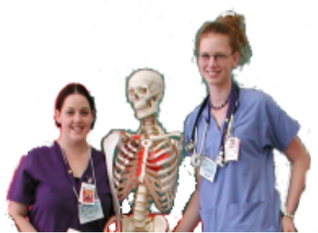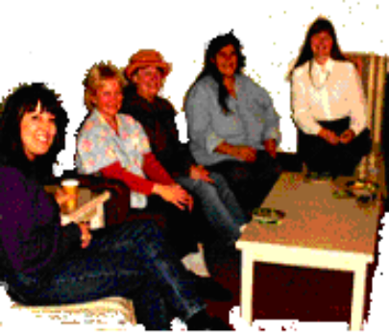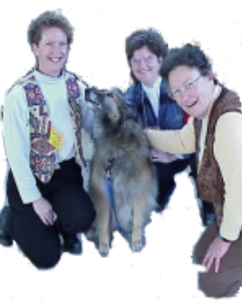

25th Anniversary Celebration!

BBQ & Networking, Saturday June 12, 2004
12:00 – 2:00 p.m.
$10/person

Location: the home of Yolanda Jones King, Moriarty, NM
(please dress casual as we will be outside)

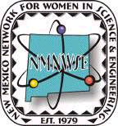

Turn West at mile marker 32 on NM Hwy 41 (between Stanley & Moriarty). When dirt road forks, take the right hand road that goes up the hill to the white house with red tile roof.

Everyone who has ever been involved with the Network and EYH is invited to come share their stories and enjoy both old and new friends. Please RSVP by June 9, to Yolanda at 505-832-4380 or lglgking@nm.net.

▲▲▲▲▲▲▲▲▲▲▲▲▲▲▲▲▲▲▲▲▲▲▲▲▲
Map to home of Yolanda Jones King

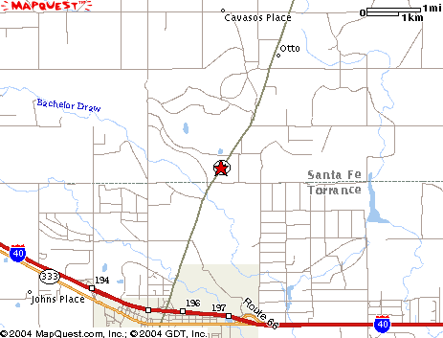

Turn West at mile marker 32 on NM Hwy 41 (between Stanley & Moriarty). When dirt road forks, take the right hand road that goes up the hill to the white house with red tile roof.

