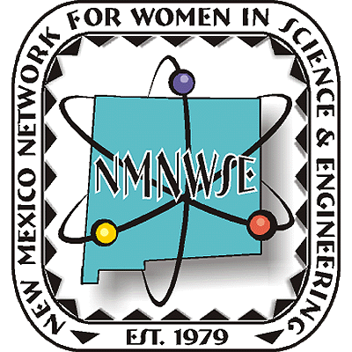
NEW MEXICO NETWORK

P.O. Box 1360 Los Alamos, NM 87544
For Women in Science & Engineering

2007 TECHNICAL SYMPOSIUM

& ANNUAL MEETING

26-28 October 2007

Eklund Hotel, Clayton, NM

First Announcement

NMNWSE AM 2007 webpage:
http://nmnwse.org/AM/2007
AM 2007 interest survey:
http://nmnwse.org/AM/2007/survey
Conference Hotel:
http://www.theeklund.com
877-355-8631 (877-EKLUND1)
NMNWSE home page:
http://nmnwse.org
NMNWSE mailing address:
P.O. Box 1360
Los Alamos, NM 87544
NMNWSE Board e-mail: NMNWSE_Board-l@list.unm.edu

The 1st Annual NMNWSE IMPACT! Award
will be presented at the Annual Meeting.
The IMPACT! Award recognizes NM Women who encourage the entry into and/or career development of women in science and engineering professions.
See http://nmnwse.org/ImpactAward
for nomination forms and more information.
Nominations due 17 August 2007.
The IMPACT! Award is given in cooperation with the New Mexico Commission on the Status of Women. Nominees do not need to be members of NMNWSE.

It's time to put NMNWSE's Technical Symposium and Annual Meeting on your calendar!
The meeting will take place in the historic Eklund Hotel, a landmark for travelers of the southwest since the 1890s. Clayton is near the Texas border in northeastern NM, in the vicinity of Mt. Capulin, Clayton Lake State Park (with dinosaur tracks), and the Kiowa National Grasslands, in addition to still-visible Santa Fe Trail tracks. It's an interesting area to explore.
The meeting will begin with a Friday evening reception. Saturday morning is the annual business meeting of the Network, followed by technical talks by members and students in the afternoon. Saturday ends with an after-dinner program highlighting the local area. Members are invited to stay though Sunday for the first meeting of the new state board, elected Saturday.
Meeting details and registration forms will be posted on the AM 2007 webpage when available. If you might come, please fill in the on-line interest survey to help our planning. If you will come, we also encourage you to make your room reservations as soon as possible. If you have questions or would be willing to help with meeting planning, please contact the NMNWSE board.
Meeting Chair:
Cheri Burch, ctburch@unm.edu, 505-286-9674

