

2008 Nominations accepted through 15 Sep 2008!



Recognizing
NM Women

who further the Network's goals

given in cooperation with the
NM Commission on the
Status of Women
http://nmnwse.org/ImpactAward
presented annually at the

NMNWSE TECHNICAL SYMPOSIUM & ANNUAL MEETING

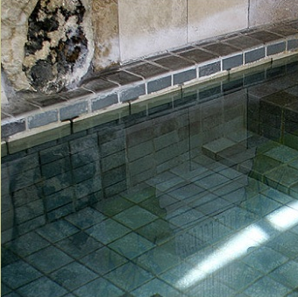
NMNWSE AM 2008 webpage:
http://nmnwse.org/AM/2008
AM 2008 registration:
http://nmnwse.org/AM/2008/register
Conference Hotel:
http://www.sierragrandelodge.com
575.894.6976
NMNWSE home page:
http://nmnwse.org
NMNWSE mailing address:
P.O. Box 1360
Los Alamos, NM 87544
NMNWSE Board e-mail:
NMNWSE_Board-l@list.unm.edu
The baths at Sierra Grande Lodge and Spa.

2008 TECHNICAL SYMPOSIUM

& ANNUAL MEETING

24-26 October 2008

Sierra Grande Lodge and Spa

Truth or Consequences, NM
http://nmnwse.org/AM/2008

Second Announcement

& Call for Papers

P.O. Box 1360 Los Alamos, NM 87544
NEW MEXICO NETWORK

For Women in Science & Engineering

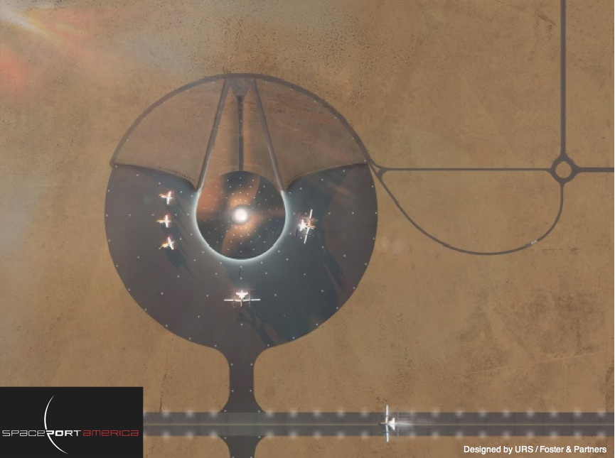
Call for Papers

Call for Papers
We are seeking poster and oral presentations for the technical session on 25 Oct 2008
- Posters are encouraged
- Appetizers will highlight the poster session
- Oral presentations are 30 min, including questions
- Students can apply for meeting scholarships
- Abstracts are due 3 October 2008
- Submit abstracts to the NMNWSE Board
It's time to register for the

NMNWSE 2008 TECHNICAL

SYMPOSIUM & ANNUAL MEETING
The meeting will take place at the Sierra Grande Lodge and Spa in Truth or Consequences, NM. Sierra County, with its soothing hot springs, scenic mountain and desert terrain, mild climate, and the two largest lakes in New Mexico, has long been a preferred vacation spot for New Mexico natives. Nearby, Spaceport America capitalizes on this region's place in the history of rocketry and the aerospace industry.
The meeting will begin with a Friday evening reception. Saturday morning is the annual business meeting of the Network, followed by technical talks by members and students in the afternoon. Saturday ends with a wine and cheese poster session followed by the Conference dinner, featuring presentation of the NMNWSE IMPACT! Award and an after-dinner talk by Gwynne Shotwell of SpaceX, which specializes in space exploration technologies. Members are invited to stay though Sunday for the first meeting of the new state board, elected Saturday.
Further meeting details and registration forms are available on the AM 2008 webpage. If you might come but are not ready to register, please fill in the on-line interest survey to help our planning. If you will come, we encourage you to make your room reservations as soon as possible (be sure to ask for the meeting discount - see the AM 2008 webpage for details). If you have questions or would be willing to help with meeting planning, please contact the appropriate Meeting Chair or the NMNWSE board.
NMNWSE is dedicated to encouraging and assisting women to enter and succeed in science-based fields by their participation and promotion of professional conferences, educational development, mentoring opportunities, and networking activities.
Meeting Chair:
Barbara Torres
torresbw@aol.com
Accommodations Chair:
Cheri Burch
ctburch@unm.edu, 505-286-9674
Technical Chair:
TBA

We would like to thank Spaceport America and the Sierra Grande Lodge and Spa for permission to use the images above and to the right, respectively.
Meeting Registration Fees
ATTENDEE | $85 | Full Meeting
ATTENDEE | $45 | Technical Sessions Only
ATTENDEE | $55 | Dinner Only
ACCOMPANYING PERSONS | $70 | Adult (12+), Full Meeting
ACCOMPANYING PERSONS | $55 | Adult (12+), Dinner Only
ACCOMPANYING PERSONS | $30 | Child (4-11), Full Meeting
ACCOMPANYING PERSONS | Free | Infant (0-3), Full Meeting
See online registration form for further details.
Meeting Schedule
 | Day & Time | Location | Event
Friday, October 24, 2008
 | 6:00 PM  - 10:00 PM | Sierra Grande Lodge Casita | Welcome reception
Saturday, October 25, 2008
 | 9:00 AM  - 11:00 AM | Sierra Grande Lodge Mtg Rm | NMNWSE Annual Business Meeting
Technical Symposium
 | 2:00 PM  - 4:30 PM | Sierra Grande Lodge Mtg Rm | Technical Talks
 | 5:00 PM  - 6:30 PM | Sierra Grande Lodge | Wine and Cheese Poster Session
Award Dinner
 | 7:00 PM  - 9:00 PM | Location TBD | IMPACT! Award presentation  Keynote Speaker: Gwynne Shotwell,  SpaceX - Space Exploration Technologies
Sunday, October 26, 2008
 | 9:00 AM  - 11:00 AM | Sierra Grande Lodge Dining Rm | first Meeting of the 2009 NMNWSE Board

