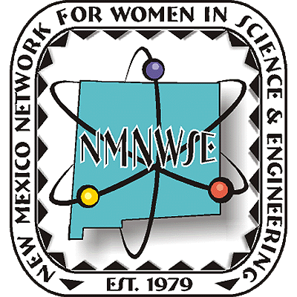
Nominations are now being accepted!


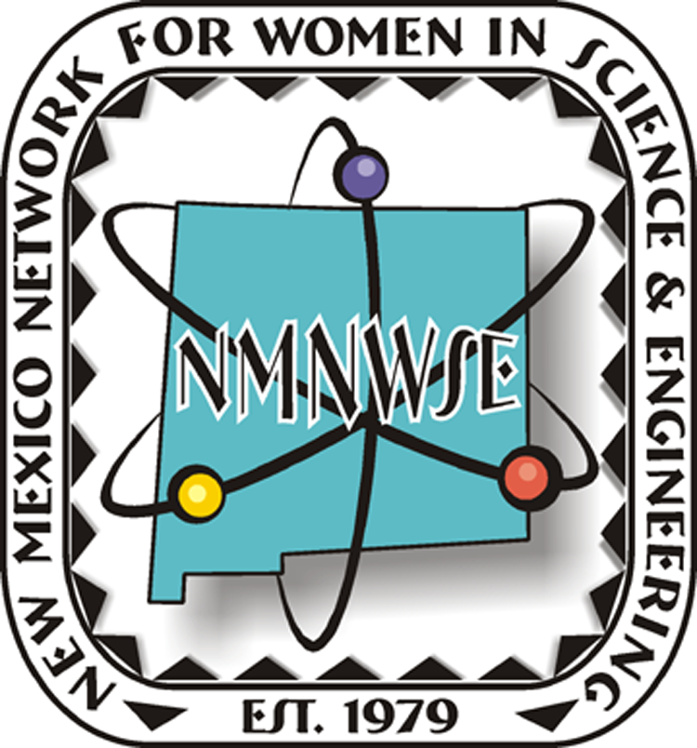

NM Commission on the
Status of Women

given in cooperation with the New Mexico Commission on the Status of Women

2008 TECHNICAL SYMPOSIUM

& ANNUAL MEETING

24-26 October 2008

Sierra Grande Lodge and Spa

Truth or Consequences, NM
http://nmnwse.org/AM/2008

First Announcement

& Call for Papers

Nominations are now being sought from all geographical areas of our state from individuals, organizations and businesses.
Nominees do not need to be members of NMNWSE.
See http://nmnwse.org/ImpactAward
for nomination forms and more information.
Nominations due 15 August 2008.
The second of these annual awards will be
presented 25 October 2008 at the

2008 TECHNICAL SYMPOSIUM & ANNUAL MEETING
http://nmnwse.org/AM/2008

deadline extended: now 15 September 2008
P.O. Box 1360 Los Alamos, NM 87544
NEW MEXICO NETWORK

For Women in Science & Engineering

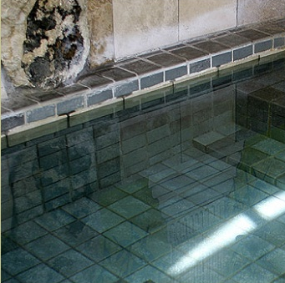
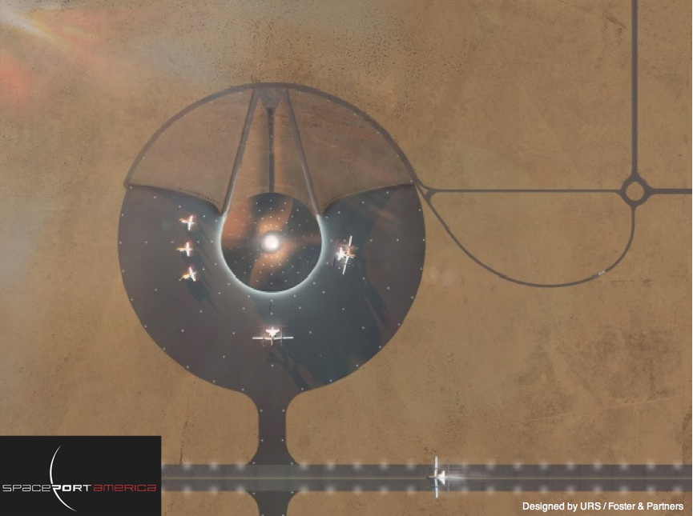
The baths at Sierra Grande Lodge and Spa.
Call for Papers
We are seeking poster and oral presentations for the technical session on 25 Oct 2008
- Posters are encouraged
- Appetizers will highlight the poster session
- Oral presentations are 30 min, including questions
- Students can apply for meeting scholarships
- Abstracts are due 3 October 2008
- Submit abstracts to the NMNWSE Board
It's time to put

NMNWSE's 2008 TECHNICAL

SYMPOSIUM & ANNUAL MEETING
on your calendar!
The meeting will take place at the Sierra Grande Lodge and Spa in Truth or Consequences, NM. Sierra County, with its soothing hot springs, scenic mountain and desert terrain, mild climate, and the two largest lakes in New Mexico, has long been a preferred vacation spot for New Mexico natives. Nearby, Spaceport America capitalizes on this region's place in the history of rocketry and the aerospace industry.
The meeting will begin with a Friday evening reception. Saturday morning is the annual business meeting of the Network, followed by technical talks by members and students in the afternoon. Saturday ends with presentation of the IMPACT! Award and an after-dinner program. Members are invited to stay though Sunday for the first meeting of the new state board, elected Saturday.
Meeting details and registration forms will be posted on the AM 2008 webpage when available. If you might come, please fill in the on-line interest survey to help our planning. If you will come, we encourage you to make your room reservations as soon as possible (be sure to ask for the meeting discount - see the AM 2008 webpage for details). If you have questions or would be willing to help with meeting planning, please contact the appropriate Meeting Chair or the NMNWSE board.
NMNWSE is dedicated to encouraging and assisting women to enter and succeed in science-based fields by their participation and promotion of professional conferences, educational development, mentoring opportunities, and networking activities.
Meeting Chair:
Barbara Torres
torresbw@aol.com
Accommodations Chair:
Cheri Burch
ctburch@unm.edu, 505-286-9674
Technical Chair:
TBA

We would like to thank Spaceport America and the Sierra Grande Lodge and Spa for permission to use the images above and to the right, respectively.

