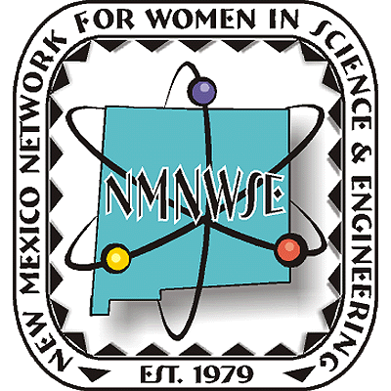
Nominations are now being accepted!



NM Commission on the
Status of Women

given in cooperation with the New Mexico Commission on the Status of Women

ANNUAL TECHNICAL SYMPOSIUM

& BUSINESS MEETING

16-18 October 2009

Hacienda Vargas Bed & Breakfast

Algodones, NM

http://nmnwse.org/AM/

Meeting Announcement

& Call for Papers

Nominations are now being sought from all geographical areas of our state from individuals, organizations and businesses.
Nominees do not need to be members of NMNWSE.
See http://nmnwse.org/ImpactAward
for nomination forms and more information.
Nominations due 18 Sep 2009
Presented each October at the annual

TECHNICAL SYMPOSIUM & BUSINESS MEETING
http://nmnwse.org/AM/

P.O. Box 1360 Los Alamos, NM 87544
NEW MEXICO NETWORK

For Women in Science & Engineering

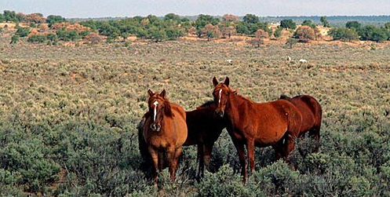
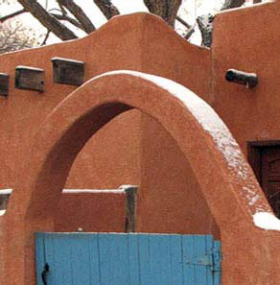
Please fill in the interest survey at
http://nmnwse.org/AM/survey/
to help us insure the meeting serves your needs.
Photos courtesy Hacienda Vargas
Call for Papers
We welcome contributed poster and oral presentations for the technical sessions
- Posters are encouraged
- Appetizers highlight the poster session
- Oral presentations are 30 min, including questions
- Students can apply for meeting scholarships
- Abstracts are due 25 Sep 2009
- Submit abstracts with your registration or email to NMNWSE_Board-L@list.unm.edu
Annual Meeting webpage:
http://nmnwse.org/AM
Annual Meeting interest survey:
http://nmnwse.org/AM/survey
Annual Meeting registration:
http://nmnwse.org/AM/2009/register
NMNWSE home page
http://nmnwse.org
NMNWSE mailing address:
P.O. Box 1360
Los Alamos, NM 87544
NMNWSE Board e-mail:
NMNWSE_Board-l@list.unm.edu

It's time to put the NMNWSE

2009 TECHNICAL SYMPOSIUM

& BUSINESS MEETING
on your calendar!
http://nmnwse.org/AM

16-18 October 2009, Hacienda Vargas B&B, Algodones, NM
This year's meeting will be held at the historic Hacienda Vargas Bed and Breakfast in Algodones, NM, a romantic getaway nestled in the Rio Grande Valley on the historic El Camino Real. The Hacienda Vargas greets travelers and pilgrims in need of lodging the same as it has since the 17th Century.
The meeting schedule, registration forms, meeting and hotel contact info, and other details are available on the Annual Meeting webpage. Early registration closes 25 Sep 2009, with late registrations accepted through the meeting date on a space-available basis. We encourage you to make your hotel reservations as soon as possible.
The meeting begins with a Friday evening reception. Saturday morning is the annual business meeting of the Network. During the lunch break attendees will have an opportunity to visit the nearby Coronado State Monument. Technical talks by members and students are presented in the early afternoon. The late afternoon features the poster session, an excellent opportunity to network - students presenting posters are eligible for a meeting scholarship. Saturday ends with dinner, presentation of the NMNWSE IMPACT! Award (nominations due 18 Sep 2009 – see back page), and an after-dinner speaker. Members are invited to stay though Sunday for the first meeting of the new state board, elected at the business meeting on Saturday.
If you have questions, would be willing to help with meeting planning, or are interested in serving on the NMNWSE Board, please contact us.
NMNWSE is dedicated to encouraging and assisting women to enter and succeed in science-based fields by their participation and promotion of professional conferences, educational development, mentoring opportunities, and networking activities.

