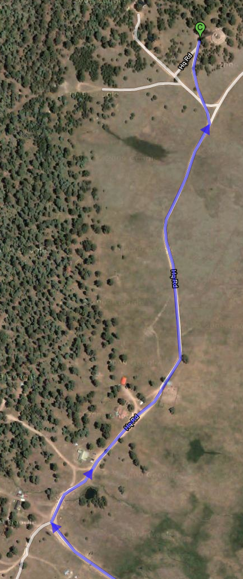
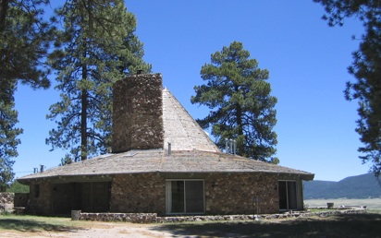
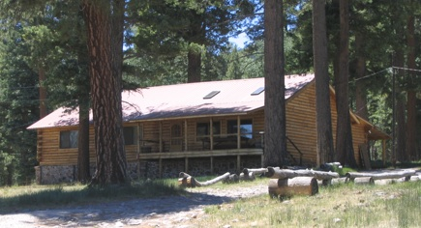
1,2
3,4
5,6
7,8
11,12
9,10
15,16
13,14
~ East
entry
kitchen
etc
common room
(meeting here)
Sketch of bed space locations in Lodge.
Each room has two twins or king.
Each pair of rooms shares bath.
Each room opens to outside.
All rooms except the one labeled “1,2” are the same size and have two twin beds – 1,2 has a king bed and is slightly larger.
Bunk-
house

Bunk-
house photo looks
to SW
Lodge
photo
looks
to NE
Lodge
East
Sketch of bed space locations in Bunkhouse.
“Single” room has single but queen could be added (1-3 bed spaces , reserve as 1).
Other two rooms have 3 stacks of 2 twins, or 1 stack plus 2 full (6 bed spaces each).
All rooms share common bath, and do not open to outside.
17,18
19,20
21,22
23,24
25,26
27,28
29 (30,31)
~ East
common room
kitchen
entry
LODGING AT NMNWSE AM 2010

The Lodge and Bunkhouse are approximately 2000 ft apart.

