Technical Sessions:
Will you be giving a Technical Presentation?
________________Yes ___________ No
Presenter’s Name and Title: ________________________________________________
Title or Subject Area of Presentation: ________________________________________________________________________________________________
Equipment Required: ___________________________
________________________________________________
Screen and overhead projector are provided.
Poster Session:
Will you be giving a Poster Session: _____Yes _____No
Presenter’s Name and Title:________________________
___________________________________________________
Title of Poster Session?_____________________________
___________________________________________________
Are you requesting a scholarship? ____Yes _____No
If attending, please make sure to tear off and send this completed registration form and Make checks for the Annual Meeting, any additional dinner fees, and membership dues to NMNWSE and mail Attention: Nanette Founds P.O. Box 1360 Los Alamos, NM 87544. Details are posted on the Annual Meeting webpage at:
http://nmnwse.org/

ANNUAL TECHNICAL SYMPOSIUM
& BUSINESS MEETING
November 4, 5 & 6, 2011
BEST WESTERN, Stevens Inn,
1829 S. Canal St, Carlsbad, NM
575 887-2851

9:00 AM NMNWSE Business Meeting
11:00 AM Break
12:00 PM Luncheon - Guest Speaker (Need a Volunteer)
1:00 PM Presentations
(30 minutes each)
3:00 PM Break
3:30 PM Poster Session
5:00 PM Break
6:00 PM Dinner
7:00 PM Featured Speaker

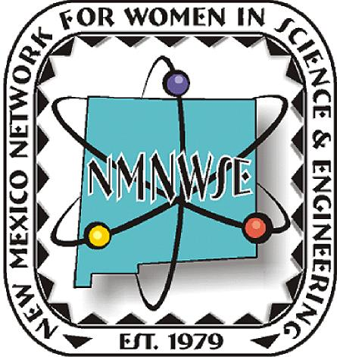

ANNUAL TECHNICAL SYMPOSIUM
& BUSINESS MEETING
November 4, 5 & 6, 2011
BEST WESTERN, Stevens Inn, 1829 S. Canal St, Carlsbad, NM 575 887-2851
If you have questions, please contact Nanette Founds at 505-845-4212 or 505-401-7805, or email at nfounds@doeal.gov or davefounds@comcast.net
NEW MEXICO NETWORK
FOR WOMEN IN SCIENCE
AND ENGINEERING
P.O. Box 1360 Los Alamos, NM 87544

2011 NMNWSE ANNUAL MEETING, TECHNICAL SYMPOSIUM, & WIPP TOUR
This year's annual meeting will be held at the BEST WESTERN in Carlsbad, NM on Nov. 4-6, 2011. Prior to the official start of the meeting, a tour of the Waste Isolation Pilot Plant (WIPP) has been arranged for Friday afternoon. The tours are not available to the general public. To attend the tour you must be at the front of the DOE Carlsbad Field Office (CBFO) by 1:00 pm. That is when the BUS LEAVES! The CBFO is located at 4021 National Parks Highway, Carlsbad, New Mexico, 1-800-336-WIPP
The tour requires registration for everyone who is participating, so please provide your contact information. You must have a photo ID (i.e. driver’s license) and your contact information must match your photo ID.
A meet and greet is scheduled at the BEST WESTERN on Friday evening beginning at 6:30 pm after the WIPP tour. This will be a simple affair with munchies and drinks. It will be a chance for additional networking with members from yours or other chapters of the NMNWSE. We will also reach out to invite and provide information about our organization to several local Carlsbad organizations. This will be a chance to introduce ourselves in an informal gathering and do what we do best -- network. So, please come to this kick-off to our annual meeting.
Saturday morning is the annual business meeting of the Network which will cover Network business, the annual calendar, and election of FY 2011-2012 Board of Directors. There will be a catered luncheon between the Annual Business Meeting and the Technical Symposium. The luncheon will begin around noon with the Technical Symposium following at around 1:00 PM. Each presentation will be approximately 30 minutes
Please indicate on this form if you will make a technical presentation. Your presentation will let each of the members get to know more about you, your work, and provide networking possibilities. Although we know you may have a hectic schedule, this is an opportunity to reach out to many talented women in our organization and the local community.
The late afternoon will feature a more formal poster session. This is also an excellent opportunity to showcase presentations and get input from students in the area. Students, teachers, and non-employed members presenting posters or papers are eligible for a meeting scholarship.
Saturday ends with dinner. Members are invited to stay though Sunday for the first meeting of the new State Board that was elected at the business meeting on Saturday.

2011 Annual Meeting Registration: Name: As shown on Photo ID – Please Print Clearly ____________________________________________
Daytime Phone/Evening Phone/Cell Phone: ____________________________________________
Email:________________________________________
Full Mailing Address and other contact Information:___________________________________
_____________________________________________
Will you be touring the WIPP site?: ___Yes ___No
Will you be attending Meet and Greet on Friday, Nov 4th?: _____Yes ______No
Will you be attending the Business Meeting on Saturday: Morning? _______Yes ________No
Will you be attending the Luncheon, and Poster Sessions?: _______Yes ________No
Will you be attending the Dinner and Guest Speaker Presentation?: _______ Yes ________No
Conference Fee: $55 per person for all events, including conference room fees, lunch and munchies. This does not include dinner on Nov 5, which will be paid separately depending on dinner selection after the meeting.
BEST WESTERN rooms are $83.63 (includes Tax and full hot buffet breakfast) per night for double occupancy. Make sure to mention you’re with the NMNWSE for discounted rate. Please register with hotel prior to Nov 1 to be guaranteed a room. Registration for the Annual Meeting needs to be received by October 28, 2011.

