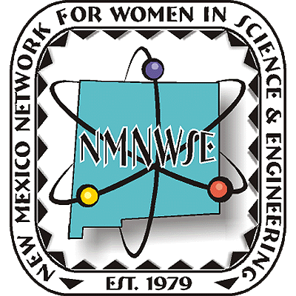
Nominations are now being accepted!



NM Commission on the
Status of Women

given in cooperation with the New Mexico Commission on the Status of Women

ANNUAL TECHNICAL SYMPOSIUM

& BUSINESS MEETING

4-6 November 2011

Carlsbad, NM

Announcement

& Call for Papers

http://nmnwse.org/AM/

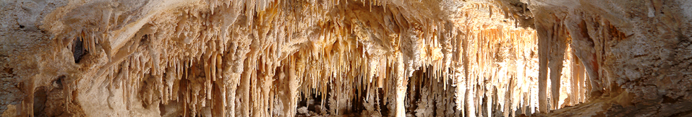

Nominations are now being sought from all geographical areas of our state from individuals, organizations and businesses.
Nominees do not need to be members of NMNWSE.
See http://nmnwse.org/ImpactAward
for nomination forms and more information.
Nominations due (TBA)
Presented each October at the annual

TECHNICAL SYMPOSIUM & BUSINESS MEETING
http://nmnwse.org/AM

P.O. Box 1360 Los Alamos, NM 87544
NEW MEXICO NETWORK

for Women in Science & Engineering

DRAFT ONLY -- NOT FOR USE
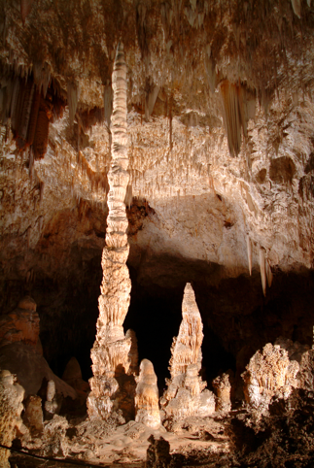
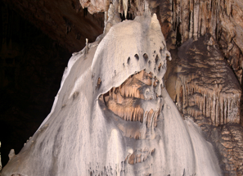
We welcome contributed poster and oral
presentations for the technical sessions
- Appetizers highlight the poster session
- Oral presentations are 30 min, including questions
- Submit abstracts to NMNWSE_Board-L@list.unm.edu
- Abstracts are due TBA
- Postdeadline posters accepted
if space
Interested?
NMNWSE home page:
http://nmnwse.org
NMNWSE mailing address:
P.O. Box 1360
Los Alamos, NM 87544
NMNWSE Board e-mail:
NMNWSE_Board-l@list.unm.edu

2011 NMNWSE

TECHNICAL SYMPOSIUM

& BUSINESS MEETING
http://nmnwse.org/AM/2011

4-6 November 2011

Carlsbad, NM
This year's meeting will be held in Carlsbad, NM.... (ADD)
The meeting begins with a Friday evening reception. Saturday morning is the annual business meeting of the Network, followed by technical talks in the early afternoon. The late afternoon features the poster session, an excellent opportunity to network – students, teachers, and non-employed members presenting posters are eligible for a meeting scholarship. Saturday ends with dinner, presentation of the 2011 NMNWSE IMPACT! Award (see back for call for nominations), and an after-dinner program highlighting.... (ADD)
Members are invited to stay though Sunday for the first meeting of the new state Board, elected at the business meeting on Saturday.
Registration forms and further details are posted on the Annual Meeting webpage. Early registration closes TBA, with late registrations accepted through the meeting date on a space-available basis.
If you have questions, would be willing to help with meeting planning, or would be interested in running for the 2012 Board, please fill in the online Interest Survey, email the NMNWSE Board, or use the comment section on the online Meeting Registration Form. If you will be coming, we encourage you to register as soon as possible.
NMNWSE is dedicated to encouraging and assisting women to enter and succeed in science-based fields by their participation and promotion of professional conferences, educational development, mentoring opportunities, and networking activities.

Make your reservations early – space fills up fast!
Annual Meeting webpage:
http://nmnwse.org/AM/2011
Registration:
http://nmnwse.org/AM/2011/register
Interest Survey:
http://nmnwse.org/AM/survey

Student, Teacher,
Not Employed?
Present a poster to qualify
for a meeting scholarship!

Call for Papers

