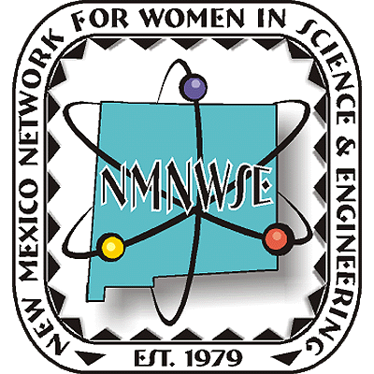
Nominations are now being accepted!



NM Commission on the
Status of Women

given in cooperation with the New Mexico Commission on the Status of Women

ANNUAL TECHNICAL SYMPOSIUM

& BUSINESS MEETING

2-4 November 2012 Alamogordo, NM

First Announcement

& Call for Papers

http://nmnwse.org/AM/

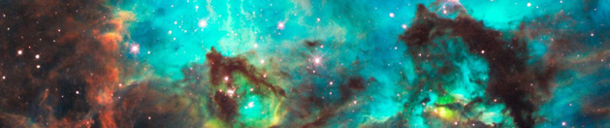

Nominations are now being sought from all geographical areas of our state from individuals, organizations and businesses.
Nominees do not need to be members of NMNWSE.
See http://nmnwse.org/ImpactAward
for nomination forms and more information.
Nominations due 1 October 2012
To be Presented 3 November at the annual

TECHNICAL SYMPOSIUM & BUSINESS MEETING
http://nmnwse.org/AM/2012

P.O. Box 1360 Los Alamos, NM 87544
NEW MEXICO NETWORK

for Women in Science & Engineering

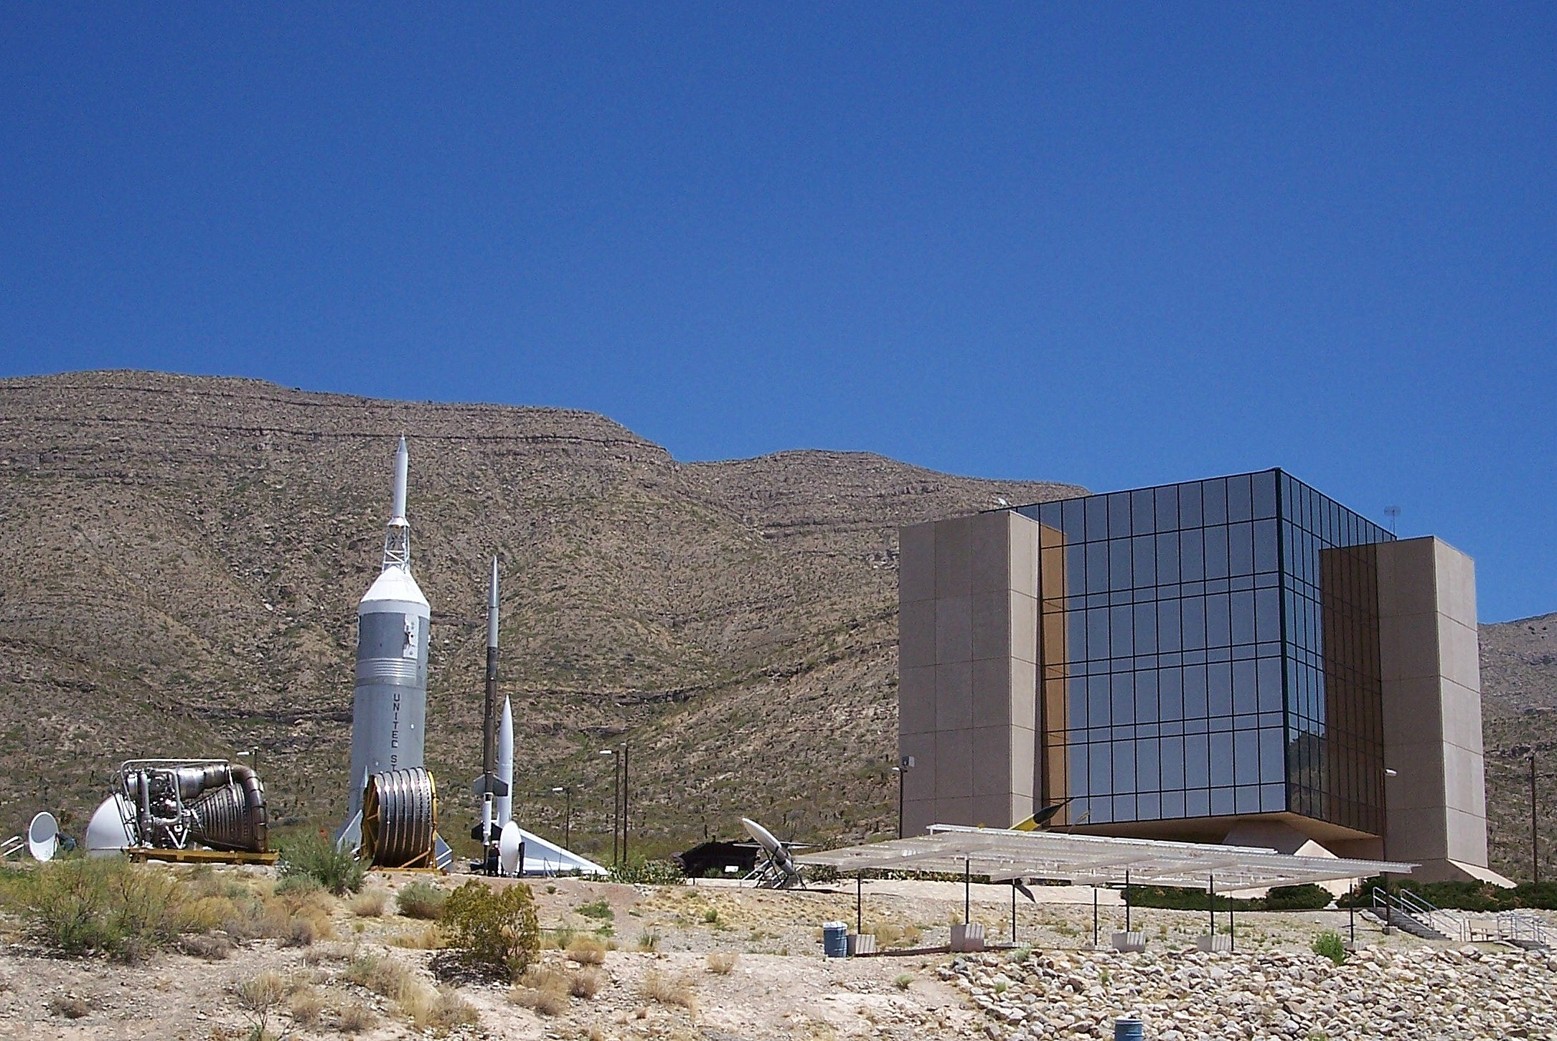
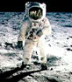
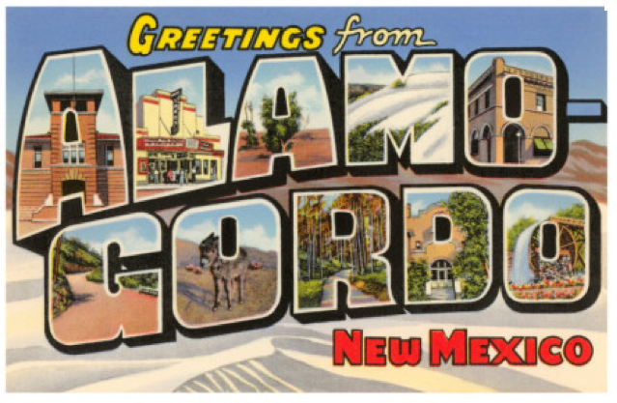
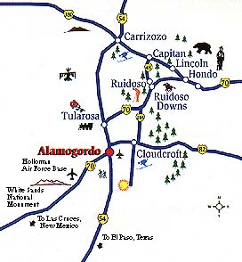
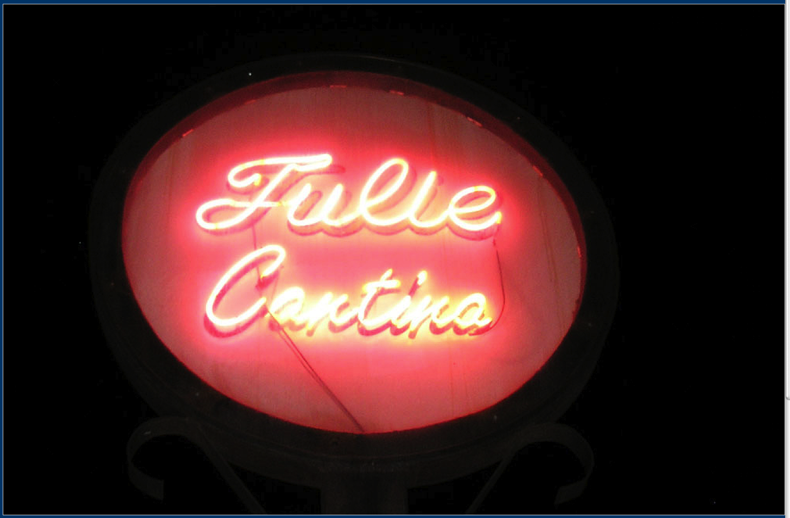
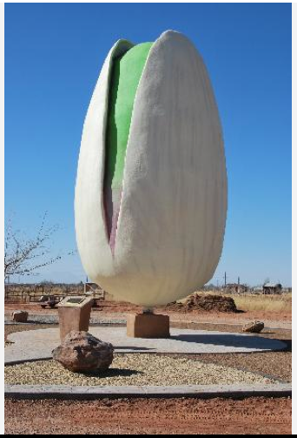
Call for Papers
Student, Teacher,
Not Employed?
Present a poster to qualify
for a meeting scholarship!

2012 NMNWSE

TECHNICAL SYMPOSIUM

& BUSINESS MEETING
http://nmnwse.org/AM/2012

2-4 November 2012

Alamogordo, NM
This year's meeting will be held in Alamogordo, NM, “the friendliest place on earth”. Alamogordo boasts scenic attractions such as White Sands National Monument as well as scientific attractions such as the New Mexico Space History Museum which stresses the role the state of New Mexico has played in the development of the U.S. Space Program.
The meeting begins with a Friday evening reception at the NM Space History Museum, with the Museum open for our browsing. Saturday morning is the annual business meeting of the Network, followed by technical talks in the early afternoon. The late afternoon features the poster session, an excellent opportunity to network – students, teachers, and non-employed members presenting posters are eligible for a meeting scholarship. Saturday ends with dinner at the Historic Tulie Cantina in Tularosa, featuring presentation of the 2012 NMNWSE IMPACT! Award, and an after-dinner program. Members are invited to stay though Sunday for the first meeting of the new state Board, elected at the business meeting on Saturday.
Registration forms and other details are posted on the Annual Meeting webpage. Early registration closes 1 Oct 2012, with late registrations accepted through the meeting date on a space-available basis. See the AM 2012 webpage for the meeting schedule and hotel information.

We welcome contributed poster and oral
presentations for the technical sessions
- Appetizers highlight the poster session
- Oral presentations are 30 min, including questions
- Submit abstracts to NMNWSE_Board-L@list.unm.edu
- Abstracts are due 1 Oct 2012

Interested?
Interest Survey:
http://nmnwse.org/AM/survey
Annual Meeting webpage & registration:
http://nmnwse.org/AM/2012
NMNWSE home page:
http://nmnwse.org

NMNWSE mailing address:
P.O. Box 1360
Los Alamos, NM 87544
NMNWSE Board e-mail:
NMNWSE_Board-l@list.unm.edu

With so much to see and do, it’s better to make your reservations early!
If you have questions, would be willing to help with meeting planning, or would be interested in running for the 2013 Board, please fill in the Interest Survey or email the NMNWSE Board.
NMNWSE is dedicated to encouraging and assisting women to enter and succeed in science-based fields by their participation and promotion of professional conferences, educational development, mentoring opportunities, and networking activities.

