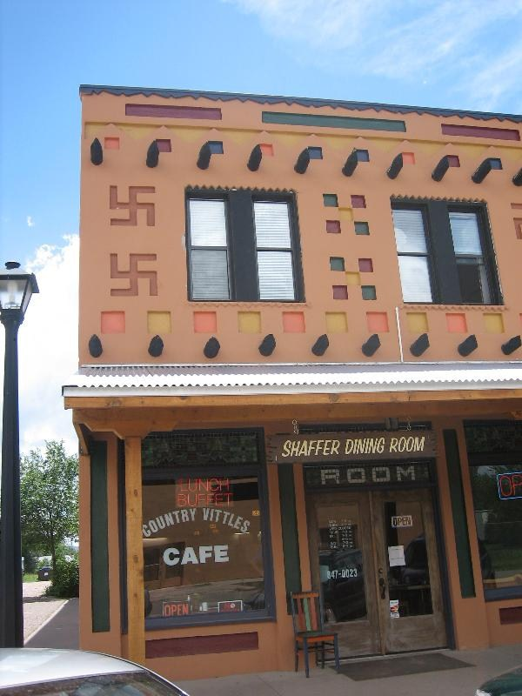
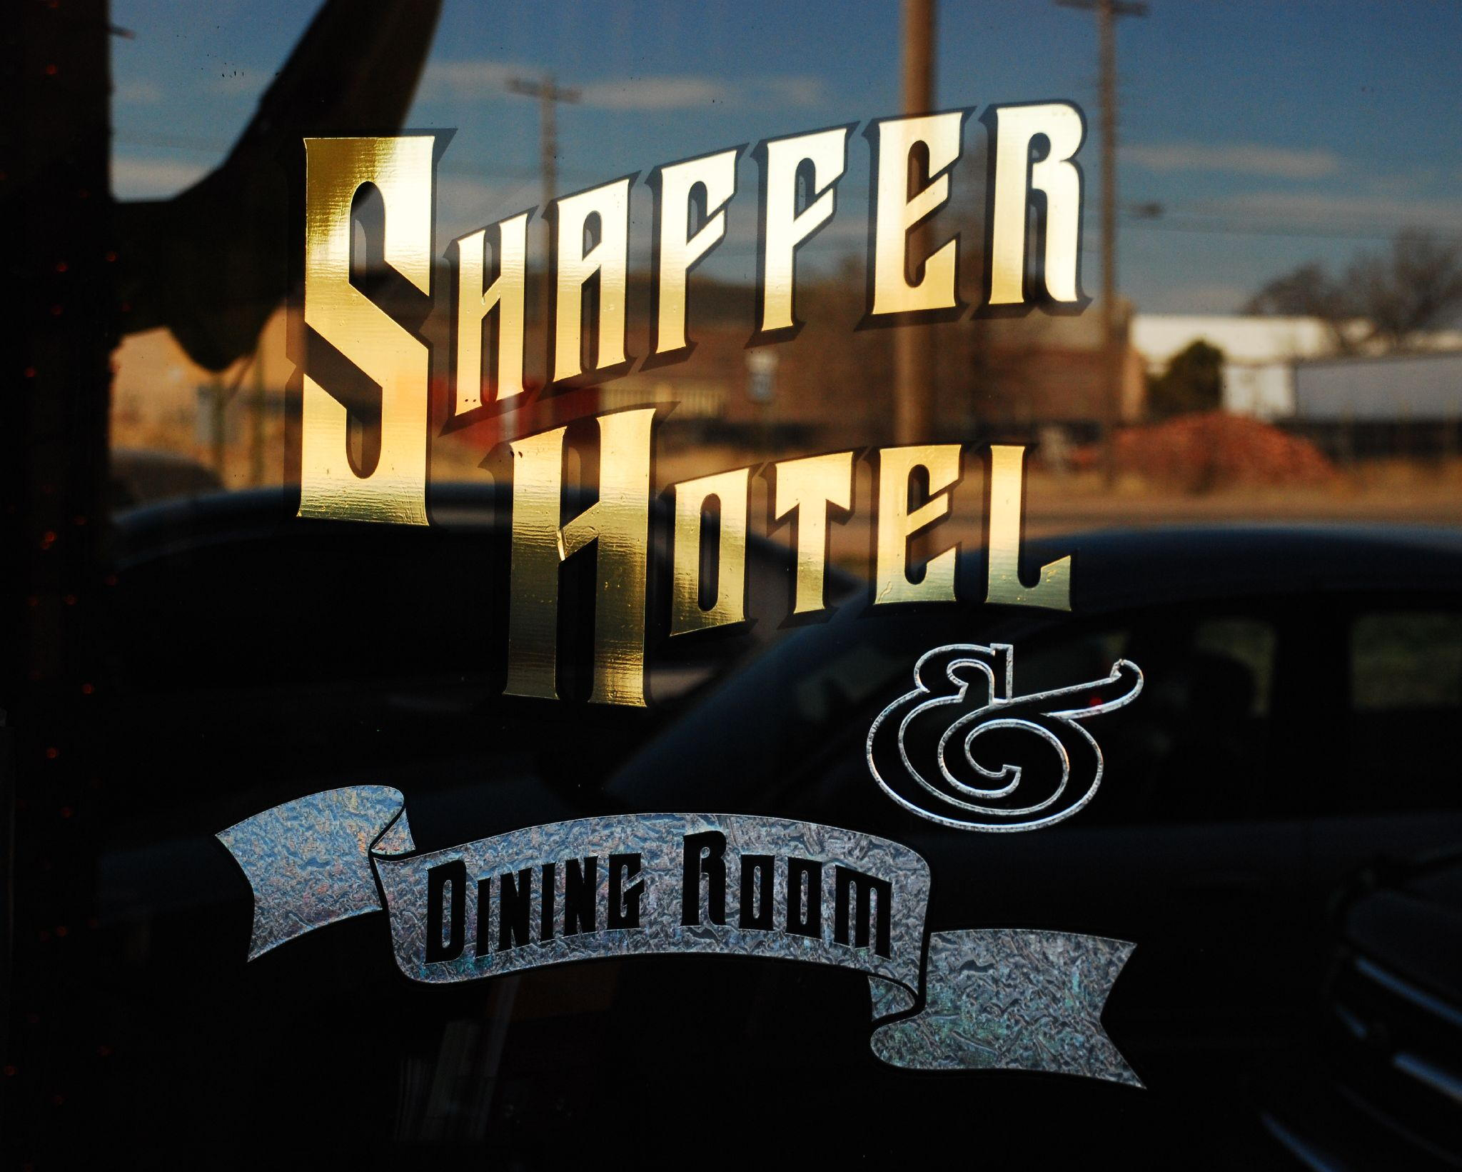
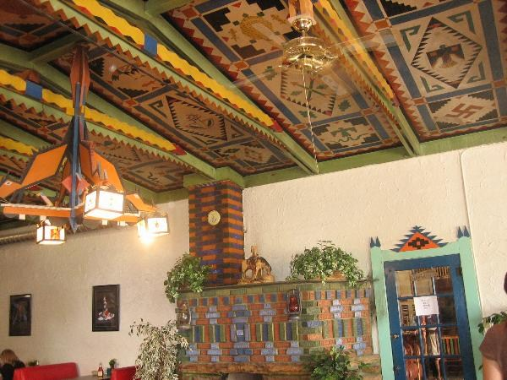
NMNWSE needs you!
Volunteer to run for
the 2014 Board!

2013 NMNWSE

TECHNICAL SYMPOSIUM

& BUSINESS MEETING
http://nmnwse.org/AM/2013

25-27 October 2013

Shaffer Hotel, Mountainair, NM
This year's meeting will be held at the Shaffer Hotel, a registered National Historical site and one of the few Pueblo-Deco buildings still in existence. Mountainair, a gem of the Old West, is nestled among charming Spanish towns along the picturesque Manzano Mountains. Mountainair is now home to many fine art galleries and studios, but still allows visitors to "step back in time" and is a delight to train enthusiasts. At the nearby Salinas Pueblo Missions National Monument you’ll find three ancient Indian pueblos sites and the ruins of majestic 17th century Spanish mission churches.
The meeting begins with a Friday evening reception. Saturday morning is the annual business meeting of the Network. Lunch features a talk on the Salinas Pueblo Missions, followed by a tour in the early afternoon. The late afternoon features the technical session - an excellent opportunity to network! Students, teachers, and non-employed members presenting posters are eligible for a meeting scholarship. Saturday ends with dinner at the Alpine Alley Restaurant and presentation of the 2013 NMNWSE IMPACT! Award (see announcement in this flyer).
Members are invited to stay though Sunday for the first meeting of the new state Board, elected at Saturday's Business Meeting.
Registration is now open. The meeting cost is $85 including lunch and dinner on Saturday. Early registration closes 10 Oct 2013, with late registrations accepted through the meeting date on a space-available basis.
See the AM 2013 webpage for the meeting schedule, hotel information, and other details as they become available.
If you have questions, would be willing to help with meeting planning, or would be interested in running for the 2014 Board, please fill in the Interest Survey or email the NMNWSE Board.
Make your reservations early,
or risk rooming with the ghosts!
NMNWSE is dedicated to encouraging and assisting women to enter and succeed in science-based fields by their participation and promotion of professional conferences, educational development, mentoring opportunities, and networking activities.

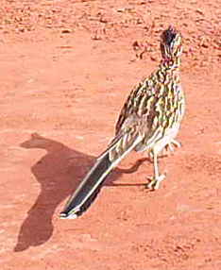
Call for Papers
Student, Teacher,
Not Employed?
Present a poster to qualify
for a meeting scholarship!

We welcome contributed posters for the technical session:
- Poster session/reception
is always a hit!
- Submit abstracts to
NMNWSE_Board-L@list.unm.edu
or include with your registration
- Poster abstracts due 10 Oct 2013
Due to time limits talks are not currently being accepted. If this is a problem, contact the Board to discuss options.

Annual Meeting webpage
& registration:
http://nmnwse.org/AM/2013
Interest Survey:
http://nmnwse.org/AM/survey
NMNWSE home page:
http://nmnwse.org
NMNWSE mailing address:
PO Box 1360, Los Alamos, NM 87544
NMNWSE Board e-mail:
NMNWSE_Board-l@list.unm.edu

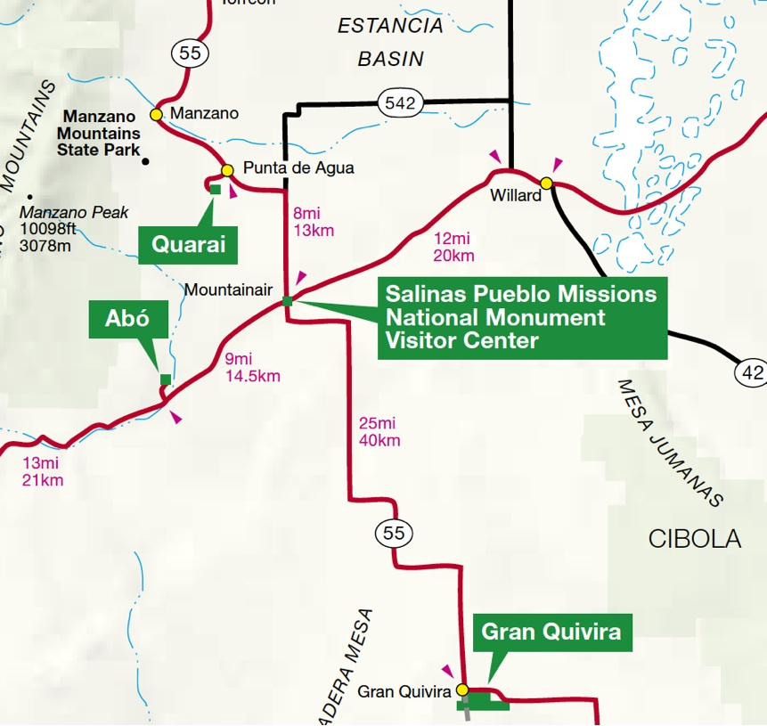
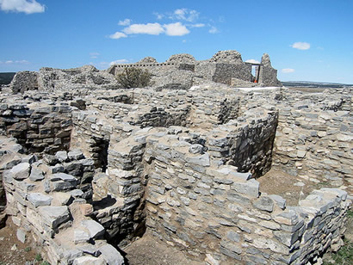
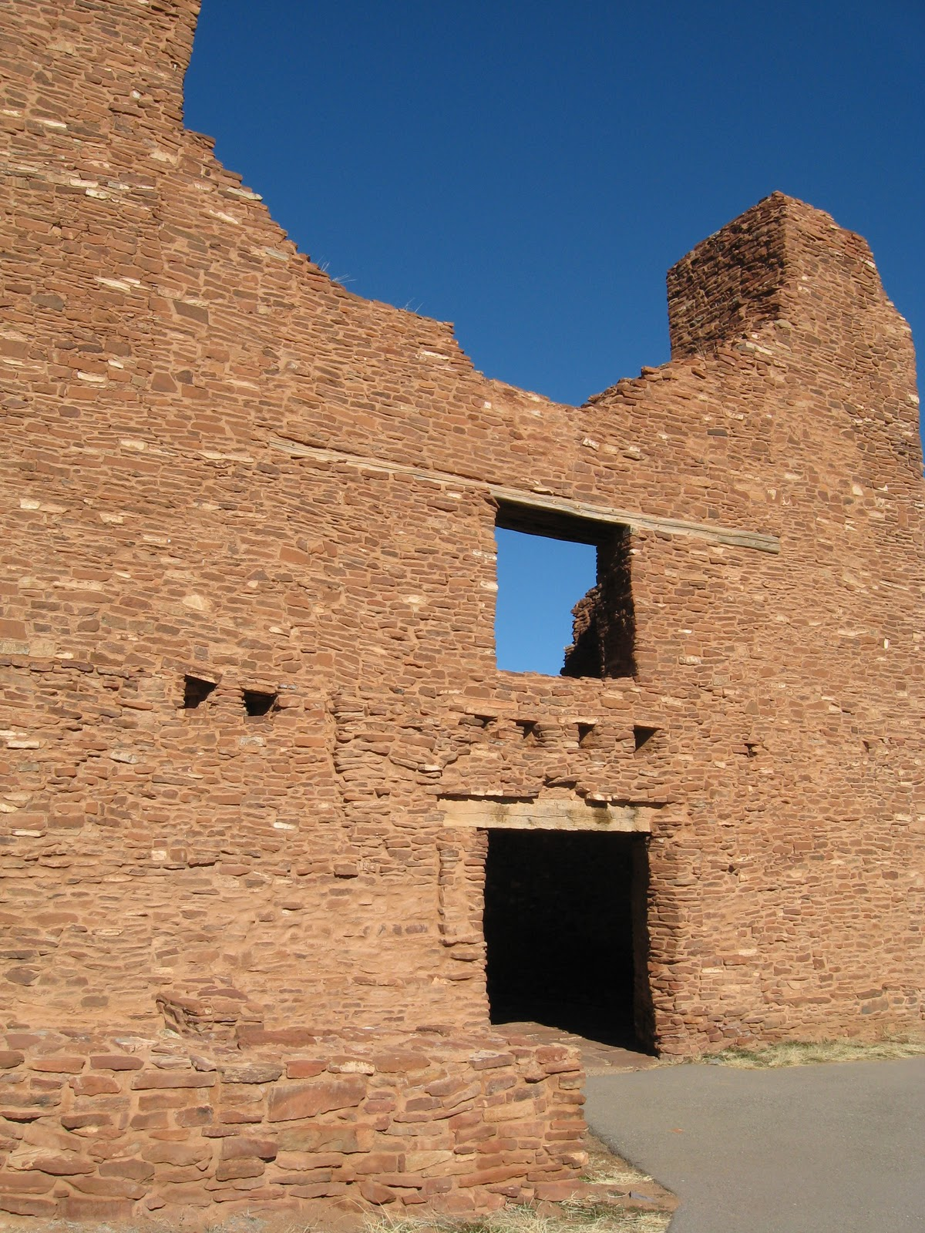
& NMNWSE AM13, Shaffer Hotel
Salinas Mission wall
Gran Quivera

Conference Hotel Information:
Shaffer Hotel
103 W. Main St.
Mountainair, NM
(505) 847-2888
(888) 595-2888
- Reservations are on your own.
- Rooms at the Shaffer Hotel are being held through Oct. 1.
- Reserving early recommend due to limited space.

Meeting
Schedule:
Friday, Oct 25th
6 - 9 pm: Registration & Reception, Shaffer Hotel
Saturday, Oct 26th
9 am - noon: Business Meeting, Shaffer Hotel
noon - 1 pm: Lunch, Shaffer Hotel
Featured Speaker: Prof. Troy Lovata, UNM
“Culture Contact: The Archaeology of the
Salinas Missions National Monument”
1 - 4 pm: Salinas Missions National Monument Tour
5 - 6:30 pm: Poster Session & Reception, Shaffer Hotel
7 - 9 pm: Dinner & IMPACT! Award Presentation,
Alpine Alley Restaurant
Sunday, Oct 27th
8:30 - 11 am: Board Meeting, Shaffer Hotel
Call for 2014 Board Volunteers:
The NMNWSE Board is actively seeking volunteers to run for the 2014 Board, elected at the Annual Meeting. We are looking for at least 3 volunteers to run for at-Large positions, plus volunteers to run for Vice President and Secretary. If you might be interested, or would like to nominate someone, contact the current board at: NMNWSE_Board-L@list.unm.edu
Nominations are due 1 October 2013.
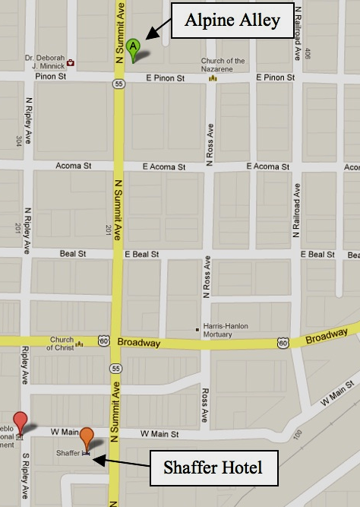

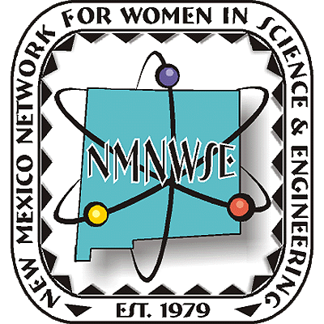
Nominations are now being sought from all geographical areas of our state from individuals, organizations and businesses. Nominees do not need to be members of NMNWSE.
for details and nomination forms, see nmnwse.org/ImpactAward
Nominations due 9 August 2013
😐 now due 9 Sep 2013 😐
Presented 26 October at the annual
TECHNICAL SYMPOSIUM
& BUSINESS MEETING
http://nmnwse.org/AM/2013

IMPACT!
The NM Network for Women
in Science & Engineering
NM Commission on the
Status of Women
recognizing NM Women who encourage
and help women to enter and succeed
in science & engineering professions.
given in cooperation with the New Mexico Commission on the Status of Women

Award
Nominations are now being accepted!

Science is Women's Work

ANNUAL TECHNICAL SYMPOSIUM

& BUSINESS MEETING
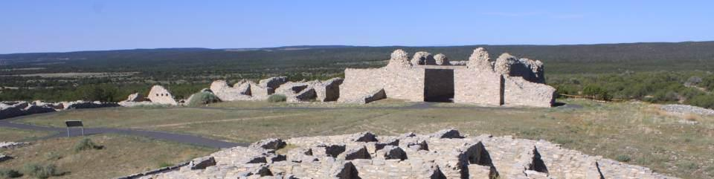
25-27 October 2013 Mountainair, NM

First Announcement

& Call for Papers

http://nmnwse.org/AM/
P.O. Box 1360 Los Alamos, NM 87544
NEW MEXICO NETWORK

for Women in Science & Engineering

