
New Mexico Network for Women in Science & Engineering
2013 Annual Meeting and Technical Symposium
Shaffer Hotel, Mountainair, NM
25-27 October 2013
http://nmnwse.org/AM/2013
AM 2013 Schedule
(Draft, rev. 10/17/13)
Friday, Oct 25th
6:00 pm  - 9:00 pm | Shaffer Hotel | Registration/Opening Reception^{(a)}
Saturday, Oct 26th
09:00 am  - 12:00 noon | Shaffer Hotel | Business Meeting ^{(b)}  (snacks provided)
12:00 noon  - 1:00 pm | Shaffer Hotel | Lunch^{(a)}  Featured Speaker: ^{(c)}  Prof. Troy Lovata, Honors College, UNM  “Culture Contact: The Archaeology of the Salinas Missions National Monument”
1:00 pm  - 4:00 pm | Salinas Missions  Natl Monument | Travel to/from and Walking Tour of Salinas Mission (probably Abo) ^{(d)}
5:00 pm  - 6:00 pm | Shaffer Hotel | Technical Poster Session  (wine & cheese reception)
6:30 pm  - 9:00 pm | Alpine Alley Restaurant, Mountainair | Dinner^{(b)} & IMPACT Award Presentation  7:00 p.m. Welcome  7:30 p.m. IMPACT! Award
Sunday, Oct 27th
8:30 am  - 11:00 am | Shaffer Hotel | First Board Meeting with Elected Officers^{(e)}  (snacks provided)
Notes:
^{(a)} Lunch and Saturday Dinner, the receptions, and snacks, are included with your registration. Breakfasts are on your own.
^{(b)} Business Meeting Agenda on page 2.
^{(c)} Abstract for Troy’s talk on page 3.
^{(d)} Entrance fee to the Salinas Missions National Monument are on your own.
^{(e)} Board Meeting Agenda not yet available. All NMNWSE members are welcome to attend. Continuing and newly elected board members should plan to attend.

New Mexico Network for

Women in Science and Engineering

OFFICERS: Nanette Founds, President; Barbara Torres, Treasurer;
Claudia Barreto, Secretary; Laurie Marnell, Past President

2013 Annual Business Meeting – Reports Encompass the Entire Year
Date: Saturday, October 26, 2013
Place: Shaffer Hotel, Mountainair, NM

TOPIC PRESENTER
Call to Order Nanette Founds
Secretary’s Annual Report Claudia Barreto
Treasurer’s Annual Report Barbara Torres
Audit Committee Cheri Burch
Approval of 2013 Budget Barbara Torres

Annual Reports from Standing Committee Chairs:
Annual Meeting Chair Yolanda King
Elections Yolanda King
Archives Mary S. Campbell
Communications Tinka Gammel
Membership Karen Agogino
Fund Raising Jennie DeMarco
Policies and Procedures Jeanne Banks
Publicity/Outreach Laurie Marnell
Student Awards Mercedes Agogino
IMPACT! Award: Jennie DeMarco.
New Mexico Girls Collaborative Cheri Burch

Expanding Your Horizons: Annual Report
State Rebecca Galves

Chapter Annual Reports:
Central Chapter Jeanne Banks
Eastern Chapter Mercedes Agogino
Northern Chapter Emily Schultz-Fellenz
Southern Becca Galves

Annual Business Meeting Action Items:
Date Opened | Open Action Items | Responsible | Status

New Mexico Network for Women in Science & Engineering
2013 Annual Meeting and Technical Symposium
Shaffer Hotel, Mountainair, NM
25-27 October 2013
http://nmnwse.org/AM/2013
Featured Speaker
Noon Saturday, Oct 26, Shaffer Hotel

Culture Contact: The Archaeology of the
Salinas Missions National Monument
Prof. Troy Lovata, Honors College, University of New Mexico
The Salinas Missions National Monument, made up of the sites of Abo, Quarai, and Gran Quivira, is one of the most visible reminders of the important role that the lands on the eastern flanks of the Manzano Mountains played in Colonial New Mexico. Contact era interactions between Native American groups and Spanish settlers left indelible marks on the landscape. But the archaeology of the region goes back much further and set the stage for how New Mexico would develop for the next three and a half centuries following the construction of the missions. This talk will discuss human organization and more than a half century of archaeological research in the region.

2013 NMNWSE

TECHNICAL SYMPOSIUM

& BUSINESS MEETING
nmnwse.org/AM/2013

25-27 October 2013

Shaffer Hotel

Mountainair, NM

Conference Hotel:
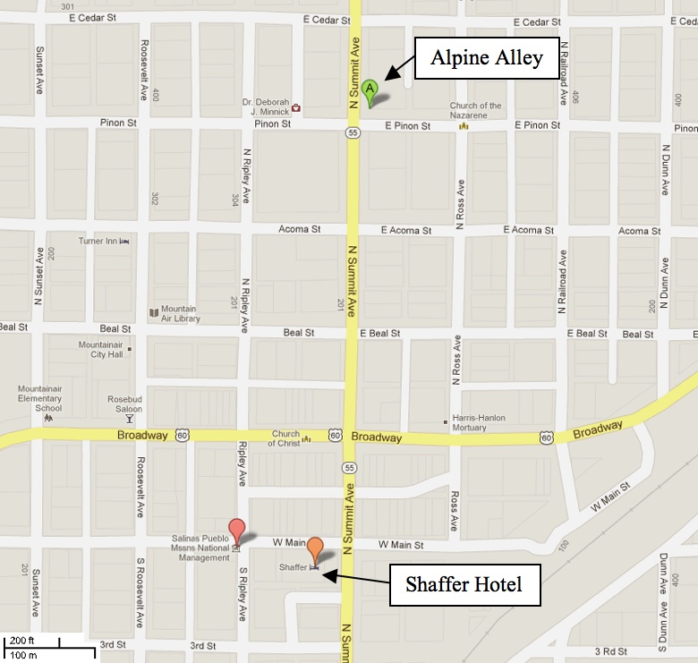
Shaffer Hotel,
103 West Main St.
Mountainair, NM 87036
(505) 847-2888
(888) 595-2888

Restaurant:
Alpine Alley
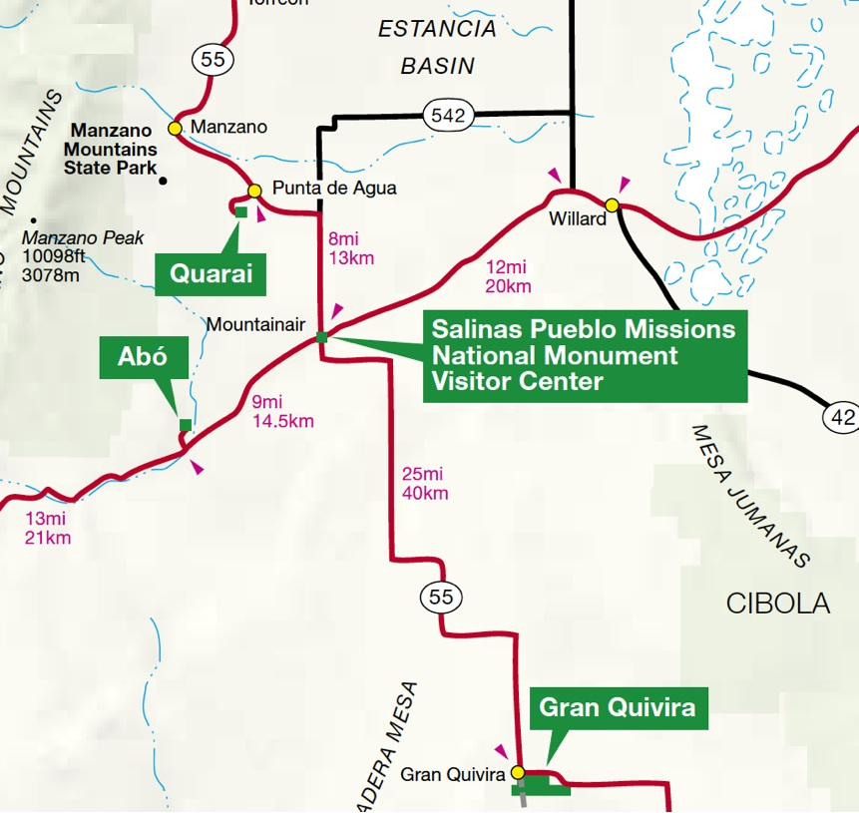
210 North Summit Avenue
Mountainair, NM 87036
(505) 847-2478

Salinas Pueblo Missions
National Monument

Park Headquarters:
Corner of Ripley and Broadway
Mountainair, NM 87036
505-847-2585

Abo Ruins:
9 miles west on US 60
and 1/2 mile north on NM 513.
(505) 847-2400.

Gran Quivira Ruins:
26 miles south on NM 55.
(505) 847-2770.

Quarai Ruins:
8 miles north on NM 55
and 1 mile west.
(505) 847-2290.

