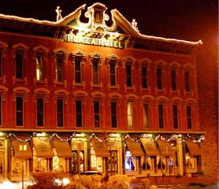

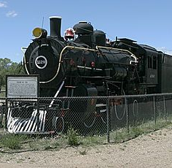
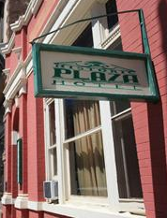
2014 NMNWSE

TECHNICAL SYMPOSIUM

& BUSINESS MEETING
http://nmnwse.org/AM/2014

17-19 October 2014

Plaza Hotel, Las Vegas, NM
This year's meeting will be held at the historic Plaza Hotel, called "The Belle of the Southwest" when it was built in 1882. Lovingly restored a century later and listed on the National Register of Historic Places, this magnificent hotel, suspended gracefully in the past, presides regally over the Old Town Plaza in Las Vegas, NM.
The meeting begins with a Friday evening reception. Saturday morning is the annual business meeting of the Network – all members are encouraged to attend. After lunch there will be a tour of a nearby university focusing on their STEM education and outreach programs (details TBA). The late afternoon features technical talks, followed by a poster session/reception before dinner - an excellent opportunity to network and for students to present their work in a supportive environment! Saturday ends with the conference dinner at Dick’s Pub and Grill featuring presentation of the 2014 NMNWSE IMPACT! Award (see call for nominations in this flyer), followed by a talk highlighting research done at one of the local universities (speaker TBA).
Members are invited to stay though Sunday for the first meeting of the new state Board, elected at Saturday's Business Meeting.
See the AM 2014 webpage for the meeting schedule, hotel information, and other details as they become available.

Registration will open as soon as costs finalized (anticipated Sep 1). The registration fee is expected to be under $100, including lunch and dinner on Saturday, receptions, and snacks. Early registration will close 3 October 2014, with late registrations accepted through the meeting date on a space-available basis ($10 late fee applies).
Students, teachers, and non-employed members presenting a poster in Saturday’s technical session are eligible for a meeting scholarship to cover the registration fee.
If you have questions, would be willing to help with meeting planning, or would be interested in running for the 2014-15 Board, please fill in the Interest Survey or email the NMNWSE Board.
Space is limited: make your hotel reservations early!
NMNWSE is dedicated to encouraging and assisting women to enter and succeed in science-based fields by their participation and promotion of professional conferences, educational development, mentoring opportunities, and networking activities.

NMNWSE needs you!
Volunteer to run for
the 2014-15 Board!

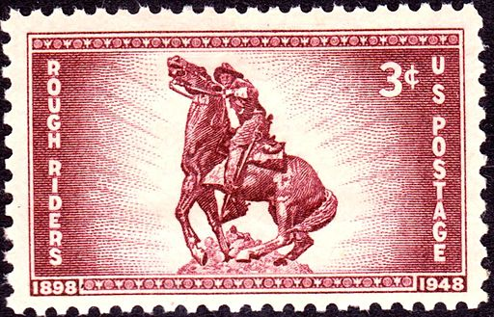
Call for Papers
We welcome contributed talks and posters for the technical session:
- Poster session/reception
is always a hit!
- Submit abstracts to
NMNWSE_Board-L@list.unm.edu
or include with your registration
- Talk abstracts due Sep 15, 2014
- Poster abstracts due Oct 6, 2014
- Post-deadline posters accepted if space available.

Student, Teacher,
Not Employed?
Present a poster to qualify
for a meeting scholarship!

Annual Meeting webpage
& registration:
http://nmnwse.org/AM/2014
Interest Survey:
http://nmnwse.org/AM/survey
NMNWSE home page:
http://nmnwse.org
NMNWSE mailing address:
PO Box 1360, Los Alamos, NM 87544
NMNWSE Board e-mail:
NMNWSE_Board-l@list.unm.edu

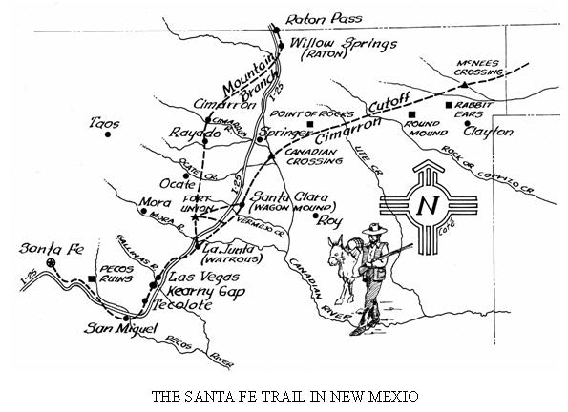
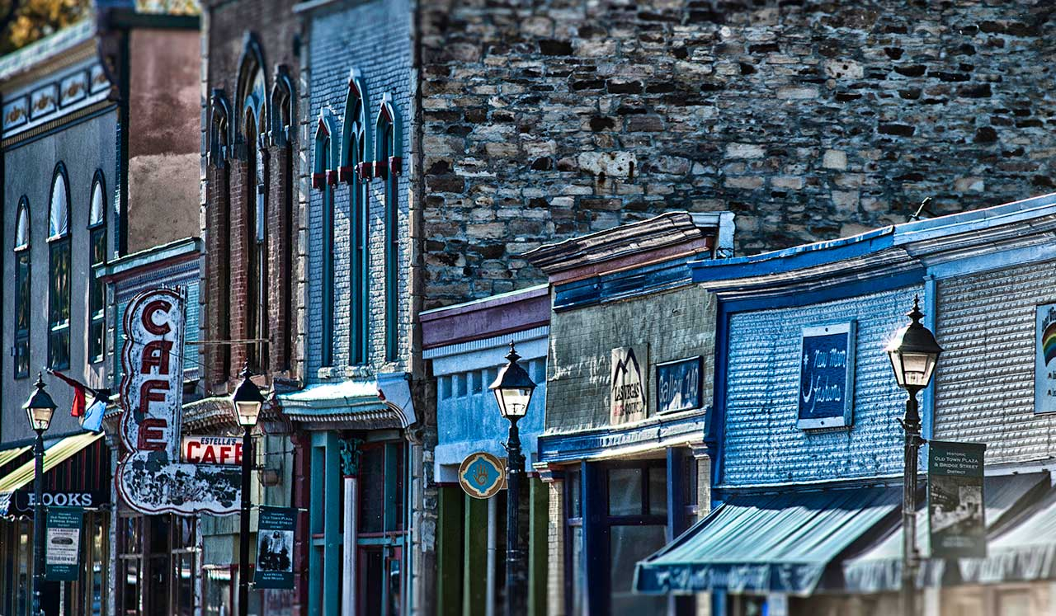
The historic Old Town Plaza reflects the town’s colorful history as a stop on the Santa Fe Trail.

Conference Hotel Information:
Plaza Hotel
230 Plaza Park
Las Vegas, NM 87701
(505) 425-3591
http://www.plazahotel-nm.com
- Reservations are on your own.
- Rooms at the Plaza Hotel are being held through (date TBA)
- Reserving early recommend due to limited space.
Draft Meeting
Schedule:
Friday, Oct 17th
6 - 9 pm: Registration & Reception, Plaza Hotel
Saturday, Oct 18th
9 am - noon: Business Meeting, Plaza Hotel
noon - 1 pm: Lunch (location TBA)
1 – 2:30 pm: University Tour (details TBA)
2:30 – 4:30 pm: Technical Talks, (location TBA)
5 - 6 pm: Poster Session & Reception, Plaza Hotel
6:30 - 9 pm: Dinner, Dick’s Pub and Grill
7:30 pm: IMPACT! Award Presentation
& Featured Speaker (TBA).
Sunday, Oct 19th
8:30 - 11 am: Board Meeting, Plaza Hotel
Call for 2014-15 Board Volunteers:
The NMNWSE Board is actively seeking volunteers to run for the 2014-15 Board, elected at the Annual Meeting. We are looking for at least 3 volunteers to run for at-Large positions, plus volunteers to run for Vice President and Treasurer. If you might be interested, or would like to nominate someone, contact the current board at: NMNWSE_Board-L@list.unm.edu
Nominations are due 1 October 2014.
Members may vote online Oct 6-15, 2014, or in person at the Annual Meeting.
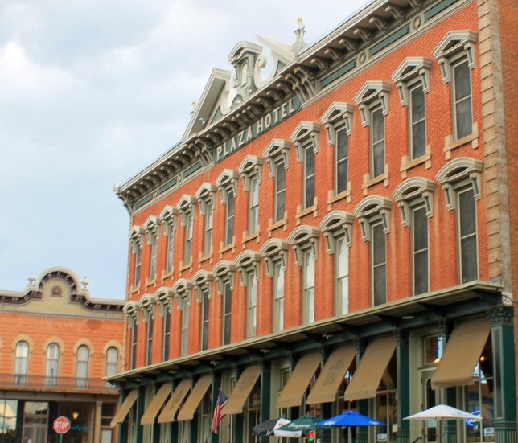

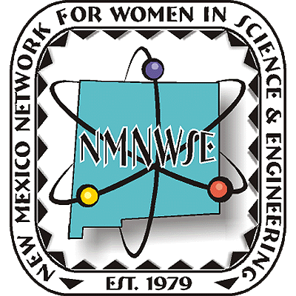
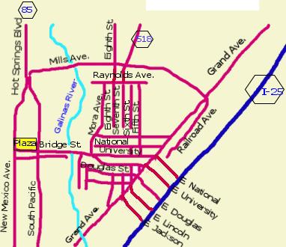
Nominations are now being sought from all geographical areas of our state from individuals, organizations and businesses. Nominees do not need to be members of NMNWSE.
for details and nomination forms, see nmnwse.org/ImpactAward
😐 Nominations due 15 Sep 2014 😐
Presented 18 October at the annual
TECHNICAL SYMPOSIUM
& BUSINESS MEETING
http://nmnwse.org/AM/2014

IMPACT!
The NM Network for Women
in Science & Engineering
NM Commission on the
Status of Women
recognizing NM Women who encourage
and help women to enter and succeed
in science & engineering professions.
developed in cooperation with the New Mexico Commission on the Status of Women

Award
Nominations are now being accepted!

Science is Women's Work

ANNUAL TECHNICAL SYMPOSIUM

& BUSINESS MEETING

(AM 2014)
17-19 October 2014
Las Vegas, NM


First Announcement

& Call for Papers

http://nmnwse.org/AM/
P.O. Box 1360 Los Alamos, NM 87544
NEW MEXICO NETWORK

for Women in Science & Engineering

