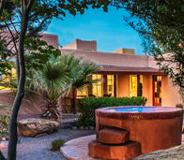
2015 NMNWSE

TECHNICAL SYMPOSIUM

& BUSINESS MEETING
http://nmnwse.org/AM/2015

23-25 October 2015

Sierra Grande Lodge and Spa

Truth or Consequences, NM
This year's meeting will take place at the Sierra Grande Lodge and Spa in Truth or Consequences, NM. Sierra County, with its soothing hot springs, scenic mountain and desert terrain, mild climate, and the two largest lakes in New Mexico, has long been a preferred vacation spot for New Mexico natives. Nearby, Spaceport America capitalizes on this region's place in the history of rocketry and the aerospace industry.
The meeting begins with a Friday evening reception. Saturday morning is the annual business meeting of the Network – all members are encouraged to attend. The afternoon features technical talks, followed by a poster session/ reception before dinner - an excellent opportunity to network and for students to present their work in a supportive environment! Saturday ends with the conference dinner and presentation of the 2015 NMNWSE IMPACT! Award (see call for nominations in this flyer), followed by a talk (speaker TBA).
Students, teachers, and non-employed members presenting a poster in Saturday’s technical session are eligible for a meeting scholarship to cover the registration fee.
Members are invited to stay though Sunday for the first meeting of the 2015-16 state Board, elected at Saturday's Business Meeting.

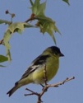
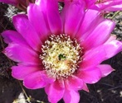
Registration is now open – the registration form is linked from http://nmnwse.org/AM/2015. The registration fee is $100 for the full meeting, including dinner on Saturday, receptions, and snacks. Early registration closes 9 October 2015, with late registrations accepted through the meeting date on a space-available basis ($10 late fee applies).
See the AM 2015 webpage for the meeting schedule and updates as they become available.
If you have questions, would be willing to help with meeting planning, or would be interested in running for the 2015-16 Board, please either note that on your registration, fill in the Interest Survey, or email the NMNWSE Board.
Space is limited and we must release our hold on rooms Sep 1, so make your hotel reservations now!
NMNWSE is dedicated to encouraging and assisting women to enter and succeed in science-based fields by their participation and promotion of professional conferences, educational development, mentoring opportunities, and networking activities.

NMNWSE needs you!
Volunteer to run for
the 2015-16 Board!

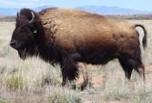
Call for Papers
We welcome contributed talks and posters for the technical session:
- Poster session/reception
is always a hit!
- Submit abstracts to
NMNWSE_Board-L@list.unm.edu
or include with your registration
- Talk abstracts due Sep 14, 2015
- Poster abstracts due Oct 5, 2015
- Post-deadline posters accepted if space available.

Student, Teacher,
Not Employed?
Present a poster to qualify
for a meeting scholarship!

Annual Meeting webpage
& registration:
http://nmnwse.org/AM/2015
Interest Survey:
http://nmnwse.org/AM/survey
NMNWSE home page:
http://nmnwse.org
NMNWSE mailing address:
PO Box 1360, Los Alamos, NM 87544
NMNWSE Board e-mail:
NMNWSE_Board-l@list.unm.edu

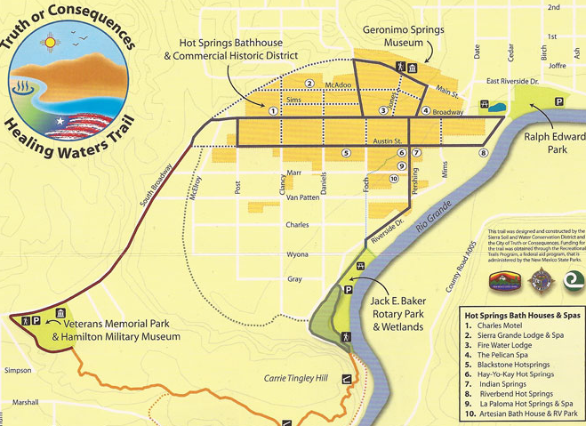
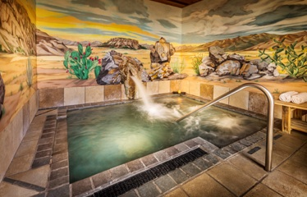

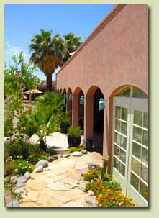
Conference Hotel Information:
Sierra Grande Lodge and Spa
501 McAdoo St.
Truth or Consequences, NM
http://www.sierragrandelodge.com
575.894.6976
Reservations are on your own. Reserve by
phone as our hold on all rooms
thru Sep 23 blocks
online booking.
Space is
limited:
book
now!
Draft
Meeting
Schedule:
Friday, Oct 23rd
6 - 9 pm: Registration & Reception, La Casita, SGL
Saturday, Oct 24th
9 am - noon: Business Meeting, SGL Meeting Room
noon – 1:30 pm: Lunch (location TBA)
1:30 – 4:30 pm: Technical Talks, SGL Meeting Room
5 - 6 pm: Poster Session & Reception (location TBA)
6:30 - 9 pm: Dinner (location TBA)
7:30 pm: IMPACT! Award Presentation
& Featured Speaker (TBA).
Sunday, Oct 25th
8:30 - 11 am: Board Meeting, La Casita, SGL
Call for 2015-16 Board Volunteers:
The NMNWSE Board is actively seeking volunteers to run for the 2015-16 Board, elected at the Annual Meeting. We are looking for at least 3 volunteers to run for at-Large positions, plus volunteers to run for President, Vice President and Secretary. If you might be interested, or would like to nominate someone, contact the current board at: NMNWSE_Board-L@list.unm.edu
Nominations are due 5 October 2015.
Members may vote online Oct 19-22, 2015, or in person at the Annual Meeting.


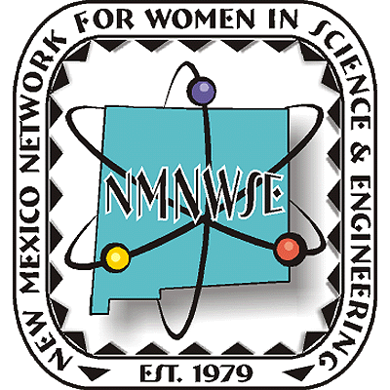
Nominations are now being sought from all geographical areas of our state from individuals, organizations and businesses. Nominees do not need to be members of NMNWSE.
for details and nomination forms, see nmnwse.org/ImpactAward
😐Nominations due 14 Sep 2015😐
Presented 24 October at the annual
TECHNICAL SYMPOSIUM
& BUSINESS MEETING
http://nmnwse.org/AM/2015

IMPACT!
The NM Network for Women
in Science & Engineering
NM Commission on the
Status of Women
recognizing NM Women who encourage
and help women to enter and succeed
in science & engineering professions.
developed in cooperation with the New Mexico Commission on the Status of Women

Award
Nominations are now being accepted!

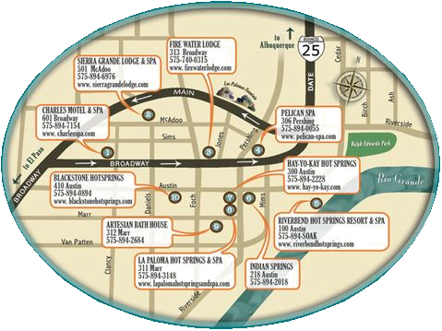
Science is Women's Work
Sierra Grande
Lodge (SGL)

ANNUAL TECHNICAL SYMPOSIUM

& BUSINESS MEETING (AM 2015)
23-25 October 2015
Sierra Grande Lodge and Spa
Truth or Consequences, NM

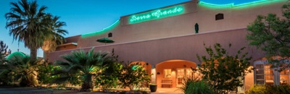
Second Announcement

& Call for Papers

http://nmnwse.org/AM/2015
P.O. Box 1360 Los Alamos, NM 87544
NEW MEXICO NETWORK

for Women in Science & Engineering

