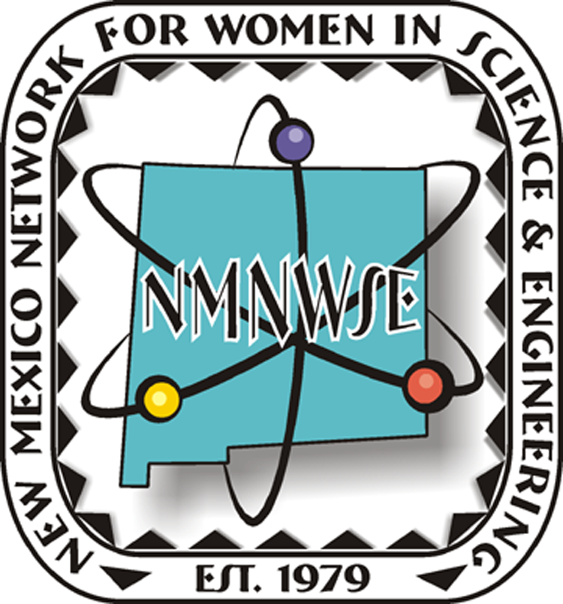
New Mexico Network for Women
In Science and Engineering
is proud to award
$50 & Tote Bag with Career Materials
to
in Recognition of Your Achievements
in the Study of Science
2013 New Mexico
Science & Engineering Fair
New Mexico Tech, Socorro, NM
April 5-6, 2013
_______________________
authorized signature
http://nmnwse.org

NMNWSE hopes you continue to develop your potential as a future scientist!

Lise Meitner
Rita Levi-Montalcini

— Shown are Nobel Prize Women in Science —

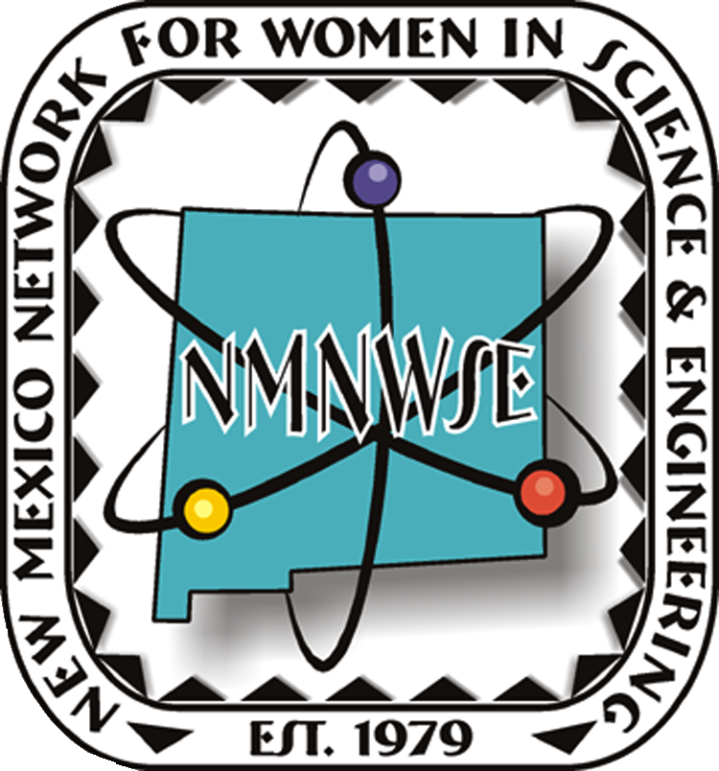
New Mexico Network for Women
In Science and Engineering
is proud to give
this award to
in Recognition of Your Achievements
in the Study of Science
2013 New Mexico
Science & Engineering Fair
New Mexico Tech, Socorro, NM
April 5-6, 2013
_______________________
authorized signature
http://nmnwse.org

NMNWSE hopes you continue to develop your potential as a future scientist!
Lise Meitner
Rita Levi-Montalcini

— Shown are Nobel Prize Women in Science —

