TM

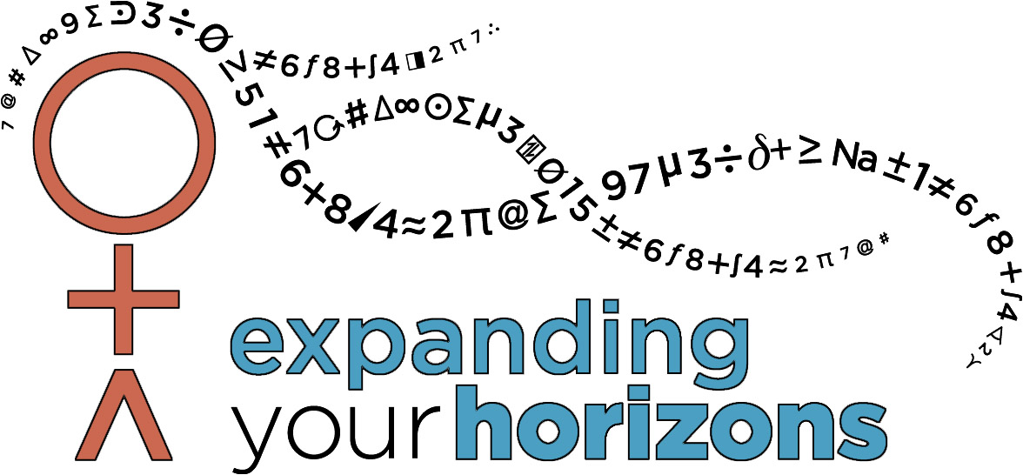
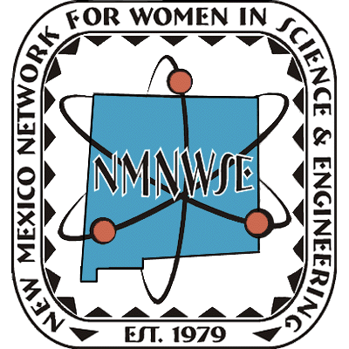

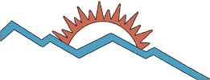
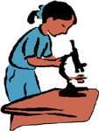


▼▼▼▼▼▼▼▼
The purpose of the Network is to encourage women to enter into and develop their careers in science, engineering, and allied professions.
Annual Meeting & Technical Symposium
http://nmnwse.org/AM

New Mexico Network
for Women in
Science and Engineering
Exploring the Possibilities
online careers
book for teens
Careers:
Award
recognizing
New Mexico women
given in cooperation with
the NM Commission on
the Status of Women

IMPACT!
annual technical
career workshops
for young women
see webpage for current
list of statewide
and local sponsors

totebag printing funded by

