
Expanding Your Horizons
TM

annual technical
career workshops
for young women




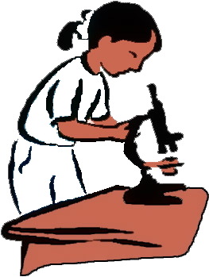

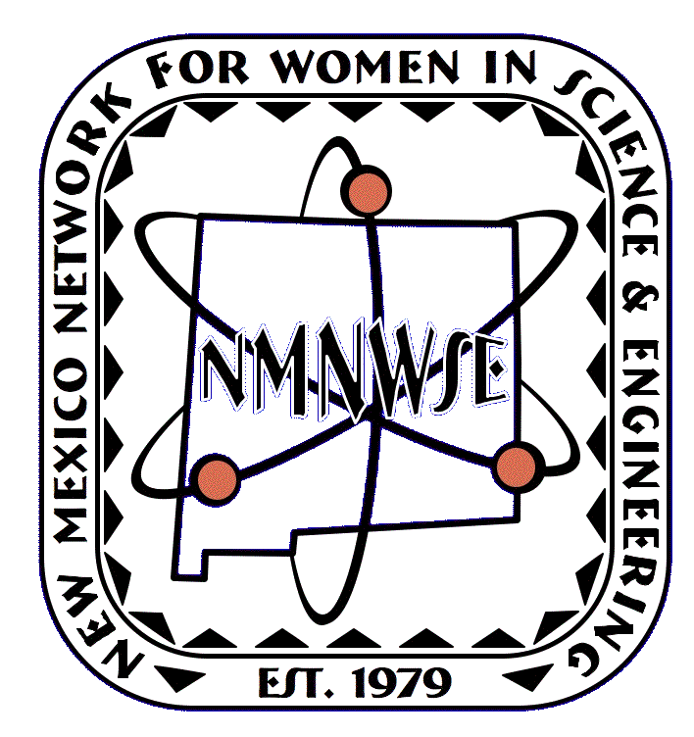
▼▼▼▼▼▼▼▼
The purpose of the Network is to encourage women to enter into and develop their careers in science, engineering, and allied professions.
Annual Meeting & Technical Symposium
http://nmnwse.org/AM

New Mexico Network
for Women in
Science and Engineering
Exploring the Possibilities
online careers
book for teens
Careers:
Award
recognizing
New Mexico women
given in cooperation with
the NM Commission on
the Status of Women

IMPACT!
see webpage for current
list of statewide
and local sponsors

