Recognizing Your Achievements  We hope you will continue to develop your potential  in Science, Technology, Engineering, Mathematics, Medicine (STEMM) and allied professions! | 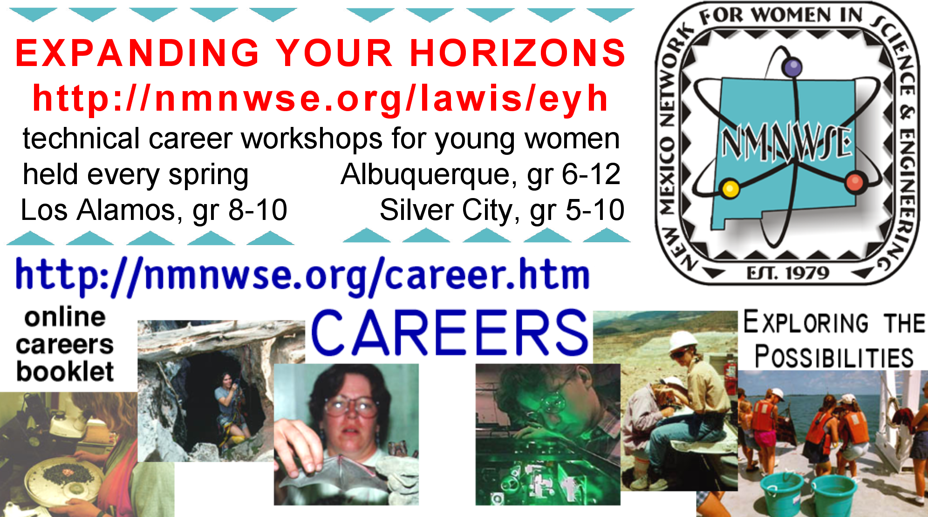  New Mexico Network for Women  in Science and Engineering  encourages women to enter into and develop their careers in science, engineering, and allied professions through annual technical symposia, outreach, and local chapter activities. For more information see http://nmnwse.org  or write us at PO Box 1360, Los Alamos, NM 87544.  EXPANDING YOUR HORIZONS  http://nmnwse.org/eyh  Technical Career Workshops for Young Women  See website for current year conference  dates, locations, and grades targeted.  CAREERS  http://nmnwse.org/careers
Recognizing Your Achievements  We hope you will continue to develop your potential  in Science, Technology, Engineering, Mathematics, Medicine (STEMM) and allied professions! | New Mexico Network for Women  in Science and Engineering  encourages women to enter into and develop their careers in science, engineering, and allied professions through annual technical symposia, outreach, and local chapter activities. For more information see http://nmnwse.org  or write us at PO Box 1360, Los Alamos, NM 87544.  EXPANDING YOUR HORIZONS  http://nmnwse.org/eyh  Technical Career Workshops for Young Women  See website for current year conference  dates, locations, and grades targeted.  http://nmnwse.org/careers  CAREERS  http://nmnwse.org/careers
Recognizing Your Achievements  We hope you will continue to develop your potential  in Science, Technology, Engineering, Mathematics, Medicine (STEMM) and allied professions! | New Mexico Network for Women  in Science and Engineering  encourages women to enter into and develop their careers in science, engineering, and allied professions through annual technical symposia, outreach, and local chapter activities. For more information see http://nmnwse.org  or write us at PO Box 1360, Los Alamos, NM 87544.  EXPANDING YOUR HORIZONS  http://nmnwse.org/eyh  Technical Career Workshops for Young Women  See website for current year conference  dates, locations, and grades targeted.  CAREERS  http://nmnwse.org/careers

