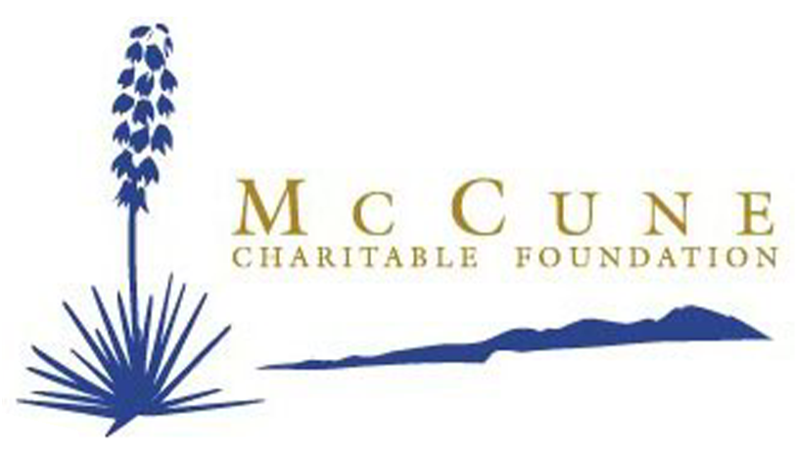


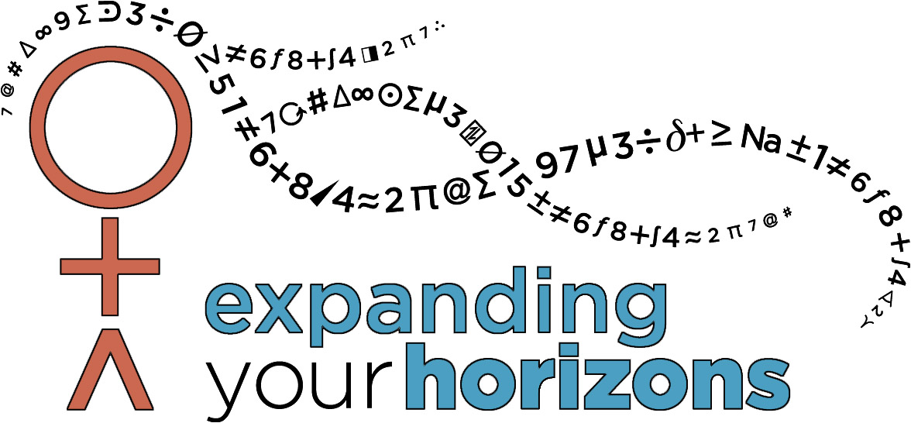
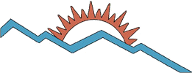



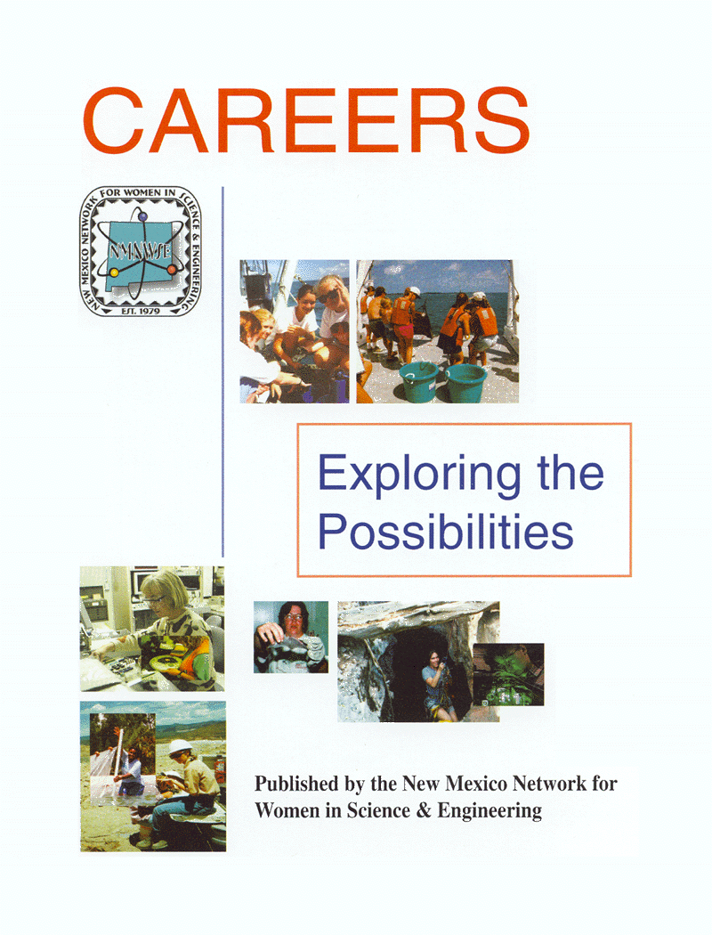
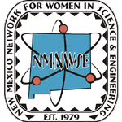
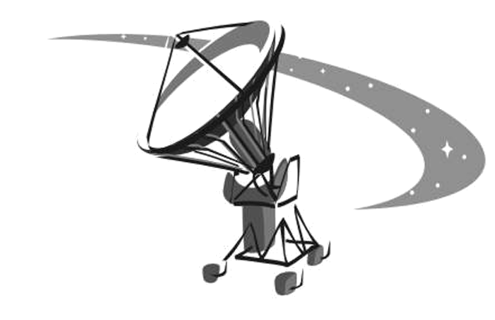
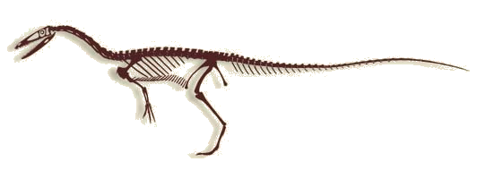
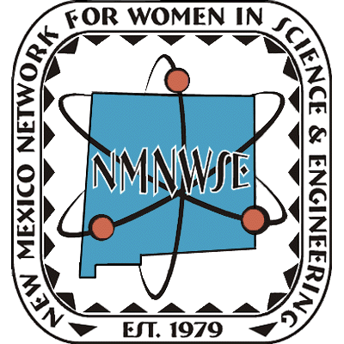
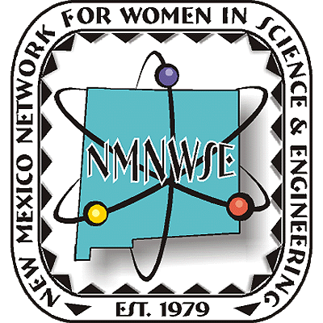

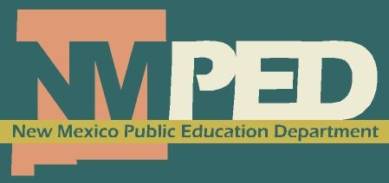

If you are interested in learning more about the Network or our activities, visit our website http://nmnwse.org,
contact us at NMNWSE_Board-L@list.unm.edu, or fill out this form and mail it to us at
NM Network for Women in Science and Engineering, PO Box 1360, Los Alamos, NM 87544
Name _
Address _
City,State,Zip _
Phone _
Email _I’d like more information on: ___Santa Fe ___Las Cruces
___EYH ___Albuquerque ___Los Alamos ___Silver City
___Annual Meeting and Technical Symposium
___IMPACT! Award
___Becoming a ___Member ___Sponsor
___Other:________________________________
Expanding
Your
Horizons
TM

Published by the New Mexico Network
for Women in Science and Engineering
http://nmnwse.org
CAREERS
Exploring the
Possibilities
recent statewide
SPONSORS
current sponsors at nmnwse.org/eyh

▼▼▼▼▼
IMPACT! Award presented each fall at the NMNWSE
Annual Meeting & Technical Symposium
nmnwse.org/AM
Contributed papers welcome - see webpage for details.

NEW MEXICO NETWORK FOR
WOMEN IN SCIENCE & ENGINEERING
Celebrating Over 30 Years of Networking
NMNWSE encourages women to enter into and develop their
careers in science, engineering, and allied professions
through annual technical symposia, outreach,
and local chapter activities.

NMNWSE Careers Book
for teens
nmnwse.org/careers
annual technical
career workshops
for young women
EYH is a conference for
young women to increase their interest in math, science, & engineering. Students attend workshops where they meet and form personal contacts with professional women from these technical fields.
Annual NMNWSE EYH
nmnwse.org/eyh
See webpage for conference
dates, locations, and age ranges.
National EYH Program
expandingyourhorizons.org
recognizing the contributions of NM women
nmnwse.org/ImpactAward
Nominations due mid-August annually - see webpage for details.

given in cooperation
with the NM Commission
on the Status of Women

