



Expanding Your Horizons™
Annual Technical Career
Workshops for Teens
are a wonderful way
for young women
to explore careers
in Science,
Technology,
Engineering,
Mathematics,
Medicine,
and allied professions!
Southern NM
•3/16/13
Silver City
Gr. 5-8, WNMU
•4/13/2013
Las Cruces
Gr. 6-12, NMSU

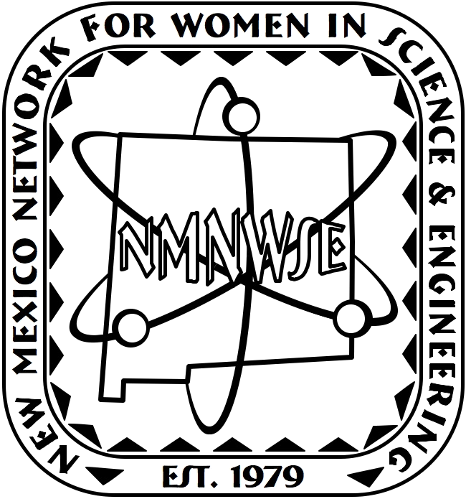

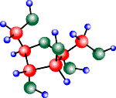
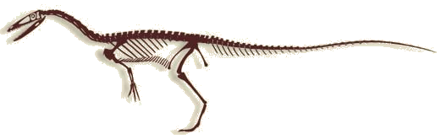

Central NM
•1/26/13
Albuquerque
Gr. 5-9, UNM
Northern NM
•3/2/13
Santa Fe
Gr. 5-12, SF Conv Ctr.

Online Careers Book
http://nmnwse.org/careers

Held Annually!
2013 Dates:
see nmnwse.org/eyh
for conference contacts & other information
see nmnwse.org/eyh/sponsors.php for sponsors
NMNWSE EYH licensed by NMNWSE from the EYH Network

