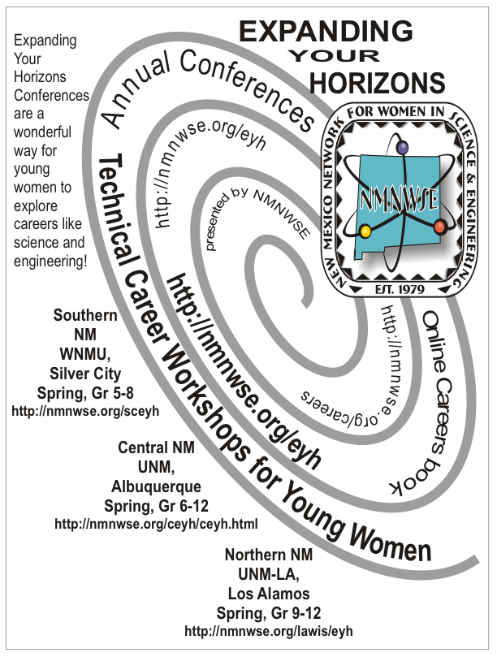
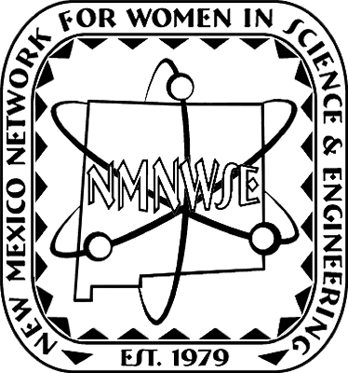


licensed by
NMNWSE from the

•2/25/12
Silver City
Gr. 5-8, WNMU

•1/28/12
Albuquerque
Gr. 5-9, UNM
Expanding Your
Horizons™
Conferences
are a
wonderful
way for
young
women
to explore
careers in
Science,
Technology, Engineering,
Mathematics,
Medicine, and
allied professions!
see nmnwse.org/eyh
for conference contacts & registration information
see nmnwse.org/eyh/sponsors.php for sponsors

•early May
Santa Fe
Gr. 4-8, details TBA

•3/21/12
Los Alamos
Gr. 8-10,

Crossroads
Bible Church

•2/25/12
Las Cruces
Gr. 6-8, NMSU

