PRESS RELEASE

Alameda, NM, scientist Dr. Deborah Potter received the Forest Service 2001 Chief’s Honor Award for Ecosystem Management at a June 4 ceremony in Arlington, Va. The award recognizes an interagency project called FLAG that focused on protecting Class I wilderness areas, national parks and wildlife refuges from air pollution. This includes areas such as the Gila Wilderness and Wheeler Peak Wilderness.

FLAG was a three-year, interagency effort to achieve greater consistency in the procedures Federal Land Managers use in identifying and evaluating air quality related values. These values are the natural resources at risk from air pollution such as visibility – the spectacular wilderness views seen through fresh, clean air; sparkling lakes and streams that can be impacted by acid rain; soils; plants such as lichens and conifer trees; animals such as salamanders and trout; and cultural resources such as petroglyphs. Biodiversity and ecosystem processes like nutrient cycling are also at risk from air pollution.

The Forest Service and other federal agencies are advisors in a permit process administered by states or tribes, EPA and local governments. They provide sound, technical advice about whether permits for large industrial sources like power plants should be issued, modified or denied based on the potential to affect visibility or terrestrial and aquatic ecosystems.

Dr. Potter accepted the Chief’s award on behalf of the Forest Service Air Program and her colleagues, the scientists that navigate their advice through the regulatory and political process in order to get lower pollution emissions and appropriate control technologies. With partnerships involving the public, environmental groups, Federal and State agencies, etc., they have had landmark success in obtaining large emission reductions at power plants and other permitted sources. There are plenty of challenges ahead, and the Forest Service Air Resource Management Program will continue to negotiate great benefits to wilderness and the array of ecosystems that are also affected by air pollution.

Dr. Potter also holds a faculty appointment at the University of New Mexico, Department of Biology, where she teaches graduate-level ecology. She was a member of the FLAG subcommittees for policy and atmospheric deposition. Other technical committees included ozone (a component of smog that impairs vegetation) and visibility.
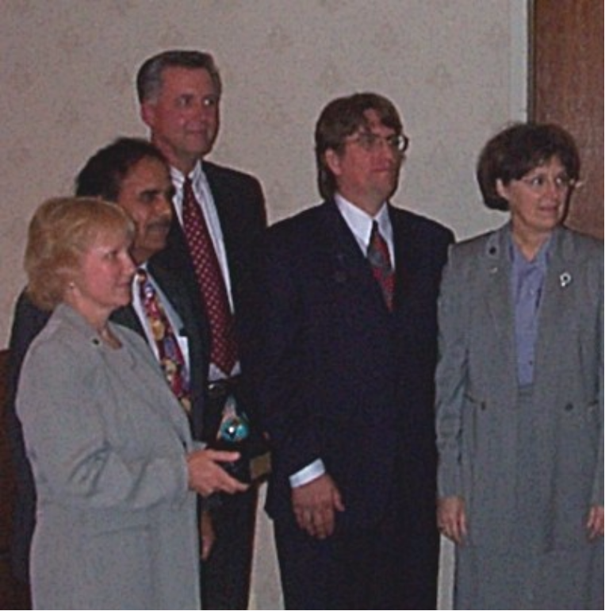

Dr. Deborah Potter (left) accepts the Forest Service Chief’s
Honor award for Ecosystem Management on behalf of
the Air Resource Management Program in a ceremony on
June 4, 2001, in Arlington, Va. Chief Dale Bosworth is at
center.

