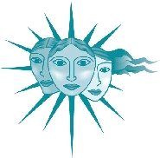
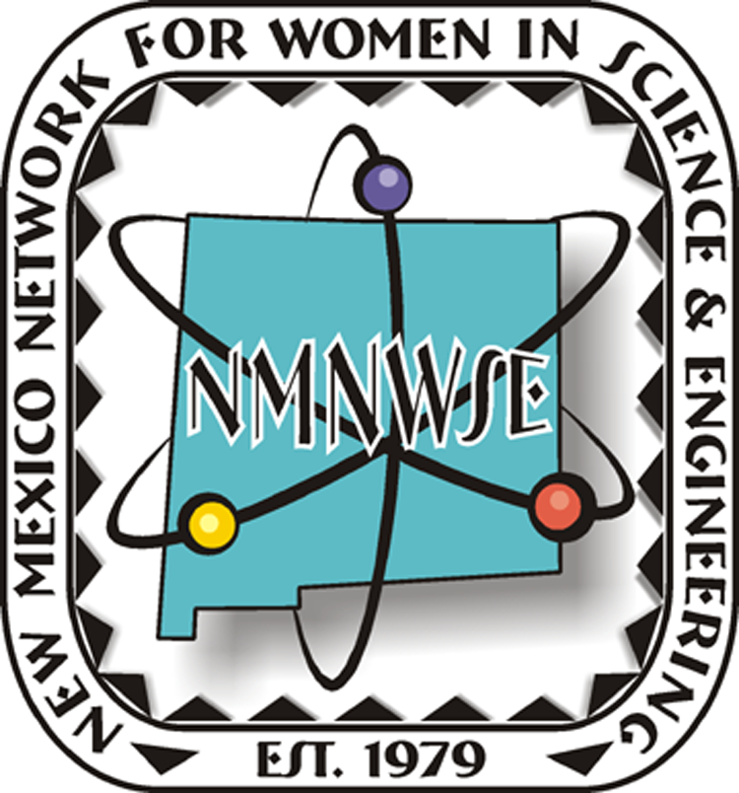
NM Commission on the
Status of Women
The tenth annual award will be presented in late October at the
NMNWSE Annual Meeting and Technical Symposium
For more information on this meeting, see
http://nmnwse.org/AM

developed in cooperation with the former New Mexico Commission on the Status of Women

See http://nmnwse.org/ImpactAward
for nomination forms and more information.
Nominations due 16 Sep 2016
Nominations are now being accepted!

Nominations are now being sought from all geographical areas of our state from individuals, organizations and businesses.
Nominees do not need to be members of NMNWSE.

