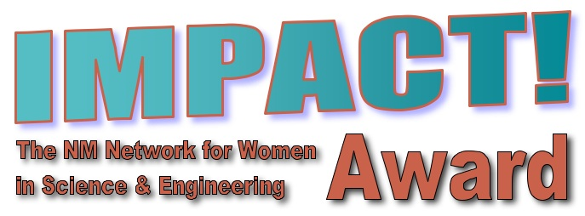  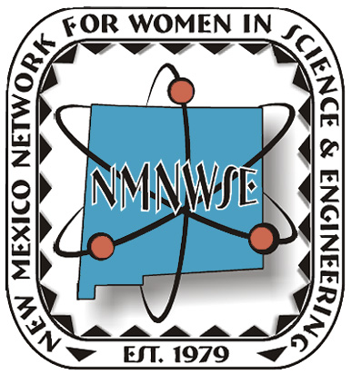 | IMPACT!  The NM Network for Women in  Science and Engineering Award  2016 Nomination Form |   NM Commission on the Status of Women
The New Mexico Network for Women in Science and Engineering, in cooperation with the NM Commission on the Status of Women, initiated in 2007 the NMNWSE IMPACT! Award to recognize the contributions of women in New Mexico. This fall, the 10th Annual IMPACT! Award will be presented to a New Mexico woman for her extraordinary efforts in furthering the goals of the Network. These goals include encouraging and helping women enter and succeed in Science, Technology, Engineering and Math (STEM) and related nontraditional careers and promoting networking and communication among women in these careers. The honoree will be recognized during the NMNWSE Annual Meeting and Technical Symposium, which will be late October 2016.
NOMINEE: ________________________________________________________________________________________
ADDRESS: ________________________________________________________________________________________
CITY: ___________________________________________________ ZIP: _____________________________________
CONTACT PHONE: ________________________________ EMAIL: _________________________________________

NOMINATOR: _____________________________________________________________________________________
AFFILIATION WITH NOMINEE: ______________________________________________________________________
ADDRESS: ________________________________________________________________________________________
CITY: ___________________________________________________ ZIP: _____________________________________
CONTACT PHONE: ________________________________ EMAIL: _________________________________________
E-mail your nomination packet to either of the IMPACT! Award co-chairs:
Phyllis Baca, 505-490-1557, phyllis.baca@sfcc.edu
Tinka Gammel, 505-690-1318, jtg@lanl.gov
or mail a hardcopy to:
IMPACT! Chair, NMNWSE, PO box 51926, Albuquerque, NM 87181
DEADLINE: Friday, September 16, 2016
Questions? Contact Phyllis, Tinka, or the NMNWSE Board at NMNWSE_Board-L@list.unm.edu
Note both Tinka and Phyllis accept texts on their cell phone numbers above.
Nominations received after the deadline will be considered for next year’s award.
Information and Instructions
Eligible candidates must be:
- over 21 years of age and
- currently living in New Mexico
Previous award recipients are ineligible for consideration. NMNWSE Board members are only eligible after six months from their final date of service. Please email the IMPACT! Chair or call the NMNWSE Communications Chair to verify Award recipients.
Submission Requirements
Please submit the following information:
- One complete packet of information to include nomination form, summary and supportive materials.
- 500-word summary that summarizes the nominee’s specific achievements, the impact of her contributions to the goals of the Network and a brief statement on why she deserves the Award.
- Supporting materials: These materials should justify consideration of the nominee and should include three or more letters of recommendation. Supporting materials should emphasize the candidate's peer mentoring (outreach within the career/job arena), community involvement (outreach outside of career/job arena), and outreach to minorities. They may also include biographical data emphasizing leadership or community roles with quantifiable results that support the goals of the Network, commitments, mentorship, volunteer and compensated advocacy work, and other supporting materials such as newspaper or magazine articles.
Please limit supporting materials to six (6) pages.
- All documents should be produced on 8.5” x 11” paper, using 12 point font. Larger documents should be reduced.
- All documents should be saved as a word document or a pdf using the applicant’s last name and first initial: LastName_FirstInitial.
- Provide one photograph (3” x 4” or 4” x 6”, color or black and white, preferable electronically) for use in publicity
- Submit a $10 nomination fee payable to NMNWSE. PO Box 51926, Albuquerque, NM 87181. Please request a receipt for your records.
NOTICE:
- Letters of recommendation can come from mentors, employers, teachers, leaders, and/or friends. Three letters are strongly recommended but not required.
- Nomination packets containing MORE than six (6) pages of supporting documents may be edited by the Network.
2016 NOMINATION DEADLINE: Friday 16 September 2016
The New Mexico Network for Women in Science and Engineering began in 1975 with a core group of faculty and staff from UNM wanting to reach out to women in science as a group. Incorporated in 1979, the Network works to encourage and help women enter and succeed in Science, Technology, Engineering and Math (STEM) careers and promote networking and communication among members by providing regularly scheduled meetings, talks and other local activities. About 1000 teens each year attend our technical career workshops. Our Annual Meeting and Technical Symposium provides members an opportunity to present technical papers in a supportive environment as well as professional development and networking opportunities. | In 1974, the NM Commission on the Status of Women was created by state statute to increase the knowledge of the rights, responsibilities and interests of women and girls in New Mexico and to preserve women’s history and contributions to our state. The office is charged with conducting statewide studies on the status of women, acting as a clearinghouse and referral service on issues impacting women, recommending methods to overcome discrimination against women, promoting methods for women to develop their skills and continue their education, hosting periodic statewide conferences for women, collaborating with other entities working with women and securing recognition for women’s accomplishments and contributions to New Mexico. The Commission was terminated in 2011.

Guidelines for a successful nomination:

IMPACT! Award judges use the following weighting system as a guide for assessing and ranking the quality of the nominees. Candidates are judged on the merits indicated in the submitted nomination packet as NMNWSE does not have the resources to solicit additional supporting materials. Please insure your packet is as strong as your nominee's IMPACT! In particular, be sure to include three letters of recommendation so your nominee does not lose out simply due to lack of supporting letters. If you have any questions regarding the nomination or judging process, contact the NMNWSE IMPACT! Award Chair or the NMNWSE Board. Thank you for taking the time to nominate one of the many outstanding New Mexico women whose IMPACT! deserves recognition.

IMPACT! Award Judging Sheet
Judge:
Nominee Name: | Total Score (out of 120):
 |  | Score
1) Peer Mentoring (outreach within the career / job arena) | (30 Pts Max)
Consider quality of peer mentoring AND quantity (length of time)
2) Community Involvement (outreach outside of career/job arena) | (30 Pts Max)
Consider quality of community outreach AND quantity (length of time)
3) Outreach to minorities | (30 Pts Max)
Consider quality of community outreach AND quantity (length of time)
4) Letters of recommendation | (30 Pts Max)
Note: 3 letters are highly recommended – nomination packets with fewer than 3 letters likely will score significantly lower. Letters from a protégé (person mentored) are weighted highest, followed by letters from employers, teachers, and leaders. Letters from others not in these catagories, such as a friend, are weighted lowest.
If more than 3 letters are provided, only the top three will be used.
Judges notes:

