
New Mexico Network for Women in Science and Engineering

OFFICERS: Laurie Marnell, President; Yolanda King, Treasurer; Claudia Barreto, Secretary; Elizabeth Kallman, President Elect

Annual Meeting Minutes
October 9, 2010
Valles Caldera

TOPIC PRESENTER

CALL TO ORDER Laurie Marnell
9:05 AM

Approval of Agenda Laurie Marnell

Introductions All

Those present today are:
- Mercedes Agogino
- Jeanne Banks
- Claudia Barreto
- Mary S. Campbell
- Caroline Dennis
- Nanette D. Founds
- Tinka Gammel
- Yolanda King
- Laurie Marnell
- Diane Oyen
- Dana Roberson
- Barbara Torres
- Eleanor Walther

NMNWSE President’s Report
Laurie Marnell, President 2009-2010

Board Meetings

Presided over board meetings: October 18, 2009 after the annual meeting at the Hacienda Vargas, Algodones NM; December 12, 2009 at the Office of Meyers and Peacock, Albuquerque NM; February 13, 2010 at the Broadstone Heights Apartments, Albuquerque NM; April 10, 2010 at New Mexico Tech, Socorro New Mexico June 12 and August 14, 2010 at the UNM Valencia Campus.

Fundraising

February 15, 2010 met with Phyllis Baca and colleagues at Santa Fe Community College to determine how the money from the NM Education Department would be distributed, i. e. making CDs and Hubble DVDs and a STEM course. It was discussed that CNM would have to be contacted to determine whether they would allow the course on their property.

July 2010: Confirmed the continuation of funding into 2011 from the New Mexico Education Department through Phyllis Baca at the Santa Fe Community College.

Applied for funding from McCune Foundation ($2000) and Lockheed Martin ($5000) for statewide EYH conferences in 2011.

Outreach

Organized a NMNWSE table at School to World, February 27, 2010.
Judged science projects at the National American Indian Science and Engineering Fair, March 12, 2010.
Judged State Science Fair projects in at NM Tech in Soccoro, April 10, 2010.
Met at the Nuclear Museum to discuss potential programs at the museum that would target girls and promote STEM careers.
Organized a NMNWSE table at the Nuclear Museum at a colloquium for young girls that accompanied their exhibit entitled “Inspired Excellence: Women in Science.”

SECRETARY’S REPORT Claudia Barreto

The minutes of the 2009 Annual Meeting held on October 16, 2009 at Hacienda Vargas
Algodones, New Mexico are posted on the web page (a few hard copies were also available). The minutes were approved as distributed.

TREASURER’S REPORT Yolanda King
The audit was performed last night (only 1 receipt was missing and Dana will send it in). The available balance is $16,261.26. The 2011 budget (see attached) was approved as submitted unanimously.

Reports from STANDING COMMITTEE CHAIRS:
Annual Meeting Dana Roberson
We gave a round of applause for Dana Roberson. Dana acknowledged Tinka Gammel’s invaluable help. We discussed the high cost of this year’s meeting, but are very satisfied with the facility and location.

ACTION: If there is a profit, the Board will decide on a policy for reimbursing any extra monies.

Dana is in the process of writing a summary report for this Annual Meeting.

Elections Georgia Pedicini
Report on 2010 Elections - online voting
As of 4PM Friday, 10 people had voted.
Jennifer Nisengard, VP
Yes: 10
There were no write-ins
Barbara Torres, Treasurer
Yes: 9
There were no write-ins
Jeanne Banks, 1 year at-large
Yes: 10
Both Dana Roberson and Tinka Gammel were on the ballot as 1-year OR 2- year
Dana Roberson, at-large
1-year: 3
2-year: 7
Tinka Gammel, at-large
1-year: 2
2-year: 7
There were no write-ins for at-large.
The ballot instructions state "Vote for up to 2" in the 1-year column. Two of the 1-year votes for Dana and Tinka also voted for Jeanne, thus voted for 3 1-year candidates. I don't know why this instruction was included, and no matter how this turns out, we will not exceed the charter on at-large members. Therefore, I am exercising my discretion to accept the "incorrect" ballots in full.
Please note also that as it stands, the majority of votes for these two candidates are for 2-year terms. If the in-person voting leads to any ambiguity, I will leave it to the presiding President, VP, and Secretary (all continuing Board officials) to resolve. That would be Laurie, Elizabeth, and Claudia.
There were no comments.

Please find the final outcomes under New Business.

ACTION: WE NEED A NEW ELECTIONS CHAIR.

Archives Mary Campbell
Mary is working on organizing materials. The intent is to complete scanning of all materials so we do not have to keep and hard copies. The hard copies could be housed at the Zimmerman Library as research materials.

Communications Tinka Gammel
The website is going well. Please send any information to Tinka for posting on the webpage. Anyone may send messages over the listserver to the entire membership (nmnwse-l@list.unm.edu) or just to the board the board (NMNWSE_Board-l@list.unm.edu). If you want to contact everyone, a message will go out to the board members (so it is not necessary to cc the board). We need a volunteer to take over the job or at least to help out.

Membership Dana Roberson
We have 31 paid members as of today.
The membership roster was sent out over the listserver.
ACTION: We need a new Membership Chair

IMPACT! Award Nancy Weinbrenner
No report.

Fund Raising Charlene Bausinger Jacka
Laurie Marnell sent in applications to McCune and to Lockheed Martin for EYH funding.
ACTION: We need a new Chair!

Policies and Procedures Claudia Barreto
Jeanne Banks has graciously offered to take over as chair. If anyone has any suggested changes, please contact Jeanne &/or the board. Jeanne Banks would like to form an ad hoc committee to review the Policies and Procedures. Eleanor asked about the policy of having the AM in October. However, this would require changing the fiscal year. The board will consider the issue.

Publicity/Outreach Charlene Bausinger
Laurie, Dana, Yolanda & XX represented us and handed out Careers CD’s, etc. at the Inspired Excellence for Women in Science Colloquium at the Museum of Nuclear Science on September 22. Laurie Marnell and Charlene Bausinger are involved with the Girl Scouts – Women & Girls Dialog.
WE need a new Chair. Laurie Marnell graciously volunteered to fill in as Chair until we can fill this position.

Student Awards Mercedes Agogino
NMNWSE gave out student awards at three events during the 2009-2010 year. At the 2010 National American Indian Science and Engineering Fair, March 11-13 2010, Albuquerque Convention Center, Albuquerque, NM, $50 awards plus tote bags with career materials were given to three students. (Two of the $50 awards were donated by the judges.) At the 2009-2010 New Mexico Supercomputing Challenge, April 26-27, 2010, Los Alamos National Laboratory, Los Alamos, NM, an award was given to one team of four, each member of the team receiving $50 and a NMNWSE tote bag with career materials. (Three of the $50 awards were donated by the judges.) At the 2010 New Mexico Science and Engineering Fair, April 9-10 2010, New Mexico Tech, Socorro, NM, ten awards of $50 with NMNWSE tote bags and career materials were given out to four junior and six senior exhibitors, as well as five awards of a tote bag with career materials. Details of the awards are provided in the fall 2010 News.

There is a report is the last newsletter (pp. 5-6)
We presented tote bags at the Eastern Regional Science Fair in Portales.
We need to encourage students in the rural areas and at local competitions. The Board should consider a strategy to accomplish this. Tinka has bags and other materials for recognizing students at science fairs we judge.

EXPANDING YOUR HORIZONS
State EYH Dana Roberson
Dana is waiting for statistics from the regional EYH chairs & will submit summary report ASAP. The new EYH in Santa Fe was a huge success. Irene Lee has volunteered to take over as EYH State Chair. Significantly younger girls are participating. For older girls their participation is shifting to peer mentoring responsibilities. We need to order new tote bags; money has been allocated in the 2011 budget and we will still be eligible for Title V funds to pay for the new tote bags through Sate Fe Community College.

Albuquerque (non-Board position) Elizabeth Kallman
Elizabeth has started working on plans for the 2011 Central EYH. 76 girls attended the 2010 Central EYH. The facilities at CNM were very suitable. We need to work on getting more attendees. We need to re-establish of connections with teachers so they encourage their studnts to attend.

Santa Fe (non-Board position) Irene Lee
Caroline Dennis gave us a summary of the 2010 Santa Fe EYH. 165 girls attended the EYH held at Santa Fe Community College. The May date seems to work well so they plan to do this again (May 25, 2011). For next year 4-9 grades girls will be invited (vs. 5-9) to reach younger girls. They will offer to provide funds for busses to facilitate attendance. They will also work on having signers from the School for the Deaf for hearing-impaired students. There were 52 volunteer workers who participated in EYH. We can offer help in using our website and set up an email ‘listservr’ for this Santa Fe EYH. We will have a Board meeting in Santa Fe so we can the opportunity to have conversations with the SF EHY folks.

Silver City Rosa Romero
No report

CHAPTER REPORTS
Central Chapter (Albuquerque) Jeanne Banks
The Central Chapter met on August 11, 2010 in the home of Ellen Evans. The activities during the meeting included networking, a presentation by Melanie Madrid of the YWCA about their Tech Girls program, a Central EYH Update by Elizabeth Kallman and an Annual Meeting/IMPACT Award update by Laurie Marnell.
The group then discussed the meeting plan for the coming year. The decision was made to meet on the second Wednesday, every other month, with the October meeting deferred in favor of the Annual Meeting. The following dates were chosen:
- Aug 11, 2010
- Oct 8-9, 2010 State Annual Meeting
    - Dec 8, 2010
    - Feb 9, 2011
    - Apr 13, 2011
    - Jun 8, 2011
The December 8, 2010 meeting is going to be at Slate Street Café in Albuquerque.

Northern Chapter Wendee Brunish
No report.

OLD BUSINESS/ACTION ITEMS

Date Opened | Open Action Items | Responsible | Status
ongoing | Funding Proposals & Publicity |  | ongoing
ongoing | Plans to Increase Membership |  | ongoing

Plans to Increase Membership: We need to coordinate efforts among all the groups whose missions include the mentoring of STEM students. We need to better communicate/disseminate what we do.

New Business, Announcements: Date & location of next Board meeting.
Date Opened | Open Action Items | Responsible | Status
October 9 | Election of 2010-2011 Board Members | Georgia | closed
October 2009 | EYH Reports to Dana - The policy is that state chairs need to submit reports within 1 month to Dana. Dana only has 3 months in which to submit State Report to National EHY.

Those members who had not voted on-line filled out paper ballots. Combined results:
- Jennifer Nisengard Vice President/President Elect
- Barbara Torres, Treasurer
- Jeanne Banks 1Year At Large
- Tinka Gammel 2 Year At Large
- Yolanda King 2 Year At Large
- Nannette Founds 2 Year At Large
- Dana Roberson 2 Year At Large
- Diane Oyen 2 Year At Large
Continuing officers are:
- Secretary Claudia Barreto
- Past President Laurie Marnell
- Elizabeth Kallman moved from Vice President/President Elect into the office of President

The meeting was adjourned at 11:45AM.

Respectfully submitted,

Claudia Barreto

Claudia Barreto, Secretary

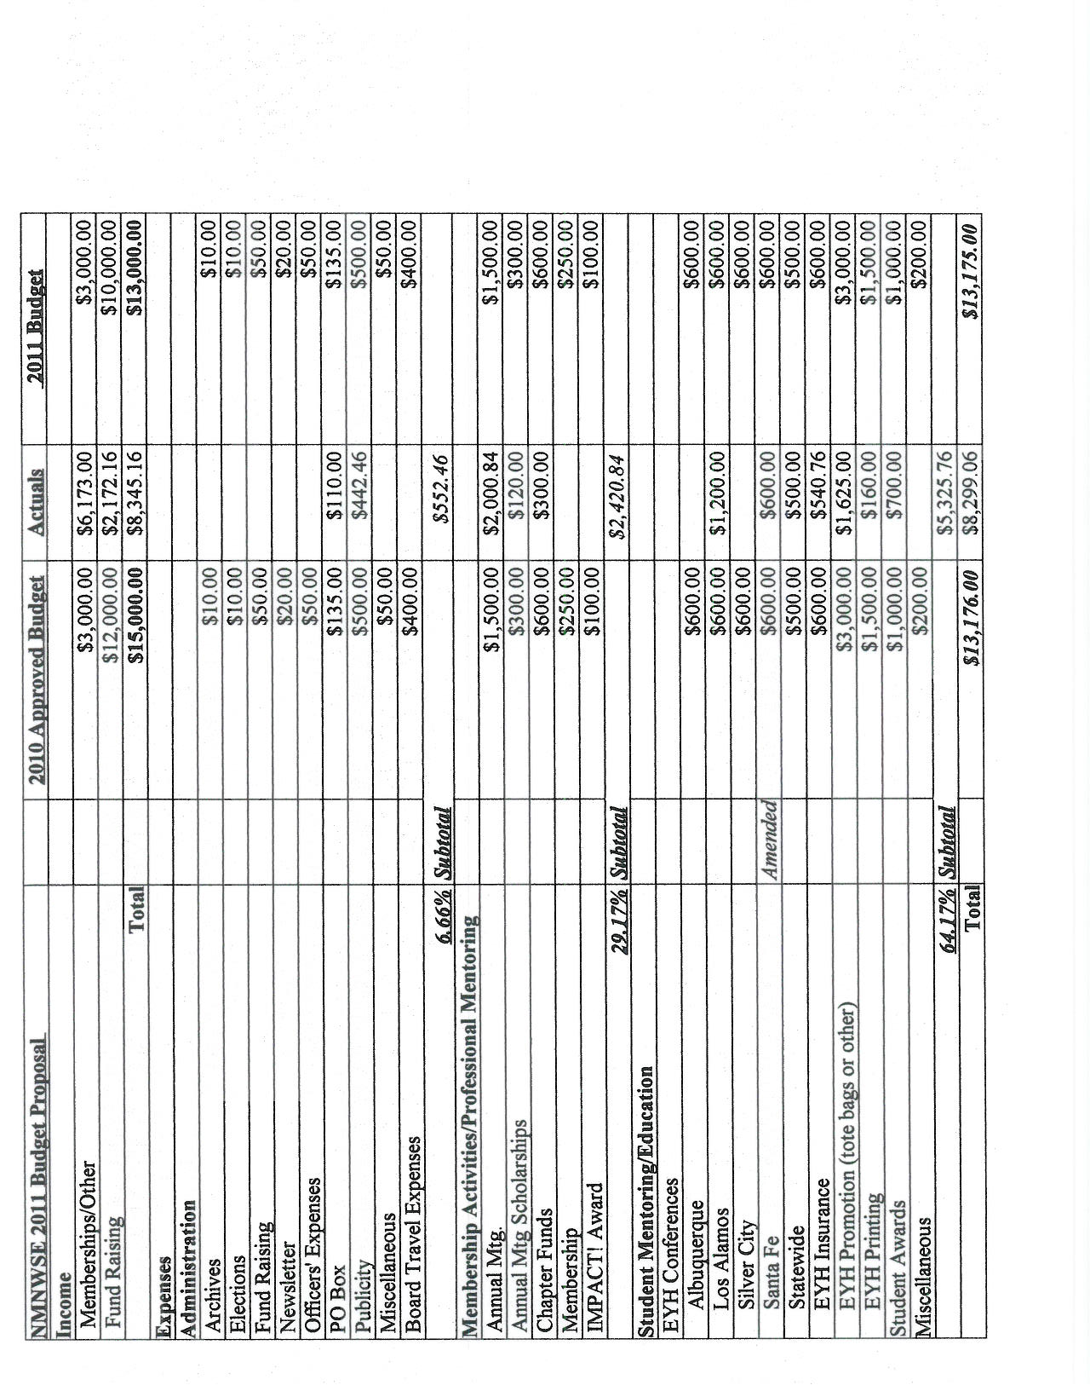

ATTACHMENT: 2011 BUDGET

