
New Mexico Network for

Women in Science and Engineering

OFFICERS: Nanette Founds, President, Elizabeth Kallman, Past President; Barbara Torres, Treasurer; Claudia Barreto, Secretary; Pat Pettit, President-Elect

Saturday April 6th, 2013
New Mexico Tech
Socorro, NM

Attendees: Claudia Barreto, Nanette Founds, Yolanda King, Laurie Marnell, Pat Petit, Diane Oyen, Barbara Torres

Proxy: Tinka Gammel to Claudia Barreto: Jeanne Banks to Barbara Torres

TOPIC PRESENTER

Call to Order: 1:55 PM Nanette Founds

Approval of Agenda Nanette Founds
Approved.

Secretary’s Report Claudia Barreto
Approved as amended.

Treasurer’s Report Barbara Torres
The NM Kids add is getting too expensive and does not seem to be worthwhile (almost $500). Taxes and PRC’s have been completed. Nanette Founds filed for an extension for AGO report and will submit it.

Reports from Standing Committee Chairs:
Annual Meeting Chair Yolanda King
Yolanda King, Chair; Cheri Burch, Logistics/Facilities; Laurie Marnell, Technical Program
Dates: 25-27 Oct 2013
Venue: The Shaffer Hotel, Mountainair, NM (Central Region)
- The Shaffer Hotel is holding all 17 rooms for us. Please call to reserve as they don’t appear to respond to email.
- A conference room at the Shaffer is reserved for our meetings Friday evening, Saturday morning, Saturday afternoon, and Sunday morning at a rate of $50 for each 4-hour block.
- Reservations for the award dinner are made at Alpine Alley a couple of blocks from the hotel. The cost will be about $20 each. No one in Mountainair has a liquor license (yet), but we can bring our own both on Friday night and on Saturday at the Alpine Alley.
- Lunch at the restaurant in the Shaffer Hotel is set for Saturday. Meals will be approx. $10 each.
- Estimated registration is $85 incl dinner/lunch/2 receptions/snacks/conf room.
- Prof. Troy Lovata, UNM, is confirmed for the walking tour/lunch lecture of the Salinas Mission on Sat.
- Technical Program call for abstracts should come out late Spring (Laurie?)
- IMPACT Award presentation is anticipated at the Sat dinner with no additional speaker/program.
We decided that the technical session will be limited to posters since we will be spending time touring the Salinas Pueblos Missions with Troy Lovata after his lecture. Make your reservations by phone (not electronically), soon.

Communications Tinka Gammel
We need to have a mailing: Newsletter, call for posters, IMPACT call for nominations, membership renewal

Membership Karen Agogino
We need to have a mailing: Newsletter, call for posters, IMPACT call for nominations, membership renewal
IMPACT! Award Jennie DeMarco
All information has been posted on our web site. We need to have a mailing: Newsletter, call for posters, IMPACT call for nominations, membership renewal.
Fundraising Rebecca Galves
NR

Policies and Procedures Jeanne Banks
Committee chairs, please update your “new traveling notebooks” by our next meeting!

Student Awards Mercedes Agogino
Due to the fact that we only had 5 judges this year, we limited out judging to the Juniors. There were 10 awards for $50 plus a certificate and tote bag with goodies:
- Botany (Plant Sciences) - Andrea Chin-Lopez, Taos Middle School: #15 Chokecherry & Cyanide
- Chemistry – Tharani Murali, Sierra Middle School: #35 Environmentally Friendly Energy
- Earth & Planetary Sciences – Cecilia Pareja, Our Lady of Fatima: #55 Greenhouse Gasses
- Energy & Transportation – Alicia Ulibarri, St. Charles Borromeo School: #68 Efficient Home Insulation
- Engineering – Molly Klein, St. Thomas Aquinas School: #78 When It Rain, It “Porous”
- Environmental Sciences – Ruby Selvage, Los Alamos Middle School: #101 Gallium Reacts to the Fuel Crisis
- Mathematical Sciences – Sueda Cetinkaya, Albuquerque School of Excellence: #106 Image Analysis of Skin Cancer Using Fractal Geometry
- Medicine & Health Sciences – Julia Johnson, Taos Middle School: #117 The Sound of Music
- Microbiology – Priyanica Velappan, Los Alamos: #134 Bacteria Vs. Spices
- Physics & Astronomy – Olivia Schmelzel, Roosevelt Middle School: Just Wheelin’ Around
We also selected 5 honorable mention awards for a certificate and tote bag with goodies:
- Botany (Plant Sciences) - Madalena Roeber, Jefferson Middle School: #22 Fungi as Fertilizer (Part II)
- Chemistry – Casey Tessier, Jefferson Middle School: #42 Cheap Efficiency
- Engineering – Candace Johnston, Los Lunas Middle School: #77 Which Gun Powder is Most Reliable?
- Environmental Sciences – Hailey Hines, Our Lady of the Assumption: #93 Phase II Exposures from Granite: Radon
- Physics & Astronomy – Tessa Dallo, Albuquerque School of Excellence: #136 Blinded By the Light

Get list of National American Indian Science and Engineering Fair (NAISEF) awardees from Tinka.

Elections --------------------------------------------------------------------------------------- Yolanda King
We have 3 Board positions (Petit, Banks, Senft) opening, although we could accommodate more. We also need a VP and Secretary (unless Claudia stays on…) for the upcoming election.
Need help getting the VP nominee. Suggestions are welcome. Also, some newer folks for Board positions would be good.

Publicity & Outreach Laurie Marnell
We need money.
We are delighted that Becca Galves & Irene Lee won “Women on the Move” awards from the YWCA.

NM Girls Collaborative Liaison Cheri Burch
NR

Expanding Your Horizons:
State Vacant
Nanette Founds will get 3 insurance quotes 2014 EYHs so that the board can vote. Paste in Nan’s info.

Central Pat, Klaus, Kelly, & Elizabeth
A “lessons learned” meeting was held. Get from Kelly

Los Alamos/Santa Fe Jan Frigo/Irene Lee
Get info on how students are tracked.
Mission:
The mission of Expanding Your Horizons (EYH) is to encourage young women to pursue science, technology, engineering and mathematics (STEM) careers. Through EYH programs, we provide STEM role models and hands-on activities for middle and high school girls. Our ultimate goal is to motivate girls to become innovative and creative thinkers ready to meet 21st Century challenges.
Conference Schedule:
8:30-9:30 9:30-9:40
9:40-10:00
10:00-11:30 11:30-1:00
1:00- 2:30 2:30 - 3:15
3:15 – 4:00
Registration and Introduction to EYH in small groups Welcome Rebecca Wurzburger (City of Santa Fe) Beth Sellers (LANL)
Keynote Presentation Tasha Nesiba (NMSU Young Women in Computing / Google) Smallgroupworkshops Lunch STEM Programs and Career Fair Small group workshops Mars Rover Presentation Agnes Cousin and Nina Lanza, (LANL) Evaluations Prizes/Drawings/Thank-yous
Keynote Presenter:
Natasha Nesiba, New Mexico State University/Google.
Natasha (Tasha) Nesiba is majoring in Computer Science at NMSU in Las Cruces. She is a research assistant and past participant in NMSU’s Young Women in Computing program and a Google Student representative. Tasha is passionate about getting young women interested in Computer Science.
While an undergraduate at NMSU, Tasha received several scholarships (including the Google Anita Borg Memorial scholarship and the NMSU President’s Associates Excellence Scholarship)—more than she needed to fund her own education—so she created a $10,000 scholarship for another NMSU student interested in majoring in CS.
A New Mexico treasure, Tasha graduated from Las Cruces High School in 2010. This summer she will be returning to Google as a third year intern.
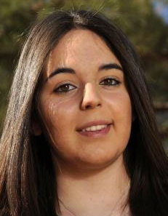
Student Workshop Descriptions and Presenters
- Pulling out DNA from your own cheek cells! (O’Keeffe) Presenter: Harshi Mukundan Topic: Biology
- Cryptography and Steganography - From Caesar to Shannon (Ballroom F) Presenter: Sarah Morgan Topic: Applied Mathematics
- Teeth in Your Future? Careers in Dentistry (Ballroom F) Presenter: Laura Heisch Topic: Dentistry
- Tails of a Veterinarian (Ballroom B) Presenter: Gretchen Yost Topic: Veterinary Medicine
- Ocean Density, Current, and Ice (Ballroom C) Presenter: Elizabeth Hunke Co-Presenter: Nicole Jeffery Topic: Environmental Science
- Aviation/Aerospace (Ballroom C) Presenter: Marianne Francois, Copresenters: Tandra Hicks, Ursula Durrer Topic: Physics, Mathematics
- Animals that live in Water (Peralta) Presenter: Jennifer Macke Topic: Biology
- Ooey Gooey Polymers (Ballroom F) Presenter: Tarryn Miller Topic: Chemistry
- Hydrogen Fuel Cells (Coronado) Presenter: Calita Quesada Topic: Engineering, Computer Science
10. Paper + Electronics (Ballroom D)
Presenter: Barbara Kimbell, Co-presenter: Rebecca Koskela
Topic: Engineering
11. Nutrition in the ICU - Metabolic Response to Injury/Illness (Ballroom B)
Presenter: Sara Pocernik
Topic: Medical Science/Nutrition
12. Chroma Key - You In The Movies! (Nambe)
Presenter: Meghan W. McClelland, Co-presenter: Susan Coulter
Topic: Computer Science
13. Help Wanted: Gamers Needed for Scientific Problem Solving (Tesuque)
Presenter: Kari Sentz, Co-presenter: Elise Elfman
Topic: Computer Science/Math
14. Ask the Astrophysicist! (Lamy)
Presenter: Ed Fenimore
Topic: Astrophysics
15. Minerals in Makeup (Ballroom B)
Presenter: Elaine Jacobs
Topic: Earth and Environmental Science
16. Extracting DNA from Strawberries! (DeVargas)
Presenter: Karen Davenport; Co-presenter: Ashlynn Daughton
Topic: Biology
17. Earth Cycles: Building and Recycling Continents (Ballroom D)
Presenter: Victoria Hughes, Co-presenter: Kate Ziegler
Topic: Geology
18. Exploring Math, Science and Technology in the Fire Department (Kearney)
Presenter: Brittany Snyder
Topic: Medicine/Emergency Medicine
19. Design Blocks (San Juan)
Presenter: Sara Hartse, CoPresenter: Stephanie Samson
Topic: Computer Science
20. Molecular Gastronomy: Fun with food (Ballroom A)
Presenter: Patty Meyer
Topic: Biology
21. PicoCricket Robotics (Pojoaque)
Presenter: Jen Dana; Co-presenter: Tasha Nesiba
Topic: Engineering/Computer Science
Teacher Workshop Descriptions and Presenters
STEM Education Programs across the State, LANL Community Programs Office Robotics for the Classroom Grant Writing, LANL Community Programs Office Mars Rover Talk
STEM Programs and Career Fair:
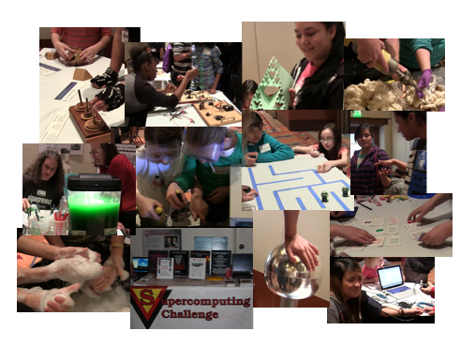
Participants in the STEM Programs and Career Fair:
Games for GUTS y Girls, GUTS y Girls/Santa Fe Institute
The Algae Future, Zibits Robot Maze, GUTS y Girls Static Electiricty, Big Sky Learning Medical Fun, Capital High Medical Science Program
Supercomputing Challenge Mars Rover, Los Alamos National Laboratory Sticky and Aqueous Foam Demos, Sandia National Laboratories Fractal Fun, Fractal Foundation Robotic Arm, Challenger Center What’s Inside a Computer, GUTS y Girls/Santa Fe Preparatory School Exploring Explora, Explora! Museum
Donors and supporters:
Thank you to our sponsors:
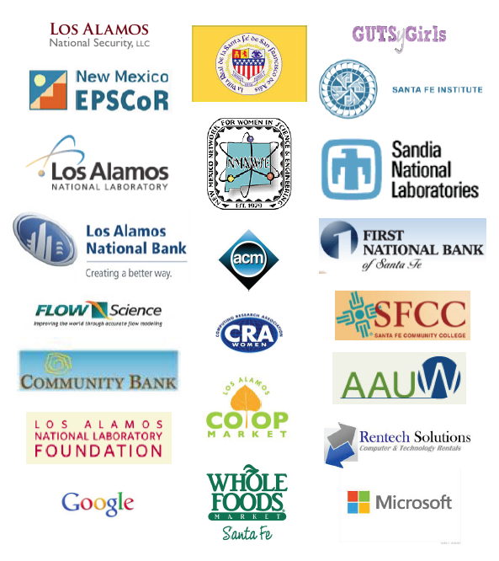
Many thanks to the City of Santa Fe and Councilor Rebecca Wurzburger for generously donating the use of the Santa Fe Convention Center for this year’s EYH conference.
NNM EYH partners:
Los Alamos Women in Science Santa Fe Institute/GUTS y Girls American Association of University Women Supercomputing Challenge New Mexico State University/Young Women in Computing
NNM EYH 2013 conference chairs:
Janette Frigo, Los Alamos National Laboratories Kathryn Ugoretz, Santa Fe Institute’s GUTS y Girls Irene Lee, Santa Fe Institute’s Project GUTS and GUTS y Girls
NNM EYH 2013 committee chairs:
Tana Cardenas – Outreach and Recruitment Lisa Colletti – Treasurer and prizes Susan Coulter – Volunteer Coordination Caroline Dennis – Publicity
Celia Einhorn – Career and Programs Fair Karen Kelley – Registration Tarryn Miller – Outreach Georgia Pedicini – Teachers’ conference Adam Shipman – Site organization, printing and prizes. Shannon Steinfadt – Packet planning and Mistress of Ceremonies
And a special thank you to our volunteers:
Nina Arko-Hay, Phyllis Baca, Dolores Baros, Eve Bauer, Jessica Baumgaertel, Jim Beck, Lynn Bennett, Liz Birkos, Katie Brown, Julie Cervantes, Janie Chen, Tony Cobian, Raylinn Coca, Lisa Colletti, Jade Comellas, Sabrina Cook, Susan Coulter, Juliet Critchlow, Basia Cruz, Teri Daly, Jen Dana, Mary Jo Daniel, Ashlynn Daughton, Karen Davenport, Caroline Dennis, Cindy Dilworth, Ursula Durrer, Elise Elfman, Celia Einhorn, Ed Fenimore, Madeleine Fort, Nanette Founds, Marianne Francois, Janette Frigo, Becca Galves, Tinka Gammel, Lina Germann, Susan Gibbs, Grace Graham, Nancy Graves, Kirstin Harriger, Sara Hartse, Laura Heisch, Catherine Hensley, Celeste Hernandez, Beverly Herrera, Tandra Hicks, Marti Hill, Diana Hollis, Jenifer Hooten, Arwen Hubbard, Victoria Hughes, Elizabeth Hunke, Elaine Jacobs, Nicole Jeffery, Nancy Johnson, Elizabeth Kallman, Alexis Kaminsky, Nidhi Kanabar, Barbara Kimbell, Rebecca Koskela, David Kratzer, Lindsay Kreslake, Erin Lay, Ellen Levy, Janet Lovato, Jennifer Macke, Marcos Maez, Pat Majerus, Laurie Marnell, Kim Martinez, Meghan McClelland, Sam McGuinn, Patty Meyer, Tarryn Miller, Chad Monthan, Sarah Morgan, Charel Morris, Harshi Mukundan, Katie Mussack, Tasha Nesiba, Mary Neu, Alicia Ortega, Rebecca Ortega, Joyce Ortega-Tapia, Cathy Padro, Stephanie Pippin, Johanna Pirolo, Sara Pocernik, Allison Poehler, Catherine Plesko, Enrico Pontelli, Calita Quesada, Marilyn Ramsey, Lindsay Rivera, Phil Rivera, Dana Robeson, Carole Rutten, Lauren Sachs, Stephanie Dawn Samson, Steve Sandoval, Joann Schilling, Beth Sellers, Kari Sentz, Michael Sheppard, Pam Smith, Brittany Snyder, Kelsey Souza, Kurt Steinhaus, Amy Tapia, Kathryn Ugoretz, Susan Unser, Stephen Vann, Ellie Vigil, Eleanor Walther, Laura Ware, Laura Wolfsberg, Belinda Wong, Lin Yin, Gretchen Yost, Kate Zeigler.
Outcomes
Number of participants:
Student participants (based on check in at conference): 223 Student mentors (high school students from GUTS y Girls): 9 Student evaluation forms received: 209 out of 223 (94%) Students receiving scholarship to attend: 95 out of 223 (42%) Adult participants: 16 (teachers, parents, educational assistants, etc.) Adult volunteers total: 128
Ratio of student participants to day-of volunteers: 223:114 (roughly 2:1) (Total volunteers includes pre-conference volunteers)
Demographics of student participants:
Demographic data on school of origin, grade level, and ethnicity of students from was collected from student evaluation materials completed onsite.
Schools:
Table 1: Schools from which participants came. (continued on next page.)
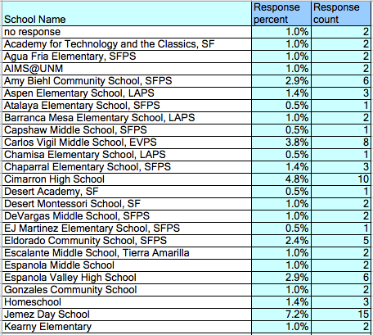
Table 1: Schools from which participants came. (continued)
Grade Levels:
The grade range of participants was 5th- 12th grade. Nearly 50% of participants were in either in the 5th or 6th grade.
Table 2: Grade level of participants
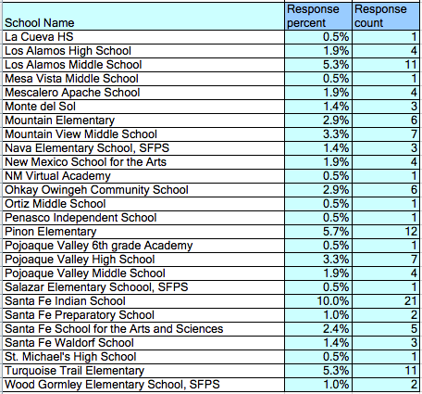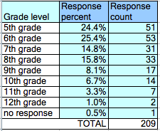
Race/Ethnicity:
57.4% of respondents were from underrepresented groups in STEM including Native Americans, African Americans, Hispanics, and students of mixed ethnicity including one of the underrepresented groups.
Table 3: Ethnicity reported by student participants
Socio-economic status:
Of the 223 students who attended, 95 individuals or 42% were given full scholarships to attend the EYH Santa Fe conference.
Evaluation of Conference Sessions
Keynote Panel
This year’s keynote presentation was given by Tasha Nesiba. Tasha spoke of girls’ different kinds of “superpowers” such as computing, and how they might harness those powers to achieve great things. The average rating received was 4.26 out of 5.
Table 4: Keynote Panel content rating.
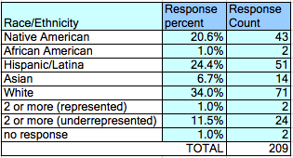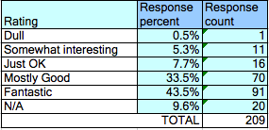
Workshops:
Participants were asked to rate the content and difficulty level of the two workshops they attended on a student evaluation form. Content ratings ranged from 1 (dull) to 5 (fantastic). Difficulty ratings ranged from -2 (too easy) to 2 (too difficult). The responses are summarized in the table below. The average content rating across all workshops was 4.35 (between mostly good and fantastic) and the average difficult rating across workshop was -0.21 (between just right and easy).
Table 6: Workshop Rating Scales.
Table 7: Workshop Ratings.
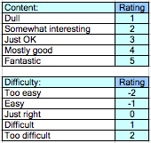
Average content
Average difficulty
Workshop name
rating
rating
1. Pulling out DNA from your own cheek cells! (OKeeffe)
5.00
-0.50
2. Cryptography and Steganography - From Caesar to Shannon (Ballroom F)
4.06
-0.69
3. Teeth in Your Future? Careers in Dentistry (Ballroom F)
4.64
-0.07
4. Tails of a Veterinarian (Ballroom B)
4.73
0.13
5. Ocean Density, Current, and Ice (Ballroom C)
4.75
-0.17
6. Aviation/Aerospace (Ballroom C)
4.21
0.11
7. Animals that live in Water (Peralta)
3.94
-0.35
8. Ooey Gooey Polymers (Ballroom F)
4.00
-0.88
9. Hydrogen Fuel Cells (Coronado)
4.77
-0.15
10. Paper + Electronics (Ballroom D)
4.57
0.29
11. Nutrition in the ICU - Metabolic Response to Injury/Illness (Ballroom B)
3.75
0.13
12. Chroma Key - You In The Movies! (Nambe)
3.54
-0.08
13. Help Wanted: Gamers Needed for Scientific Problem Solving (Tesuque)
4.32
0.21
14. Ask the Astrophysicist! (Lamy)
4.04
-0.21
15. Minerals in Makeup (Ballroom B)
4.35
-0.55
16. Extracting DNA from Strawberries! (DeVargas)
4.62
-0.41
17. Earth Cycles: Building and Recycling Continents (Ballroom D)
4.00
-0.65
4.88
0.00
4.38
4.93
4.59
18. Exploring Math, Science and Technology in the Fire Department (Kearney) 19. Design Blocks (San Juan) 20. Molecular Gastronomy: Fun with food (Ballroom A) 21. PicoCricket Robotics (Pojoaque)
0.26 -0.37 0.00
Table 8: Workshops by Average Content Ratings (scale: dull = 1 to fantastic = 5).
Table 9: Workshops by Average Difficulty Ratings (too easy = -2 to too difficult = 2).
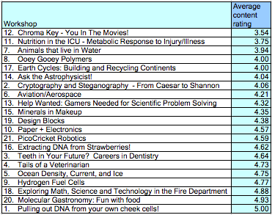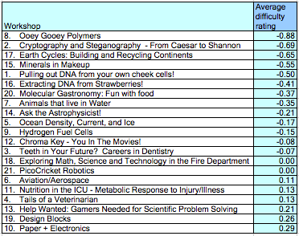

Three questions were asked that aimed to capture the impact of the conference on participants. Table 10: Change in Attitudes and Interests.
Responses to Open-ended questions on the Student Evaluation Form. A sample of responses to “What I expected was...”
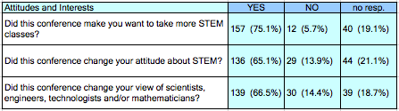
a boring thing where all we do is eat and listen
a bunch of girls going through workshops. I expected to do all of the workshops
a lot of semi boring math and science
a nervous weird meeting. I also expected to not know anyone and to not make any friends
for this to be not that fun
going to different workshops and learning science and meeting women scientists
I expected a really long lecture about stuff. I also expected no hands on stuff
I expected a smaller group of people
I expected it to be more like a conference where I would just sit + listen
I expected that this was going to be hard
I expected that we were going to pick which workshops we are going to do for the day
I expected there to be really smart kids answering every question and me being all alone not knowing anything
I expected this was going to be fun and it was!!!
A sample of responses to “What I got was...”
2 classed that i loved
a bit more of a discussions bit it was still fun
a bunch of different people/workshops -career opportunities -science technology
A FRIEND A NEW FRIEND
a lot of cool experiences
a very fun and full of learning day
an amazing experience that was really fun. I made lots of friends
an introduction to some new areas of science
awesome stuff
classes that were ok, but not great.
exciting fun conversation
going into groups that I didn't really get along with
hands on activities

I got that science is really fun. Not just really prestigious.
learning more about science
meeting people that have majored in different things. It taught me that I can be anything.
new friends and more knowledge
really fun things to do and it doesn't seem like math or science, it's so fun
A sample of responses to “Next, I will...”
-better my education to become something great.
apply these to my computer classes and geology skills to fulfill my dream
aspire to become a program/ computer designer with my newfound knowledge
be very excited to learn more on different kinds of science
come back next year
continue looking into computer science and engineering
continue viewing math and science as interesting areas of study that are never boring!
do more science
figure out my superpower
Find more places similar to this and continue to advance my knowledge and interest in the field
Get more information about engineering, scholarships and my future
go home and have some fun experimenting with the stuff i learned
I WILL BE A SCIENTIST
I will next tell my mom about all the cool things I learned today and how cool everything was.
I'm going to see if in the summer there are any science classes
Learn about scientist discoveries and become a mathematician
learn more about the different jobs
look more closely at careers that combine engineering & sciences with art
share this all the information I learned and study more about science
take more STEM related classes in High School and advance in the field
A sample of responses to “And the best part was...”
All the new knowledge about how science integrates with my other interests
everything except the talk at the beginning
Everything! This conference was very informative and interesting.
for me the best part was when we got to do the hands on experiments
getting to talk to experts in the things I like
hands on activities
hearing personally from women who are in STEM careers
Interacting with other women who shared my interest in STEM.
learning so much information about science
meeting and making new friends
The passion of speakers and Presenters
the workshops and the opportunities to hear the presentations
we got to have fun while learning
when there was a fair during lunch

A sample of responses to “Is there anything else you would like to share?”
Most responses were very positive:
I liked how when I cam everybody was nice to me, (new student)
I liked that we were put into groups because it helped us work with new people that shared the same interests.
I love it!!!
I really enjoyed this program and you should do it every year.
It was a cool and fun way to learn about what people do in STEM
It was amazing STEM ROCKS, I loved it
It was really fun!
The only reason it did not change my views is that I already knew lots of awesome scientists
A few responses suggested changes we could make in the future:
have more interactives
I had a great time, thanks! The material, however was a bit simple
I really would have liked to been in the workshop with the veterinary people
I think hand-outs for each workshop would be beneficial. They could include some basic information on the topic as well as the activities we did and any other resources.
I wish I had the chance to do more stuff about biology
I would've liked the classes to be more advanced; the classes seemed almost too easy.
I'd like to have more classes about different things
It would have been better if the Mars Rover thing was a demonstration and not just a conference
It would have been nice if we could choose our workshops. Please spell names correctly. Don't have the event on a Saturday!!!!!!!!!!!
Less time for lunch
More food, more natives, more prizes
more workshops in a day.
You should do this twice a year!
You should get a recycling bin and you should have shorter classes, but more classes.
Teacher Workshops:
Participants in the teachers’ workshops represented the following schools: Carlos Vigil Middle School (1), Cimarron High School (2), Espanola Public Schools (2), Jemez Day School (3), Mescalero Apache School (2), Mountain View Elementary (1), Ohkay Owingeh Community School (2), Pojoaque Public Schools (2), and unknown (2). They were asked to evaluate their workshop experience. The average content rating across all workshops was 4.44 (between mostly good and fantastic) and the average difficult rating across workshop was -0.13 (between just right and easy).
Some free response comments included:
I really enjoyed and I learned a lot about how fun science can be. The students can really enjoy these things we learned.
I enjoyed the speakers from a variety of occupations. This is the only opportunity for such wide exposure to these careers.
I enjoyed the entire day! I am motivated to go back to school and write a LANL grant for robots. We will also create a team to do the RoboRun.

Concluding Thoughts
Our 2013 Expanding Your Horizons conference event can be viewed as very successful based on several diverse metrics. The event drew a diverse group of girls with respect to geographic, racial/ethnic and socioeconomic characteristics: Students represented 50 different public, private, and homeschools in Northern New Mexico; 57.4% of respondents were from underrepresented groups in STEM; and 42% of participants received scholarships to attend.
The mission of EYH is to encourage young women to pursue STEM careers by providing STEM role models and hands-on activities for middle and high school girls. Based on the participant responses, the event changed perceptions of STEM careers (65.1%) and STEM practitioners (66.1%) in a positive way, and 75.1% of the girls were encouraged to take more STEM classes. (Note that of those who said that their attitudes towards STEM did not change, several noted that they already had a positive attitude towards STEM.)
Our workshops were appropriate for girls at various age and maturity levels. The average content rating across workshops was 4.35 (between mostly good and fantastic) and the average difficulty rating was -0.21 (between just right and easy).
Some changes made to this year’s EYH conference included: partnering with Los Alamos Women in Science, hosting the event at the Santa Fe Convention Center, moving the conference to a Saturday, decreasing the cost of registration from $10.00 to $5.00 per student, and accommodating a wider range of students (5th-12th grades). The new venue supported 200+ participants, and our workshop durations were increased from 1.25 hr to 1.5 hours.
The overwhelming number of people who volunteered to support this event was not only gratifying, but also integral to the success of the event. We hope that in future years, the volunteer pool will continue to grow.

Silver City ------------------------------------------------------------------------------------ Adrienne Dare
Nan will be getting update from Adrienne.

Las Cruces ----------------------------------------------------------------------------------- Rebecca Galves
Our final EYH of 2013 will be held next weekend!

Chapter Reports:
Central Chapter ---------------------------------------------------------------------------- Jeanne Banks
We will be meeting on the April 17th.

Northern -------------------------------------------------------------------------------------- Emily Schultz-Fellenz
NR
Southern -------------------------------------------------------------------------------------- Becca Galves
NR

Old Business:
11/4/12 | State Chair for EYH: Nan will be Temp. | Board | Open
12/8/12 | Speaker Send a short-list of past IMPACT! Award winners & board members & anyone else that someone would like to suggest. | Tinka | Open
12/8/12 | Copy of NM Kids! Magazine for Archives: Check if Tinka got it. | Board | Open
12/8/12 | Policies & Procedures:  Committee chairs find and update the duties/responsibilities | Board | Open
12/8/12 | Policies & Procedures:  Committee chairs find and update the duties/responsibilities: Creation of template for committee chairs | Jeanne & Nanette | Open
12/8/12 | Insurance for 2014 EYH | Nan & Board | open

New Business:

Future Board Meetings: Every 2nd Saturday
June 8, 2013 UNMVC @ 10:00 AM (STEM Resource Center)
August 10, 2013 ABQ UNM Main

Adjourned: 2:55 PM

 |  |  | Oct-12 | Nov-12 | Dec-12 | Jan-12 | Feb-13 | Mar-13 | Apr-13 | May-13 | Jun-13 | Jul-13 | Aug-13 | Sep-13 | YTD Total |  | 2012-2013 Budget
INCOME
 | Annual Meeting |  | $610.00 |  | $920.00 |  | $25.00 |  |  |  |  |  |  |  | $1,555.00 |  | $400.00
 | Memberships |  | $140.00 |  | $740.00 |  | $260.00 |  |  |  |  |  |  |  | $1,140.00 |  | $1,200.00
 | Fund Raising |  |  |  |  |  |  |  |  |  |  |  |  |  | $0.00 |  | $10,950.00
 | Donations |  | $200.00 |  | $345.00 |  |  |  |  |  |  |  |  |  | $545.00 |  | $250.00
 | Other |  |  |  | $180.00 |  |  |  |  |  |  |  |  |  | $180.00 |  | $0.00
 |  | TOTAL | $950.00 | $0.00 | $2,185.00 | $0.00 | $285.00 | $0.00 | $0.00 | $0.00 | $0.00 | $0.00 | $0.00 | $0.00 | $3,420.00 |  | $12,800.00
EXPENSES
Administration
 | Archives |  |  |  |  |  |  |  |  |  |  |  |  |  | $0.00 |  | $10.00
 | Elections |  |  |  |  |  |  |  |  |  |  |  |  |  | $0.00 |  | $10.00
 | Fund Raising |  |  |  |  |  |  |  |  |  |  |  |  |  | $0.00 |  | $50.00
 | Communications |  |  |  |  |  |  |  |  |  |  |  |  |  | $0.00 |  | $20.00
 | Officers' Expenses |  |  |  |  |  |  |  |  |  |  |  |  |  | $0.00 |  | $50.00
 | PO Box |  |  |  |  |  |  |  |  |  |  |  |  |  | $0.00 |  | $110.00
 | Publicity |  |  | $112.81 |  |  |  |  |  |  |  |  |  |  | $112.81 |  | $500.00
 | Miscellaneous |  |  |  |  |  | $10.00 |  |  |  |  |  |  |  | $10.00 |  | $50.00
 | Board Travel Expenses |  |  |  |  |  |  |  |  |  |  |  |  |  | $0.00 |  | $250.00
 |  | Subtotal | $0.00 | $112.81 | $0.00 | $0.00 | $10.00 | $0.00 | $0.00 | $0.00 | $0.00 | $0.00 | $0.00 | $0.00 | $122.81 |  | $1,050.00
Membership Activities/ Professional Mentoring
 | Annual Meeting |  |  | $557.63 |  |  |  |  |  |  |  |  |  |  | $557.63 |  | $400.00
 | Annual Meeting Scholarships |  |  |  |  |  |  |  |  |  |  |  |  |  | $0.00 |  | $0.00
 | Chapter Funds |  |  |  |  |  |  |  |  |  |  |  |  |  | $0.00 |  | $600.00
 | Membership Expenses |  |  |  |  |  | $11.97 |  |  |  |  |  |  |  | $11.97 |  | $300.00
 | IMPACT! Award |  |  | $97.87 |  |  | $118.93 |  |  |  |  |  |  |  | $216.80 |  | $200.00
 |  | Subtotal | $0.00 | $655.50 | $0.00 | $0.00 | $130.90 | $0.00 | $0.00 | $0.00 | $0.00 | $0.00 | $0.00 | $0.00 | $786.40 |  | $1,500.00
Student Mentoring/Education |  |  | .
 | EYH Conferences
 |  | Albuquerque |  |  |  | $600.00 |  |  |  |  |  |  |  |  | $600.00 |  | $600.00
 |  | Las Cruces |  |  | $600.00 |  |  |  |  |  |  |  |  |  | $600.00 |  | $600.00
 |  | Los Alamos |  |  |  |  |  |  |  |  |  |  |  |  | $0.00 |  | $600.00
 |  | Silver City |  |  |  |  | $600.00 |  |  |  |  |  |  |  | $600.00 |  | $600.00
 |  | Santa fe |  |  |  |  |  |  |  |  |  |  |  |  | $0.00 |  | $600.00
 |  | Statewide |  |  | $500.00 |  |  |  |  |  |  |  |  |  | $500.00 |  | $500.00
 |  | EYH Insurance |  |  |  |  | $875.52 |  |  |  |  |  |  |  | $875.52 |  | $900.00
 |  | EYH Promotion (totebags/other) |  |  |  |  | $470.91 |  |  |  |  |  |  |  | $470.91 |  | $3,000.00
 |  | EYH Printing |  |  |  |  |  |  |  |  |  |  |  |  | $0.00 |  | $1,500.00
 | Student Awards |  |  |  |  |  |  |  |  |  |  |  |  |  | $0.00 |  | $1,150.00
 | Miscellaneous |  |  |  |  |  |  |  |  |  |  |  |  |  | $0.00 |  | $200.00
 |  | Subtotal | $0.00 | $0.00 | $1,100.00 | $600.00 | $1,946.43 | $0.00 | $0.00 | $0.00 | $0.00 | $0.00 | $0.00 | $0.00 | $3,646.43 |  | $10,250.00
 |  | TOTAL | $0.00 | $768.31 | $1,100.00 | $600.00 | $2,087.33 | $0.00 | $0.00 | $0.00 | $0.00 | $0.00 | $0.00 | $0.00 | $4,555.64 |  | $12,800.00
 |  | Account Balance Start | $9,569.78 |  |  | $9,751.47 |  | $10,236.47 |  | $8,434.14 |  | $8,434.14 | $8,434.14 | $8,434.14
 |  | Income | $950.00 |  |  | $2,185.00 |  | $285.00 |  | $0.00 |  | $0.00 | $0.00 | $0.00
 |  | Expenses | $768.31 |  |  | $1,700.00 |  | $2,087.33 |  | $0.00 |  | $0.00 | $0.00 | $0.00
 |  | Account Balance End | $9,751.47 |  |  | $10,236.47 |  | $8,434.14 |  | $8,434.14 |  | $8,434.14 | $8,434.14 | $8,434.14

