Draft New Mexico Kids! Magazine Ad for EYH

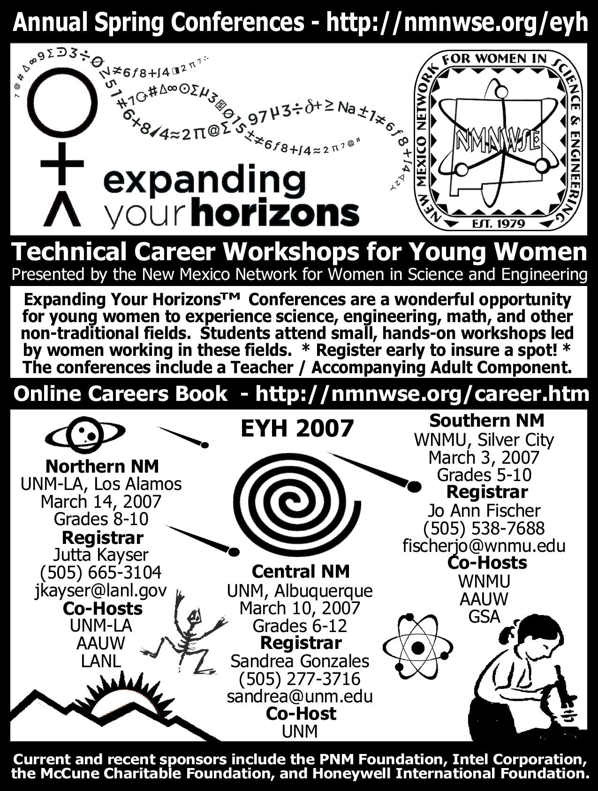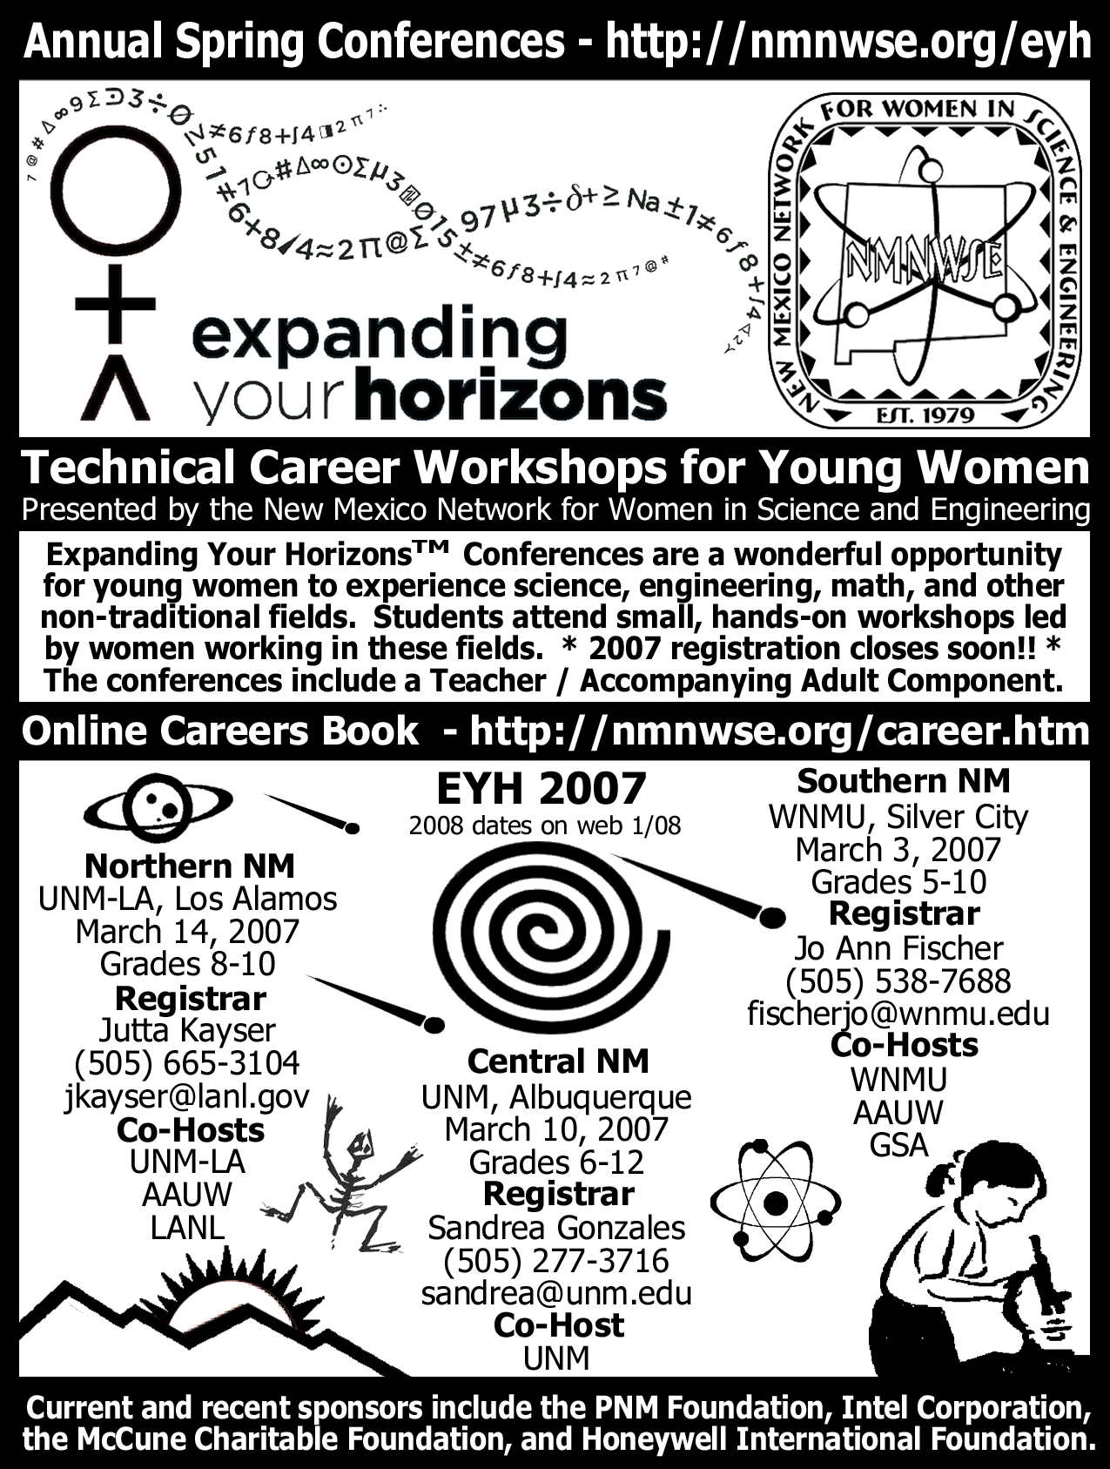

Version one: 'register early' Version 2: '2007 registration closes soon, check web for 2008

Cost: ¼ page (4.25"x5.625"), 1-time: $460
Publication date: Feb 27

