P.O. Box 1360 Los Alamos, NM 87544
NEW MEXICO NETWORK

for Women in Science & Engineering

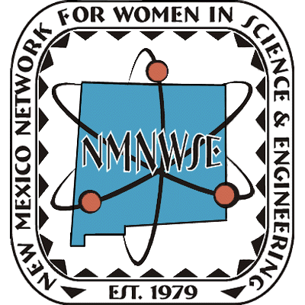
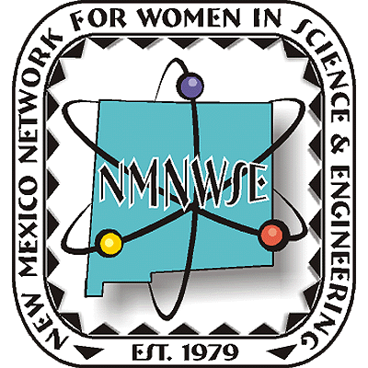
Note from the President
Nanette Founds
May 2013
Hi,
Wow, the year is almost up, eight months down and four more to go. So I thought I had better introduce myself, Nanette Founds. Instead of telling you more about my career path, I thought I would tell a story of how I became part of the Network. I met a young woman many years ago. I suspect many of you all know her well, Yolanda Jones – King. She was a Jones back then in 1984 and she introduced me to the Network. She also introduced me to the world of STEM, Science, Technology, Engineering, and Math. Not that I didn’t have a degree, but that there were wonderful ways to bring this world, these opportunities to young women in New Mexico. You could say, she helped me see the need and satisfaction of staying STEM STRONG.
So now with four Expanding Your Horizons (EYH) Conferences behind us, I would like to thank all those who dedicated there time and efforts to making these possible. I got to personally be a part of both the Albuquerque and Santa Fe EYH conferences. I want to let everyone know how fun it really is. Hard work yes, but I also got to attend a workshop on Cosmology, “Everything You Wanted to Know about the Universe”. So, let me see, Dark Energy and Dark Matter, where on earth did these concepts come from? Well not from studying chemistry and aeronautical engineering as I did. But, what fun it was to take a day, not only to have young women ask about these concepts, but to learn more about them myself. It was really fun and do you know how much more you can learn from PBS and You Tube. What resources these can be to inspire and to learn.
Of course not only do we put on EYHs, but we judge science fairs as well. I missed out on the Native American Indian Science and Engineering Fair and Expo (NAISEF). But, Laurie Marnell and Tinka Gammel went, had a ball, and continued the networks encouragement of young women at this event. In addition, Yolanda Jones-King, Diane Oyen, Laurie Marnell, Claudia Barreto, and I judged the New Mexico Science and Engineering Fair. Always great to see the faces of the young women who are interested and really enjoy talking about their projects and their new found insights into the world of STEM. Eleanor Walther was the network’s judge at the New Mexico Super Computing challenge. Truly rewarding and we have received many thanks for the awards presented at these events.
This is where I would like to return to the beginning. Remember Yoland Jones-King well we have had quite a number of years putting on EYH’s and judging science fairs. Blew up a rocket and set fire to a Biology Lab at the University of New Mexico. Got it out quickly and kept it fairly quiet. So obviously we taught those young ladies a thing or two about fire control as well. But most importantly, it has been fun and the friendships good as well. I’ve really met professionals who care tremendously about STEM and passing on the love of science to the next generation. Tinka Gammel, Claudia Barreto, Barbara Torres, Laurie Marnell, Jeanne Banks, Pat Pettit, Elizabeth Kallman, Rebecca Galves, Karen Agogino. Have I mentioned just a few, I really have. Please go to the website, NMNWSE.org and see all the women who make this network a success. Did I also mention that Tinka Gammel is the greatest webmaster around!
But, to really get to the point, I would like to extend to each and every one of you a personal invitation to attend our Annual NMNWSE meeting and Technical Symposium at the Shaffer Hotel in Mountainair, New Mexico. The annual meeting is October 25-27th. At this event, it will be our pleasure to present our IMPACT! Award to one of the fabulous women in New Mexico who have tirelessly used their time, energy, and talents to make an impact. So, please come and share your experiences with the Network or your passion to help a new generation become STEM STRONG.
See ya there,
- Nan
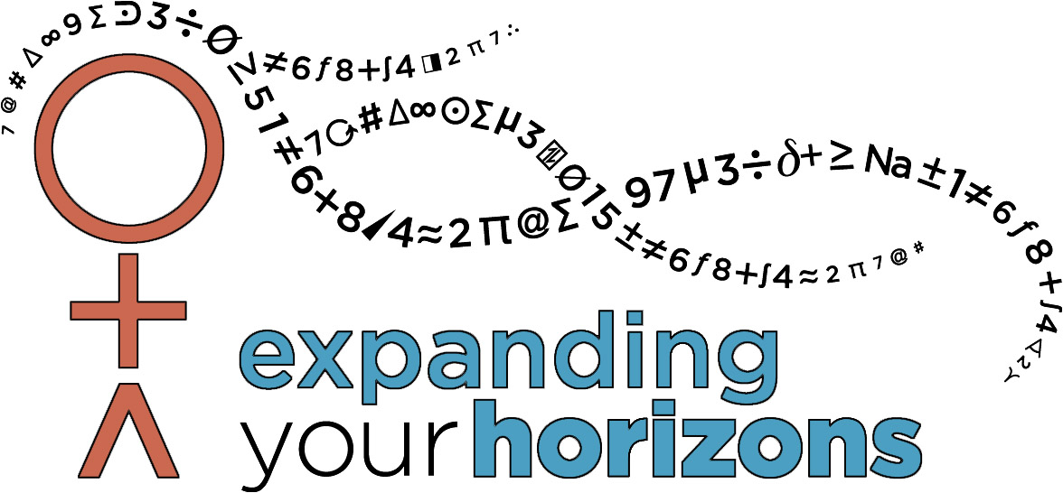

See also:
• Annual Meeting Flyer with Call for Papers
and Call for for IMPACT! Award Nominations
http://nmnwse.org/AM/2013/AM13flyer.pdf
• Annual Meeting Registration Form
http://nmnwse.org/AM/2013/AM13reg.pdf
• IMPACT! Award Nomination Form
http://nmnwse.org/ImpactAward/ImpactForm.pdf

