NEW MEXICO NETWORK | June 2015
P.O. Box 1360 Los Alamos, NM 87544
For Women in Science & Engineering

FALL 2015 STATEWIDE EVENTS & IMPORTANT DATES
CONTENTS
Fall Events, Dates, p. 1
- AM 2015, Annual Elections,
& IMPACT! Award
BCBS Donates to EYH, p. 1
Student awards, p. 2
- NM SCC, NMSEF
“Careers” in Spanish, p. 2
- help needed to finish
Personal Highlights
Dana Roberson, p. 3
Chapter reports, p. 3
Expanding Your Horizons
Upcoming, p. 3
Santa Fe-fall: Sep, 2015
Carlsbad: Oct 2, 2015
Spring Reports, p. 4-6
for more news, see
nmnwse.org
Contact us at:
NMNWSE_Board-L
@list.unm.edu
or
webmaster@nmnwse.org

note new date!

* September 14, IMPACT AWARD! Nominations due
Please take a moment to reflect about your and your colleagues accomplishments: who is the one person you know that has really gone the extra step to get women participating; to help the next generation get equipped with the right tools and skills to make a difference; to make an IMPACT! If you know someone who has truly made a difference in the lives of many, please nominate that person for the IMPACT! Award.
For nomination form and instructions, see http://nmnwse.org/ImpactAward/.

* October 5, nominations for board candidates due
Make time for giving back to the community by volunteering on the NMNWSE Board!! We are looking for a volunteer for both the President and the Vice President/President-elect for the October election, as well Members-at-Large and standing Chair positions. If you are interested in serving on the Board, please contact the Elections Chair via the Board email, NMNWSE_Board-L@list.unm.edu.

* 23-25 October 2015, Annual Meeting & Technical Symposium (AM 2015), Truth or Consequences, NM
Please plan to join us at this year’s annual meeting: a weekend of networking and technical interchange where you will have a chance to interact with many incredible New Mexico women and meet the 2015 IMPACT! Award winner. The Saturday afternoon technical sessions are an excellent opportunity to present your work in a supportive environment and learn what others in the Network do. To provide planning input, please fill in the interest survey at http://nmnwse.org/AM/survey/. See http://nmnwse.org/AM/2015/ for further meeting details and the call for papers.

BCBS Donates $5000 for EYH
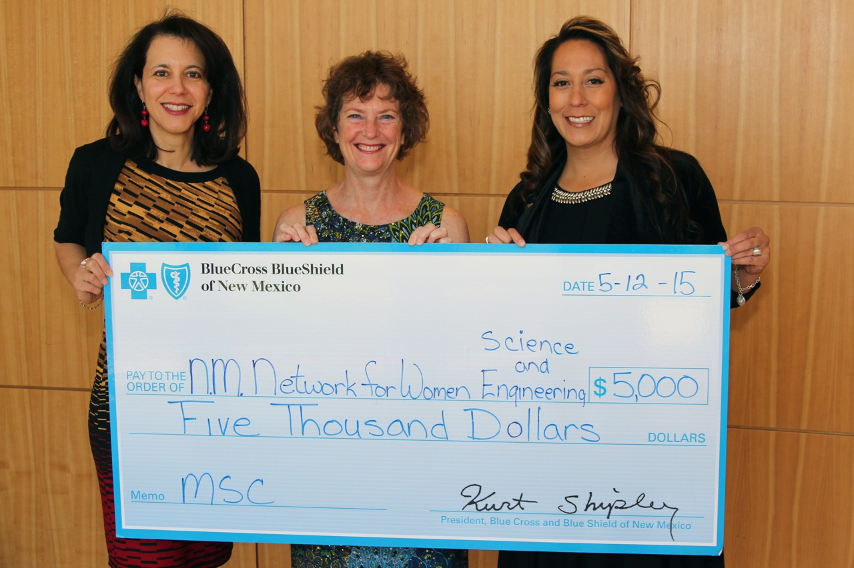
Blue Cross Blue Shield (BCBS) of New Mexico donated $5,000 to NMNWSE in support of NMNWSE EYH on May 12, 2015! Big thanks to Denise Kawas and Jeanene Kerestes of BCBS for seeking out our organization and recognizing the value EYH brings to the young women of New Mexico. Albuquerque EYH Chair Kelly Collins (center) was invited to receive the check at their managers forum and she provided a 5 minute overview of NMNWSE and EYH. Along with this check, BCBS management encouraged their employees to volunteer at EYHs around the state.

2015 NMNWSE Award winners at NMSEF and NMSCC
Network News, p.2
Congratulations to the NMNWSE Award winners at the 2015 New Mexico Science and Engineering Fair (NMSEF), held 1-2 April 2015 at New Mexico Tech in Socorro, NM:
There were 10 awards for $50 plus a certificate and tote bag with career materials:
Junior Division:
Anyssa Lopez‐Gaston, Our Lady of the Assumption, Albuquerque, NM, JR Chemistry,
“What Toothpaste Cleans the Best?”
Eliza Evans, Barranca Mesa Elementary, Los Alamos, NM, JR Energy and Transportation,
”Constructing and Comparing Functional Solar Cells to Generate Electricity”
Arianna Urquidi, Sierra Middle School, Las Cruces, JR Zoology,
“Dancing on a Spider Web”
Senior Division:
Lea' Godret Miertschin, Nex Gen Academy, Albuquerque, NM, SR Chemistry,
“Efficiency in Desalination: Conduction vs. Radiation”
Jennifer Paige, Los Alamos High School, Los Alamos, SR Chemistry,
“Visible Spectroscopy: Allura Red”
Kelly Charley, Navajo Preparatory School Inc, Farmington, NM, SR Energy and Transportation,
“Developing a Self‐Sufficient Solar Heating System”
EliseAnne Koskelo, Los Alamos High School, Los Alamos, NM, SR Engineering,
“Biomimetic Skyscrapers Inspired by Dendroseismology”
Priyanka Jain, La Cueva High School, Albuquerque, NM, SR Medicine and Health Sciences,
“Novel Strategy for Removing Gene Inhibitors from DNA to Induce Apoptosis to Kill Cancer Cells”
Rene Smith, Grants High School, Milan, NM, SR Microbiology,
“Mutagenic Capabilities of Aromatic Hydrocarbons on Bacteria: How Safe Are You?”
Katherine Schneider, V. Sue Cleveland High School, Rio Rancho, NM, SR Physics and Astronomy,
“Demonstrating Wave‐Partical Duality of a Quantum System”
Congratulations to the NMNWSE Award winners!! The judges felt it was a hard choice, and wish to also congratulate all the students who participated in the State Science Fair, and their teachers and mentors! We hope these students continue to develop their potential as future leaders in STEMM (Science, Technology, Engineering, Mathematics, Medicine) and allied professions!
Judges for the NMNWSE Awards were Tinka Gammel, Yolanda King, Claudia Barreto, Clifton Murray, Diane Janni, and Diane Oyen.
Congratulations to the NMNWSE Award winners at the 2015 New Mexico Supercomputing Challenge (NMSCC), held 20-21 April 2015 at Los Alamos National Laboratory in Los Alamos, NM:
Team 39, Las Cruces High School
Team Members: Grace Cowie, Mollyanne Hurd, Vladislav Sevostianov
Project: PAVL: Personal Assistance for the Visually Limited
Teacher: Elisa Cundiff, Mentor: Stephen Guerin
The goal of Team 39's project was to create an inexpensive device to help blind people navigate their surroundings. They modeled and then built and tested prototypes, with moderate success although the final device still had problems with sharp corners and low-lying objects, as their simulations had predicted. The final report on their project is available at http://supercomputingchallenge.org/archive/14-15/finalreports/39.pdf
Congratulations to the team members, as well as their mentor and teacher!
Each student on the team received $70, an award certificate, and a tote bag with career materials. The judge for NMNWSE was Eleanor Walther.
NMNWSE Careers book and Trifold soon to be available online in Spanish
Thanks to Southern Chapter member Jessica Garcia, the NMNWSE ‘Who We Are’ Trifold and a large portion of the NMNWSE Careers Book “Exploring the Possibilities” (http://nmnwse.org/careers/) have been translated into Spanish. SF-spring EYH volunteer Alexine Salazar is currently proof-reading it to check for regional differences in the Spanish. If you would like to help finish this project, or view the current version, please contact the NMNWSE webmaster, Tinka Gammel, webmaster@nmnwse.org. We hope to get the translations online this summer so they will be available to Fall EYH attendees.

Personal Highlights

 NMNWSE Board Member Dana Roberson was recognized this January as the Project management Institute, Rio Grande Chapter (http://www.pmirgc.org) Volunteer of the Year (2014). PMIRGC president Fred May stated in the February 2015 newsletter that Dana’s “selfless service and dedication to the practice of project management is very much appreciated!” Dana and her husband Gary were both recognized for their support of the new PMIRGC mentorship program initiative. Congrats, Dana!
The NMNWSE Board welcomes suggestions for women to nominate for awards and similar recognition.
- email your suggestions to NMNWSE_Board-L@list.unm.edu -
Chapter Reports
Central Chapter is currently the only active Chapter – contact the Board if you would like help revitalizing your chapter. Contact the NMNWSE webmaster if you would like to be on the appropriate mailing list for local chapter meeting announcements
NETWORK News, p.3
Central Chapter
The Central Chapter plans to continue to hold monthly meeting through the summer on the 3rd Wednesday of the month, 6:30pm, at the Flying Star Restaurant- Downtown. See http://nmnwse.org/central for more information.
Northern Chapter
Northern Chapter plans to hold a meeting on the near future in the Santa Fe area. Please contact SF-fall EYH Chair Lina Germann, lsgermann@gmail.com, if you would like to help plan this event.
NMNWSE Expanding Your Horizons (EYH) Conferences
NMNWSE members volunteer time and energy to ensure that young people, especially young women, have access to information on exciting and meaningful careers in science, technology, engineering, mathematics, medicine, and allied professions (STEMM). NMNWSE has been sponsoring annual Expanding your horizons (EYH) conferences statewide since 1980, reaching over 23,500 students and their teachers. The NMNWSE EYH are licensed from the EYH Network - internationally, this program as reached over 625,000 students since 1976. The students receive career information and encouragement at an early age, a key factor of future success. The EYH currently held throughout New Mexico (NM) are:
- EYH Santa Fe-fall September 19, 2015 note new date!
- EYH Carlsbad October 2, 2015
For details, see
nmnwse.org/eyh

- EYH Albuquerque Early Spring, 2016 exact dateTBA aka Central
- EYH Las Cruces Early Spring, 2016 exact dateTBA
- EYH Silver City Early Spring, 2016 exact dateTBA
- EYH Santa Fe-spring Spring, 2016 exact dateTBA aka Los Alamos, Northern
The National EYH Network, from which NMNWSE licenses our EYH, has recently formed regional groups of EYH to help promote communication and idea sharing between planning committees. I am proud to note NMNWSE licenses half of the Mountain Consortium EYH, making New Mexico a very active state in STEM outreach to teenage girls.
This spring’s EYH were very successful. We are looking forward to a great fall and continuing the tradition into 2016. I hope you will consider helping out as a planning committee member, presenter, day-of helper, or whatever you have time for. It is a very rewarding experience, and I know you will enjoy helping introduce girls to STEMM (Science, Technology, Engineering, Math, Medicine) and related non-traditional careers.
– Rebecca Galves, NMNWSE state EYH chair, rgalves@cs.nmsu.edu
or via the NMNWSE board at NMNWSE_board-L@list.unm.edu

Upcoming EYH
The girls’ 2014 conference evaluations described EYH as:
Inspiring, awesome, fun, wonderful, and intriguing
— Santa Fe-fall EYH, late September, 2015
The Santa Fe-fall planning committee is currently planning to hold an EYH on a Saturday in late September, 2015, at Santa Fe Community College (SFCC), targeting 170 girls in Grades 5-8. The Santa Fe-fall EYH Conference is presented by NMNWSE and AAUW Santa Fe, and hosted by SFCC. If you are interested in volunteering or attending, contact Lina Germann at 505-310-4122, lsgermann@gmail.com.
— Carlsbad EYH, October 2, 2015
“Be the change you want to see in the world.” - Ghandi
We have a date for our fall EYH! It will be October 2nd at NMSU - Carlsbad with girls bussed in from the middle school. We're excited to try this different model and see how it works for our girls and our professionals. Please contact Lisa Chappa, Stem4Lisa@gmail.com, if you’d like help plan or otherwise to be part of this fall’s Carlsbad EYH.

NMNWSE Expanding Your Horizons (EYH) Reports
Network News, p.4
Las Cruces EYH January 31, 2015
LC EYH summary to be included in the fall newsletter.
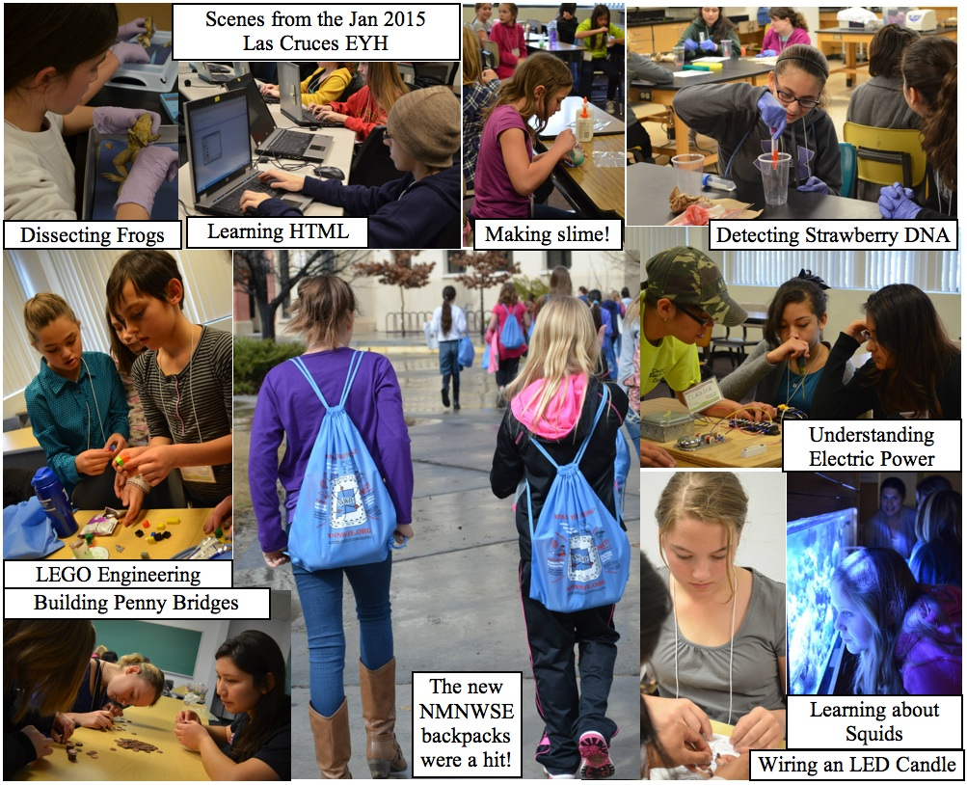

Santa Fe-spring EYH March 6, 2015
SF-spring EYH pictures to be included in the fall newsletter.
This year boasted 253 participants from all over northern New Mexico, including Albuquerque, Acoma Pueblo, Los Alamos, Mescalero, Dixon, Espanola, Ohkay Owingeh, Jemez Pueblo, Pena Blanca, Zia Pueblo, Santa Cruz, Santa Fe, Velarde, and Taos. For 77% of those students, this was their first EYH experience. The impact the EYH conference has on youth participants is dramatic. More than 93% of the students attending our conference expressed that they feel more motivated to take STEM classes. Even more impressive is that close to 95% of those polled say their attitude toward STEM fields was positively affected by their experience at the conference.
Importantly, EYH 2015 reached out to underrepresented areas and demographics with an impressive participation by minorities with over 39% of the total participation by Native American young women and close to 32% of the total participation from young Hispanic women.
Thanks so much to all who helped for their support of the NNM (aka Santa Fe-spring) EYH this year! It was a wonderful event and I think we are truly making an impact in the lives of young students!
- Jan Frigo, NNM EYH Chair

EYH Reports, cont’d
Silver City EYH February 28, 2015
NETWORK News, p.5
SC EYH 2015 -
Inspiring Future:
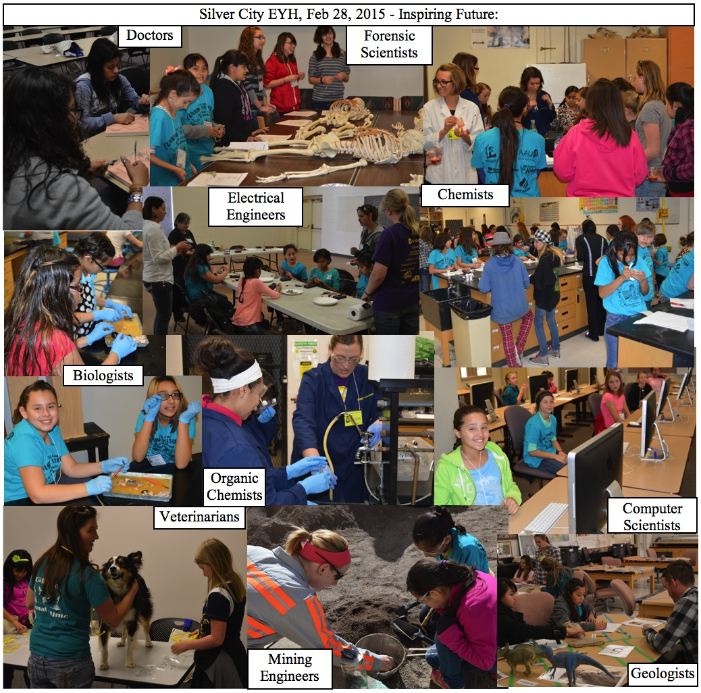
This year we held our 23rd EYH in Silver City. It was a great year! We had 330 students, 44 volunteers and 31 presenters for 20 workshops. Girls attended from 21 schools and home schools in a four county area of southwestern New Mexico. We had a total of 6 buses from Lordsburg, Deming, and Columbus. Responses to the program were enthusiastic, especially to our two newest work-shops: The first on electricity was conducted (no pun intended) by a local journeyman electrician and her apprentice who is also her sister. The second was an introduction to the “Alice” computer programming software led by a WMNU math professor and her students - the response was so great we will be supplying jump drives for each school and several public libraries so more students will have the chance to explore this programming tool. The new NMNWSE bags were very well received, and we will be giving middle school libraries in the 4 counties we pull students from the signed copies of “Blazing the Trail: Essays by Leading Women in Science” NMNWSE provided (thanks in part to the author Rhiannon Meharchand, a former NMNWSE member).
We are looking forward to an even better 24th Silver City EYH 2016, but our success has created challenges. We are outgrowing our space and costs are increasing. We are scheduling a planning meeting this summer to discuss options: limit the attendees, split the Deming and Columbus students off into another group, or change the date so we can do this during the summer. Each option has its downside, and I am open to any ideas or suggestions. We need much more aggressive fundraising, and a solution to the transportation costs that are a big hit to our budget.
We are also trying to develop a program for high school. Currently our district does not teach calculus and the excitement at EYH when a possible continuation in math past 8th grade is offered is hard to ignore. Anyone willing to share experience with high school EYH is welcome to contact me. These girls have few options and usually little or no support from adults with college experience. We are hoping to utilize some AAUW university student members to help mentor them, whether we get a full EYH together or not.
Outreach to the women who attended EYH as students is beginning, and at the 25th event in 2017 we will be celebrating them and their decisions to continue in school and in STEM fields.
- Mikki Jemin, SC EYH Chair
EYH Reports, cont’d
Albuquerque EYH February 7, 2015
Network News, p.6
I liked everything about this program and I will gladly tell others about it!
On February 7th earlier this year, the Central Chapter EYH held their annual conference at Dane Smith Hall on the UNM campus. This year’s conference featured a variety of hands-on workshops ranging from digital fabrication with 3D printing to learning about fire science to binary numbers and career opportunities in mathematics. Workshops in chemistry and medical sciences were popular topics - the students enjoy creating cosmetics and slime as well as discovering animal care, diseases, and DNA. The workshop presenters at the conference had a great time with the students and were very successful in encouraging girls to enter STEM careers.
The opening session keynote speaker, Kim Sawyer, Deputy Laboratories Director of Sandia National Labs, spoke about the use of technology to do science with examples from Sandia National Laboratory women staff members. Her talk was well received and received numerous comments including “I really loved the interactive poll during the keynote.” The adult sessions included topics covering STEM-related after school programs for girls, how to encourage girls to enter STEM fields at home, and navigating high school to prepare girls for STEM careers.
We’d like to give our express our gratitude to all of the volunteers and sponsors that helped to make this a fruitful and inspirational event. We invite you to join us for the Central EYH conference in 2016. Please contact Rochelle Larson at rochellelnjim@gmail.com for more information.
My daughter wants me to sign her up every year - she spoke about it that night out of the blue!
I learned, I learned, I learned!

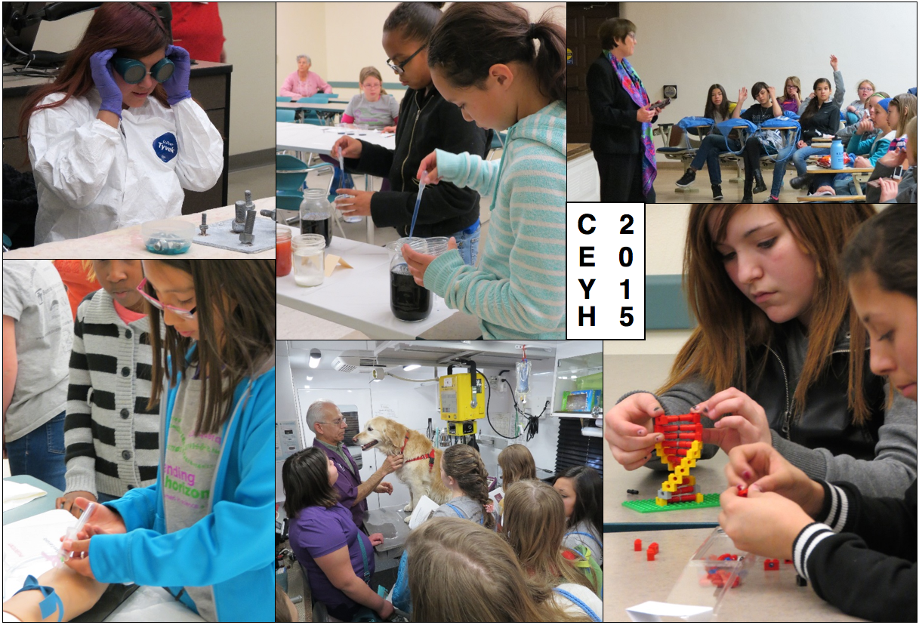
I loved the hands-on activity
I did two very fun workshops

 Additional 2015 EYH reports to be included in the fall newsletter and/or presented at AM 2015 
Copies of the full official conference reports may be obtained from the NMNWSE state EYH Chair.
See http://nmnwse.org/eyh/ for more information on NMNWSE EYH Conferences.

