NEW MEXICO NETWORK | August 2015
P.O. Box 51926 Albuquerque, NM 87181
For Women in Science & Engineering

FALL 2015 STATEWIDE EVENTS & IMPORTANT DATES
CONTENTS - FIX
Fall Events, Dates, p. 1
- AM 2015, register now!
- IMPACT! Award Call
(nomination form, p. 6)
- Call for Board Members
- Membership Reminder
Mentoring News
- Million Women Mentors, p. 2
- NM Girls Collaborative, p. 2
- STEMconnector®, p. 3
- Student Award Thanks, p. 3
Expanding Your Horizons
- 2015-16 NMNWSE EYH, p. 3
- Santa Fe-fall: Sep, 2015, p. 4
- Carlsbad: Oct 2, 2015, p. 4
- Spring Reports, p. 4-5
Chapter reports, p. 5
for more news, see
nmnwse.org
Contact us at:
NMNWSE_Board-L
@list.unm.edu
or
webmaster@nmnwse.org

* 23-25 October 2015, Annual Meeting & Technical Symposium (AM 2015), Truth or Consequences, NM
Please plan to join us at this year’s annual meeting: a weekend of networking and technical interchange where you will have a chance to present your work in a supportive atmosphere, interact with many incredible New Mexico women, and meet the 2015 IMPACT! Award winner (see call for nominations below).
This year's meeting will take place at the Sierra Grande Lodge and Spa in Truth or Consequences, NM, long famous for it’s hot springs and scenic setting. The nearby Spaceport America adds a futuristic twist to this historic town.
The meeting begins with a Friday evening reception. Saturday morning is the annual business meeting of the Network – all members are encouraged to attend. The Saturday afternoon technical sessions are an excellent opportunity to present your work in a supportive environment and learn what others in the Network do. Students presenting posters are eligible for a meeting scholarship to cover registration. Saturday ends with the conference dinner and presentation of the 2015 NMNWSE IMPACT! Award, followed by a talk highlighting area science. Members are invited to stay though Sunday for the first meeting of the 2015-16 state Board, elected at Saturday's Business Meeting.
The call for papers, registration form, and further meeting details are online at
http://nmnwse.org/AM/2015/. Note we must release our block hold on rooms at the Lodge on Sep 1, so if you plan to attend we encourage you to register and make your room reservations as soon as possible.

* October 5, nominations for board candidates due
Make time for giving back to the community by volunteering on the NMNWSE Board!! We are looking for a volunteer for both the President and the Vice President/President-elect for the October election, as well Members-at-Large and standing Chair positions. If you are interested in serving on the Board, please contact the Elections Chair via the Board email, NMNWSE_Board-L@list.unm.edu.

* September 14, IMPACT AWARD! Nominations due
Please take a moment to reflect about your and your colleagues accomplishments: who is the one person you know that has really gone the extra step to get women participating; to help the next generation get equipped with the right tools and skills to make a difference; to make an IMPACT! If you know someone who has truly made a difference in the lives of many, please nominate that person for the IMPACT! Award.
For nomination form and instructions, see http://nmnwse.org/ImpactAward/.
The NMNWSE Board welcomes suggestions for women to nominate


for awards and similar recognition from other organizations.
- email your suggestions to NMNWSE_Board-L@list.unm.edu -

* 2015-16 Memberships welcome now
The NMNWSE membership year begins Oct. 1. Current year Memberships are good through the Annual Meeting, allowing you to vote in the upcoming elections, but we encourage you to renew or join for 2015-16 now so you don’t forget. See http://nmnwse.org/Membership.php for membership forms and related information.

Mentoring News & Opportunities
Network News, p.2
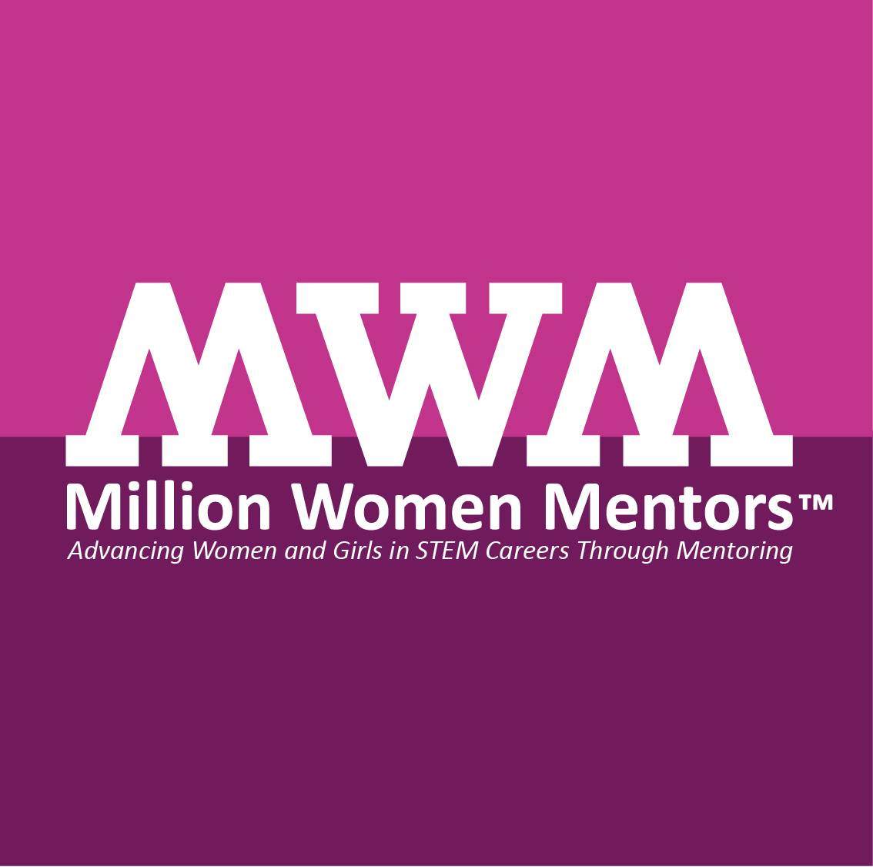
from Rebecca Galves, NMNWSE state EYH chair, rgalves@cs.nmsu.edu
 Million Women Mentors:
Reflections on Girls and Women in STEM
Million Women Mentors (MWM), http://millionwomenmentors.org/, is a nationwide movement to fully realize the critical role that mentors often play in the lives of young women. It aligns with NMNWSE’s goal to encourage women to enter into, and develop their careers in, science, engineering, and allied professions through an annual technical symposia, outreach, and local chapter activities. Our members serve as community leaders, competition judges, reflective advisors, and so much more. We also provide mentoring at many different levels through various ways.
As girls grow up, they are told they can be anything, work in any job, in any environment and achieve any goals they set for themselves. But as girls grow up and enter STEM classes they often feel pushed out by boys and pulled out by female friends and sometimes faculty comments. According to the US Department of Commerce, Economics and Statistics Administration, women make up 50% of the workforce, yet women only account for 24% of the STEM workforce and 50% of women drop out of STEM positions in the first 10 years. However, given that 71% of jobs in 2018 will require STEM skills and STEM jobs pay women better (we learned from the White House women in STEM make 92 cents for every dollar a man makes versus the average of 77 cents on a dollar), advancing girls and retaining women in STEM will be critical.
Working with MWM partner, My College Options, they shared that in 2014 15% of high school female seniors reported they were interested in pursuing a STEM career vs. 44% of boys. Over 70% of girls selected sciences and boys were eight times more likely to select technology and engineering as their area of interest. What was really surprising was that only 4% of the 368,000 girls who plan to pursue STEM said that they were encouraged by a mentor. We also know from the National Mentoring Partnership that only 1:3 college students graduate with a mentor; and therefore we see STEM mentoring as a huge opportunity for our nation.
Please consider adding your name to the list! Our young women in NM will benefit tremendously.
 New Mexico Girls Collaborative in C-STEM
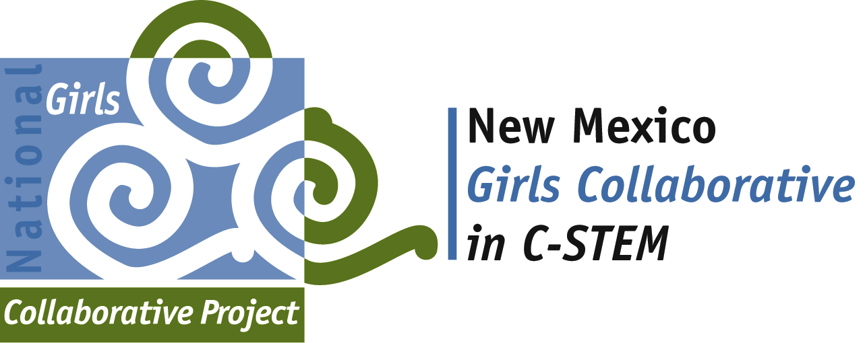
The NM Girls Collaborative (NMGC) is transitioning and in the process of supporting and integrating the new directives of the NGCP. We have so many fantastic STEM programs throughout our wonderful state, with an outstanding echelon of devoted professionals, parents, educators, community leaders, and more.
This Collaborative takes on many different roles, but the primary goals never waiver:
1. Maximize access to shared resources within projects and with both public and private organizations and institutions interested in expanding girls’ participation in STEM.
2. Strengthen capacity of existing and evolving projects by sharing research-based exemplary practices and program models, outcomes and products.
3. Use the leverage of a network or collaboration of individual girl-serving STEM programs to create the tipping point for gender equity in STEM.
We are here to help maximize the access to and share resources -- statewide! We are all working to strengthen the capacity projects by sharing exemplary practices! And we want to leverage the incredible work already happening through even greater collaboration!
Thank you ALL for the truly outstanding work you do to help move gender equity in STEM throughout NM. If you would like to share feedback on best practices for moving the NMGC forward, based on the new positioning and directions of the NGCP, please don't hesitate to share your thoughts. As this Collaborative is intended to create greater empowerment and statewide movements, versus being a stand alone, coordinating program, we are evaluating the best method/s for moving forward.
Many thanks for your time and THANK YOU SO very much for being a fantastic WOMAN in New Mexico!
Please contact Rebecca Galves, rgalves@cs.nmsu.edu, (575) 646-1901, for more information.

Mentoring News & Opportunities
cont’d
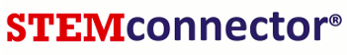
 Help young women find your program
by adding it to the STEMconnector!
Enter your event, girl-serving program and EYH Conference in STEMconnector at http://stemconnector.org/!
NETWORK News, p.3
WHAT IS STEMconnector? The National Girls Collaborative Project (NGCP) has transitioned and utilizing their many partnerships, have joined the NGCP Program Directory with this online resource.
STEMconnector®, a Diversified Search company, is a consortium of companies, nonprofit associations and professional societies, STEM-related research & policy organizations, government entities, universities and academic institutions concerned with STEM education and the future of human capital in the United States. STEMconnector® is both a resource and a service, designed to link "all things STEM" through a comprehensive website that connects national, state and local STEM entities. The STEMconnector® website, http://stemconnector.org/, contains profiles of more than 20 categories of STEM-related entities and details ‘Who is Doing What’ on over 6000 STEM-related organizations all 50 states.

 NMNWSE Student Award “Thank You”s
from 2014&15 New Mexico Science and Engineering Fair (NMSEF) NMNWSE Award winners.
“Thank you very much for your support of my science fair project. I am very grateful for the gift of the tote bag as well as the check. Both of these encouraged me to continue science fair. As well, the money will help me to further my projects. I sincerely appreciate your work in supporting women in science and engineering. It is hard to pursue a career in such a male-dominant field, but your work will help to stop that.” - Jennifer Paige, NMNWSE Award winner at NMSEF 2015
“Thank you so much for your generous cash and gift award as well as your continuous interest in Science Fair and its participants. Its wonderful to know there are organizations out there like yours encouraging and rewarding the female participants in our endeavors.” - Rene Smith, NMNWSE Award winner at NMSEF 2015
“It was a great honor for me to receive an award from NMNWSE in the Junior Division at the 2014 NMSEF. The Award means a lot to me. Thank you so much for your generous support and contributions to the NMSEF. These events would not be possible without your continued support and sponsorship.” - Lien Tang, NMNWSE Award winner at NMSEF 2014
NMNWSE Expanding Your Horizons (EYH) Conferences
The NM EYH Conferences are continuing their wonderful traditions of connecting hundreds of young women with hands-on workshops. Incredible professional women and volunteers bring passion and excitement to the world of science, technology, health, engineering, mathematics, and more! And NM women are leading the nation in their creativity and willingness to share their passion.
NM will offer six EYH Conferences again this year, placing us 5th in the nation as the highest number of conferences offered. The year is shaping up to host the following events:
- EYH Santa Fe-fall September 19, 2015
For details, see
nmnwse.org/eyh

- EYH Carlsbad October 2, 2015
- EYH Albuquerque Jan/Feb, 2016 (TBA) aka Central
- EYH Las Cruces Jan/Feb, 2016 (TBA)
- EYH Silver City Feb/Mar, 2016 (TBA)
- EYH Santa Fe-spring March, 2016 (TBA) aka Los Alamos, Northern
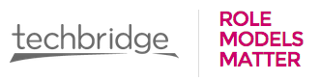
Conference coordinators are continually looking to add new workshops and include even more fantastic volunteers. If you would like to build a workshop and teach young women about your work, a great place to start is on the Techbridge site: http://techbridgegirls.org/rolemodelsmatter/toolkit/. The national EYH Network (EYHN) has partnered with this outstanding group who recognize that, “Role Models Matter.” The site contains videos and tutorials on everything from, “Sharing About You” to “Choosing a STEM Activity” to “Giving Girls Feedback.”
Even as an experienced workshop leader, the Techbridge Toolkit will teach you new ways to connect with and engage the young women who join us! It’s an excellent resource for strengthening your personal style and approach, as well as your fellow volunteers. Consider it an online mentoring source!
To contact a conference coordinator and volunteer, visit http://www.nmnwse.org/eyh/ and contact one of our truly wonderful leaders today!
– Rebecca Galves, NMNWSE state EYH chair, rgalves@cs.nmsu.edu
or via the NMNWSE board at NMNWSE_board-L@list.unm.edu

Network News, p.4
Upcoming EYH
— Santa Fe-fall EYH, September 19, 2015
The girls’ 2014 conference evaluations described EYH as:
Inspiring, awesome, fun, wonderful, and intriguing
The Santa Fe-fall planning committee is actively seeking presenters and other volunteers to help with the SF-fall EYH on Saturday, September 19, 2015, at Santa Fe Community College (SFCC). We are planning for 150 to 170 girls (grades 5-8) to come explore careers in Science, Technology, Engineering, Math and Computing (STEM-C). The girls will attend two workshops, hear a dynamic speaker, and see a STEM fair. Adult volunteers (and parents) may attend a two hour workshop led by Victoria Runhorse and Duane Dillon from Explora. A description of available volunteer positions and sign up form is at http://www.signupgenius.com/go/10c0d49afa829a3fc1-eyh20151. If you are interested in volunteering or attending, you may also contact Lina Germann at 505-310-4122, lsgermann@gmail.com.
The Santa Fe-fall EYH Conference is presented by NMNWSE and AAUW Santa Fe, and hosted by SFCC.
— Carlsbad EYH, October 2, 2015
“Be the change you want to see in the world.” - Ghandi
Our second EYH in Carlsbad will be held on Friday, October 2nd at NMSU-Carlsbad with girls bussed in from the middle school. We're excited to apply the lessons learned from our first EYH in 2014, and take advantage of all the contacts made. Despite small attendance in 2014 (mostly due to problems getting the word out about this new EYH), the girls had a great time and learned a lot, and there was a lot of enthusiasm by the volunteers for continuing this fantastic project. We hope the new model of holding it on a school day and bussing in students will work better for our girls and our professionals. Please contact Lisa Chappa, Stem4Lisa@gmail.com, if you’d like help plan or otherwise to be part of this fall’s Carlsbad EYH.
See also the writeup on the 2014 Carlsbad EYH in the Carlsbad Current-Argus at
http://www.currentargus.com/carlsbad-news/ci_26894488/conference-gives-girls-peek-at-stem-careers
(with the caveat there are a few misquotes, etc).

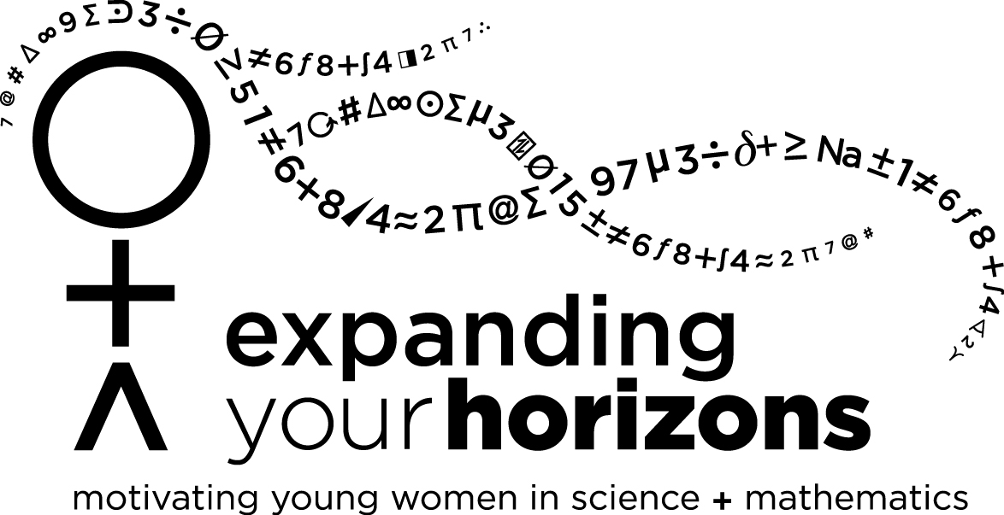
Spring 2015 NMNWSE EYH Reports
Las Cruces EYH January 31, 2015
(see spring 2015 newsletter for photos)
The 4th Annual Las Cruces EYH was held on Saturday, January 31, 2015, in the Science Hall on the campus of New Mexico State University. It was a great success! The Conference showed a 30% increase in attendance over the previous year, offered 13 workshops, of which 10 were held on Conference day, and offered two workshops for parents and teachers. The EYH Conference brought together 26 presenters plus 10 additional ‘day of’ volunteers, with the capability of reaching several hundred girls.
Registration for the Conference occurred online, prior to the event, as well as the day of the conference. The online system was open and live for just over 4 weeks, beginning on Friday, January 2, 2015. Each registrant attended 2 workshops, based on their top 3 workshop preferences, in order to facilitate the workshop schedule and registration. 102 students and 3 adults attended this year’s EYH (compared to 108 pre-registered, with 5 on-side registrations), representing 36 schools from 5 counties. Students were mostly in grades 5-8 (about 20% each grade), although grades 9-12 were represented (about 10% in each of 9,10 and 2% in each of grades 11,12). Minority participation was high: almost 35% of the students self-identified as Hispanic, with another 14% percent self-identifying from other minorities (4% Asian, 6% African American, and 4% Native American), with 13% of the students receiving a scholarship to waive the registration fee.
The 13 workshops available at the conference were “Algae BioFuels”, “Bacteria and Squid – It Takes 2 to Tango”, “Create an Online Game in SNAP!”, “Curious about Internal Anatomy?”, “DNA Discovery”, “Drawing in 3D with a 3Doodler”, “Electricians Power Up”, “Fill it Up – Alternative Energy & Fuels for Moving Vehicles”, “Java & HTML Awesomeness!”, “Legos and Engineering”, “Linux Bash”, “Slime!”, and “Sustainable and Engineering”. On average, the students rated their overall experience 3.54/4, the sessions 3.6/4, and the presenters: 3.4/4.
Submitted by Rebecca Galves, NMSU/YWiC, rgalves@cs.nmsu.edu

Spring 2015 NMNWSE EYH Reports, cont’d
Santa Fe-spring EYH
NETWORK News, p.5
March 6, 2015 (see spring 2015 newsletter for summary)
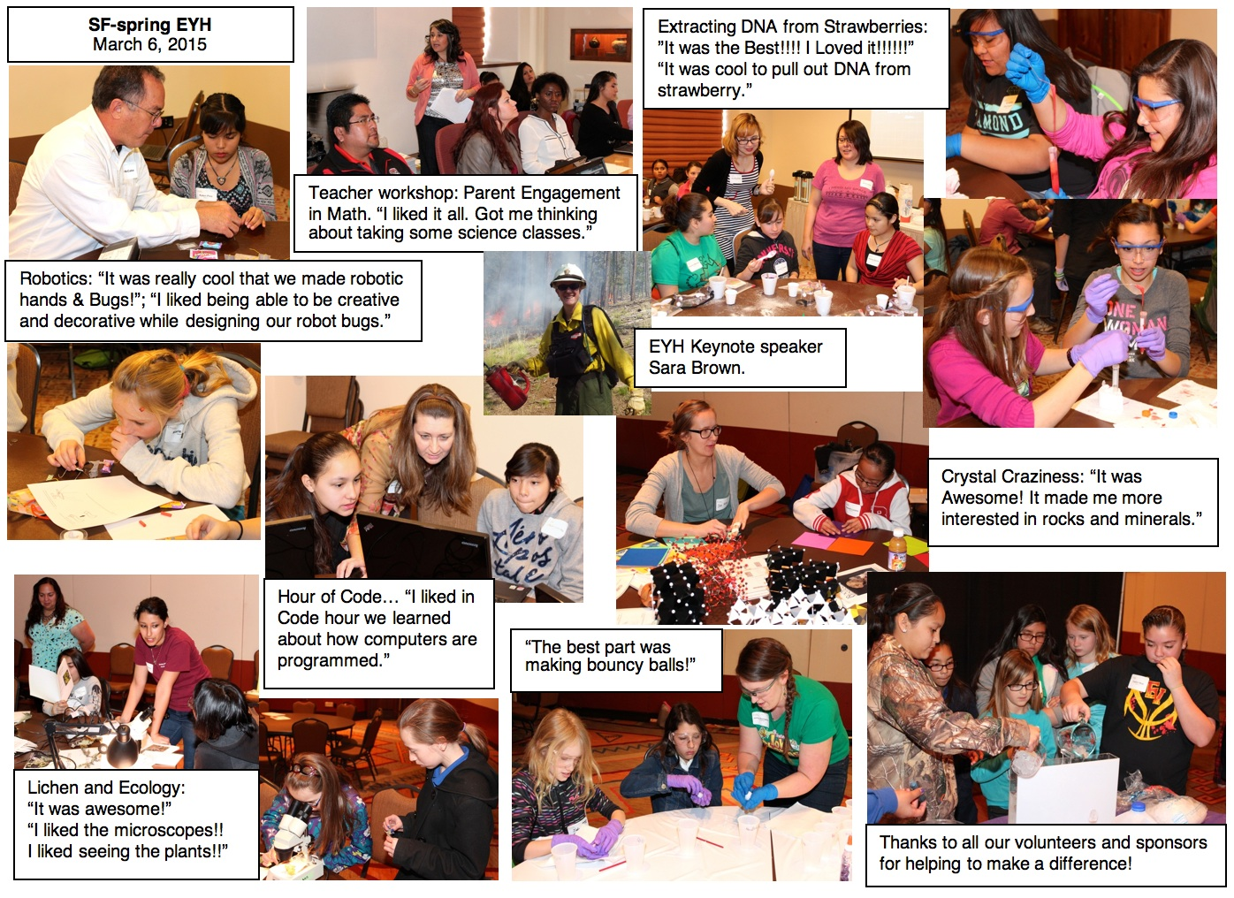

 Additional 2015 EYH reports were included in the spring newsletter and/or will be presented at AM 2015 
Copies of the full official conference reports may be obtained from the NMNWSE state EYH Chair.
See http://nmnwse.org/eyh/ for more information on NMNWSE EYH Conferences.
Chapter Reports
Central Chapter is currently the only active Chapter – contact the Board if you would like help revitalizing your chapter. Contact the NMNWSE webmaster if you would like to be on the appropriate mailing list for local chapter meeting announcements
Central Chapter
The Central Chapter plans to hold monthly meetings through the fall on the 3rd Tuesday odd months, from 6-7:30pm, at the Flying Star Restaurant- Downtown in Albuquerque. See http://nmnwse.org/central for more information. At the September meeting (Tue, Sep 15), Kelly Collins will speak on "Putting out the Fire: Closing the Socorro Tire Fire Site".
At the July 22 meeting, Cheri Burch spoke about the 2015 Tech Trek, held Jul 12-18 in Las Vegas, NM. This AAUW program is gaining momentum with 8th grade girls in NM, and Cheri's presentation showed it is a great opportunity for the girls, as well as a fun time for both the girls and the presenters. They are looking for 2016 volunteers already, so if you'd like to be involved click on the 'volunteer' link on the Tech Trek webpage, http://techtrek-nm.aauw.net/.

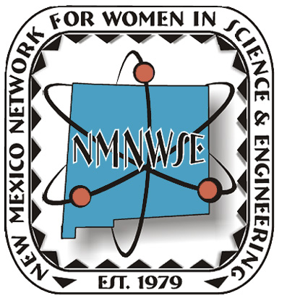 | IMPACT!  The NM Network for Women in  Science and Engineering Award  2015 Nomination Form |   NM Commission on the Status of Women  Information and Instructions  Eligible candidates must be:  - over 21 years of age and  - currently living in New Mexico  Previous award recipients are ineligible for consideration. NMNWSE Board members, Commission staff and Commissioners are only eligible after six months from their final date of service. Please email the IMPACT! Chair or call the NMNWSE Communications Chair to verify Award recipients.  Submission Requirements  Please submit the following information:  - One complete packet of information to include nomination form, summary and supportive materials.  - 500-word summary that summarizes the nominee’s specific achievements, the impact of her contributions to the goals of the Network and a brief statement on why she deserves the Award.  - Supporting materials: These materials should justify consideration of the nominee and should include three or more letters of recommendation. Supporting materials should emphasize the candidate's peer mentoring (outreach within the career / job arena), community involvement (outreach outside of career/job arena), and outreach to minorities. They may also include biographical data emphasizing leadership or community roles with quantifiable results that support the goals of the Network, commitments, mentorship, volunteer and compensated advocacy work, and other supporting materials such as newspaper or magazine articles. Please limit supporting materials to six (6) pages.  - All documents should be produced on 8.5” x 11” paper, using 12 point font. Larger documents should be reduced.  - All documents should be saved as a word document or a pdf using the applicant’s last name and first initial: LastName_FirstInitial.  - Provide one photograph (3” x 4” or 4” x 6”, color or black and white, preferable electronically) for use in publicity  - Submit a $10 nomination fee payable to NMNWSE. PO Box 1360, Los Alamos, NM 87544. Please request a receipt for your records.  NOTE:  - Letters of recommendation can come from mentors, employers, teachers, leaders, and/or friends. Three letters are strongly recommended but not required.  - Nomination packets containing MORE than six (6) pages of supporting documents may be edited by the Network.  2015 NOMINATION DEADLINE: Monday, September 14, 2015
E-mail your nomination packet to the IMPACT! Chairs:  Phyllis Baca, phyllis.baca@sfcc.edu, 505-490-1557  Tinka Gammel, webmaster@nmnwse.org, 505-690-1318  or mail a hardcopy to:  IMPACT! Chair c/o NMNWSE, PO box 51926, Albuquerque, NM 87181  Questions?  Contact the IMPACT! Chairs or the NMNWSE Board at  NMNWSE_Board-L@list.unm.edu | The New Mexico Network for Women in Science and Engineering began in 1975 with a core group of faculty and staff from UNM wanting to reach out to women in science as a group. Incorporated in 1979, the Network works to encourage and help women enter and succeed in Science, Technology, Engineering and Math (STEM) careers and promote networking and communication among members by providing regularly scheduled meetings, talks and other local activities. About 1000 teens each year attend our technical career workshops. Our Annual Meeting and Technical Symposium provides members an opportunity to present technical papers in a supportive environment as well as professional development and networking opportunities. | In 1974, the NM Commission on the Status of Women was created by state statute to increase the knowledge of the rights, responsibilities and interests of women and girls in New Mexico and to preserve women’s history and contributions to our state. The office is charged with conducting statewide studies on the status of women, acting as a clearinghouse and referral service on issues impacting women, recommending methods to overcome discrimination against women, promoting methods for women to develop their skills and continue their education, hosting periodic statewide conferences for women, collaborating with other entities working with women and securing recognition for women’s accomplishments and contributions to New Mexico. The commission was terminated in 2011 by Governor Martinez.
The New Mexico Network for Women in Science and Engineering, in cooperation with the NM Commission on the Status of Women, initiated in 2007 the NMNWSE IMPACT! Award to recognize the contributions of women in New Mexico. This fall, the 9th Annual IMPACT! Award will be presented to a New Mexico woman for her extraordinary efforts in furthering the goals of the Network. These goals include encouraging and helping women enter and succeed in Science, Technology, Engineering and Math (STEM) and related nontraditional careers and promoting networking and communication among women in these careers. The honoree will be recognized during the NMNWSE Annual Meeting and Technical Symposium, which will be held 23-25 October, 2015 in Truth or Consequences, NM.
NOMINEE: _______________________________________________________________________________________
ADDRESS: _________________________________________________________________________________________
CITY: ___________________________________________________________ ZIP: ______________________________
PHONE: ______________________________________ EMAIL: ________________________________________________
NOMINATOR: ____________________________________________________________________________________
AFFILIATION WITH NOMINEE: _____________________________________________________________________________
ADDRESS: _________________________________________________________________________________________
CITY: ___________________________________________________________ ZIP: ______________________________
PHONE: ______________________________________ EMAIL: ________________________________________________

