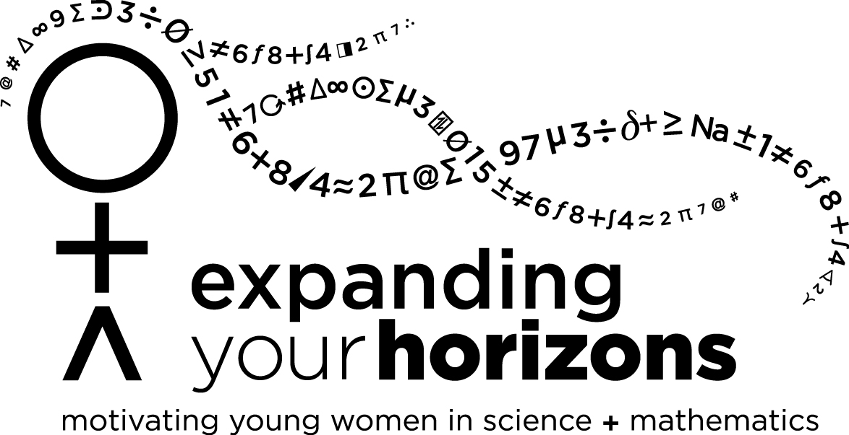
2012 Albuquerque, NM
Expanding Your Horizons (CEYH 2012)
University of New Mexico (UNM), main Campus Saturday, January 28, 2012

Draft Student Schedule

8:30-9 |  | Registration
9-9:30 |  | Opening/Panel
9:45-10:35 |  | Workshop 1
10:45-11:35 |  | Workshop 2
11:45-12 |  | Closing ceremonies  – quick evaluation and door prizes

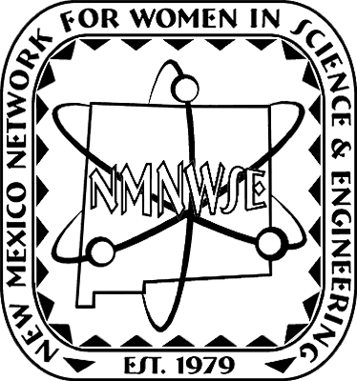
CEYH 2012 is licensed by the New Mexico Network for Women in Science & Engineering (NMNWSE), http://nmnwse.org/, from the Expanding Your Horizons Network, http://expandingyourhorizons.org/.
Registration forms and information for attendees may be found at http://www.expandingyourhorizons.org/conferences/Albuquerque/.
Further information on CEYH 2012 and how you can get involved may be found at http://nmnwse.org/ceyh/. For all NMNWSE EYH conferences see http://nmnwse.org/eyh/eyh_confs.php.

