

2013 Albuquerque, NM
Expanding Your Horizons (CEYH 2013)
University of New Mexico (UNM), main Campus Saturday, January 26, 2013

Draft Student Schedule

8:30-9 |  | Registration  - in Atrium of Dane Smith Hall
9-9:30 |  | Opening/Panel
9:45-10:35 |  | Workshop 1
10:45-11:35 |  | Workshop 2
11:45-12 |  | Closing ceremonies  – quick evaluation and door prizes

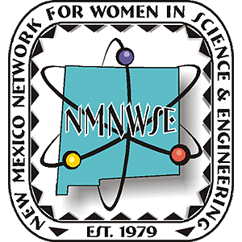
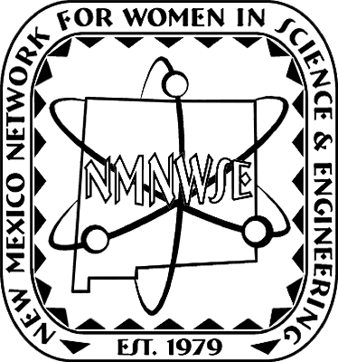
CEYH 2013 is licensed by the New Mexico Network for Women in Science & Engineering (NMNWSE), http://nmnwse.org/, from the Expanding Your Horizons Network, http://expandingyourhorizons.org/.
Registration forms and information for attendees may be found at http://www.expandingyourhorizons.org/conferences/Albuquerque/.
Further information on CEYH 2013 and how you can get involved may be found at http://nmnwse.org/ceyh/. For all NMNWSE EYH conferences see http://nmnwse.org/eyh/.

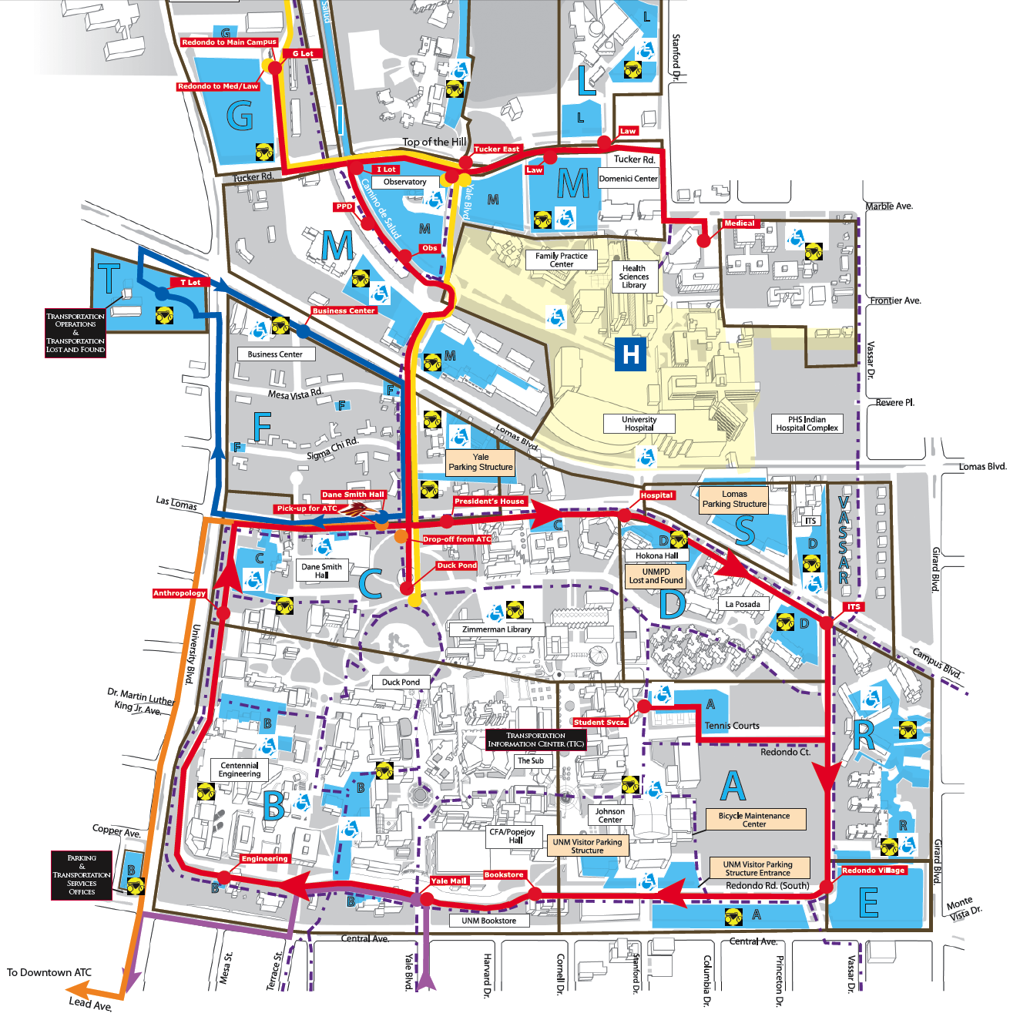
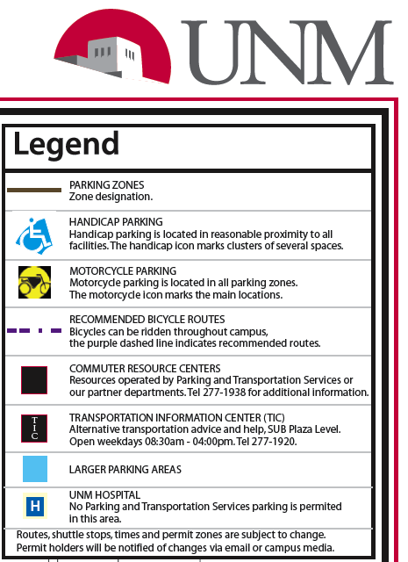
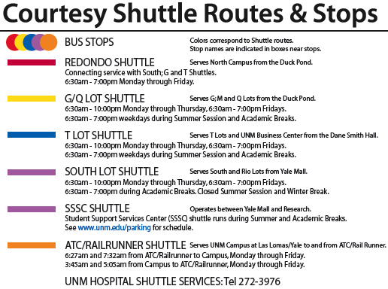
Park in E lot
& take
shuttle to EYH
Sign in at Dane Smith
Hall Atrium
shuttle runs 7am-1pm
EYH Shuttle stops at Yale roundabout

