 |   motivating young women in science + mathematics | 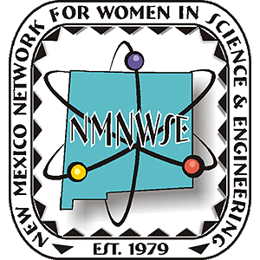
2010 Albuquerque Conference nmnwse.org/ceyh
8am - 1pm April 3, 2010 Grades 6-12 Central New Mexico Community College
main page

motivating young women in science + mathematics
nmnwse.org/ceyh
main page |  | 2010 Albuquerque EYH Conference  8am - 1pm Saturday, April 3, 2010 Grades 6-12  Central New Mexico Community College
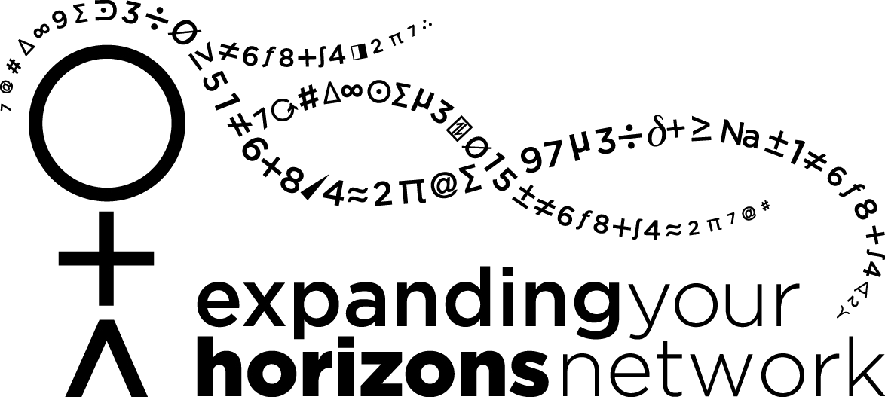

licensed by NMNWSE from the EYH Network
presented by NMNWSE Central Chapter, co-hosted by…
2010 Sponsors etc….

