



expanding your horizons
2010 Albuquerque EYH Conference
Saturday, April 3

8 am - 1 pm

Central New Mexico Community College

Technical career workshops for young women grades 6-12

Motivating young women in science and mathematics

Fu n f o r s t u d e n t s a n d a d u l t s!

For Students

Here is your chance to meet with woman professionals from the community
who have found satisfying careers in law, mathematics, engineering, computing, medicine, and other non-traditional technical careers.

Middle and high school girls attend three workshops, each led by a professional who shares an aspect of their technical field through a hands-on activity. Workshops typically have 10 to 15 students, facilitating interaction between the presenter and students.

For educators and counselors

Here is your chance to attend the Santa Fe Community College course STEM 115, STEM-focused Team-based Design: Team-based activities to engage under-represented females and minorities into STEM-based careers. Attendees may receive1 CEC credit-hour (with 6-8 hours of remaining course available online).

For Other Adults

Here is your chance to find out more about such topics as academic college preparation, paying for college, and keeping girls interested in science and math.
These workshops are designed for parents and educators. Adult participation is optional, but adults must register to attend workshops. Adults are not permitted to attend student workshops.


SCHEDULE

For Students & Adults

7:00 - 8:00am Adult & Student Registration
Smith Brasher Hall, CNM Main Campus

8:00 - 8:45am Opening Session

9:00 - 9:50am Workshop 1

10:05 - 10:20am Refreshment Break

10:20 - 11:10am Workshop 2

11:25 - 12:15pm Workshop 3

12:30 - 1:00pm Closing Session
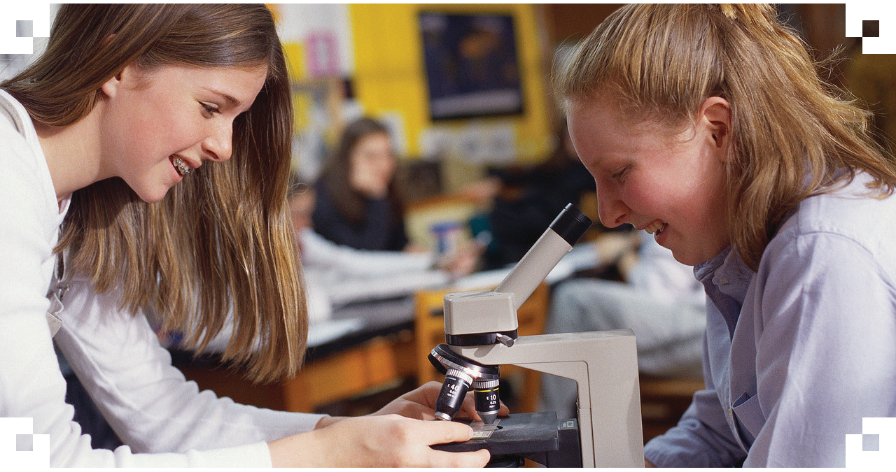

For general information and registration visit: http://nmnwse.org/ceyh

or contact Diane Albert at 505-235-2277 or dalbert@cybermesa.com

