
2013 Albuquerque, NM
Expanding Your Horizons (CEYH 2013)
University of New Mexico (UNM), main Campus Saturday, January 26, 2013
Student Permission Slip
The following information must be filled out by a parent/guardian and brought with the student to CEYH 2013. A signed permission slip is required to attend.
Child’s Name:

Parent/Guardian name:

Parent/Guardian email: (leave blank if none)

Parent/Guardian phone with area code:

Emergency Contact Name:

Emergency Contact Phone Number:

Liability Release:
Participants shall remain liable and hold CEYH 2013 and UNM harmless for any liability arising from their participation in CEYH 2013 on January 26th, 2013 at UNM, except injury or damages that may occur because of the sole negligence, or willful and wanton misconduct of the University, University’s officers, agents or employees.

Photo Permission:
I give my permission to use photos or videos that includes my child for the purpose of publicizing and promoting future Expanding Your Horizons conferences. I understand that the images and recordings may be published in local newspapers, the Internet, or used in other marketing material promoting NMNWSE EYH conferences. Names and other private information such as addresses, phone numbers, email or schools will NOT be published.

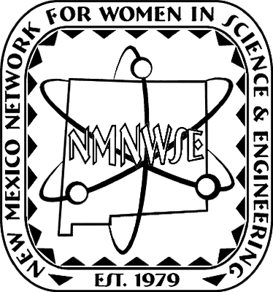
________________________________ ___________
Signature of parent/guardian Date
CEYH 2013 is licensed by the New Mexico Network for Women in Science & Engineering (NMNWSE), http://nmnwse.org/, from the Expanding Your Horizons Network, http://expandingyourhorizons.org/.
Registration forms and information for attendees may be found at http://www.expandingyourhorizons.org/conferences/Albuquerque/.
Further information on CEYH 2013 and how you can get involved may be found at http://nmnwse.org/ceyh/. For all NMNWSE EYH conferences see http://nmnwse.org/eyh/eyh_confs.php.

