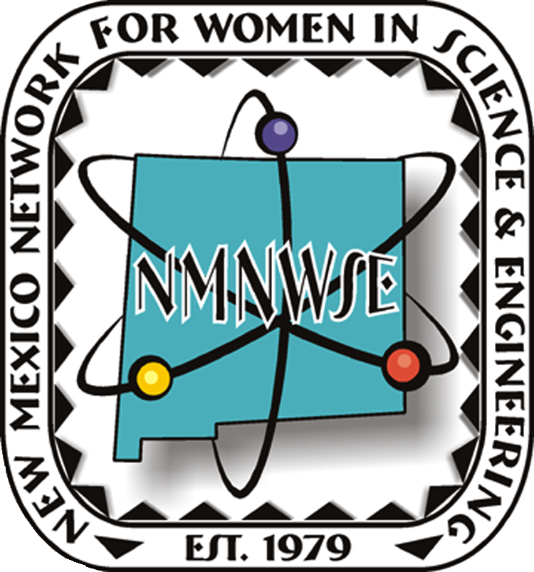
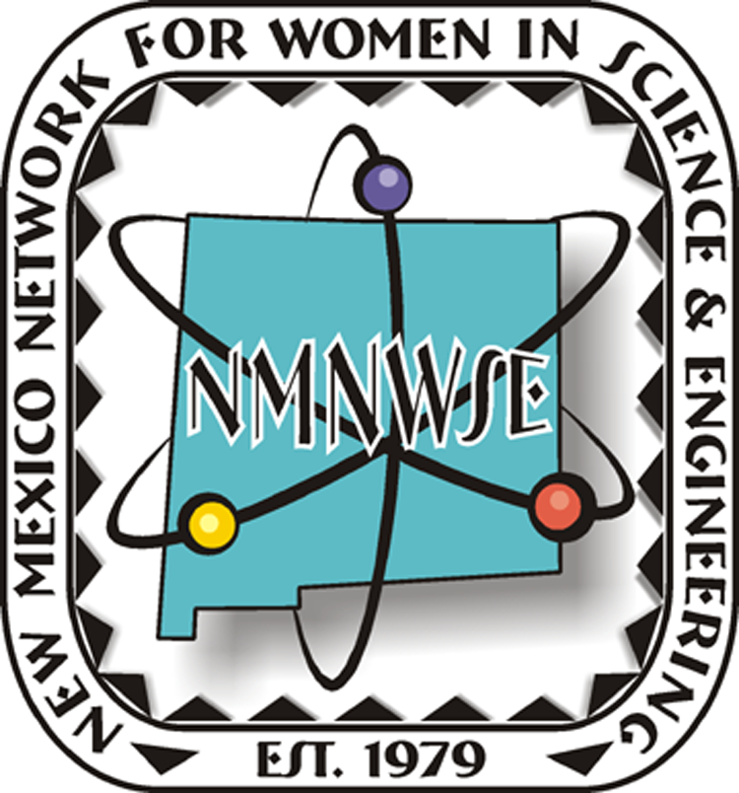

Lise Meitner
Rita Levi-Montalcini

— Shown are Nobel Prize Women in Science —
Name
Workshop Title
or
Voluteer Position
_______________________
authorized signature
http://nmnwse.org/ceyh
2010 Albuquerque EYH
8am - 1pm April 3, 2010, Grades 6-12, Central New Mexico Community College
New Mexico Network for Women in Science & Engineering
Central Chapter

April, 2010

motivating young women in science + mathematics

