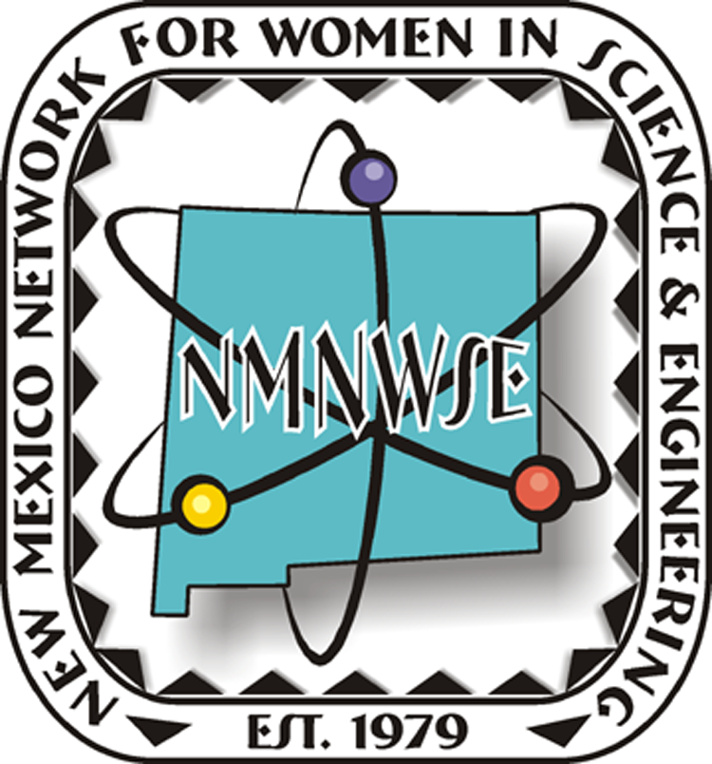
NMNWSE Special Award winners at the
New Mexico Science and Engineering Fair
held April 1-2, 2011 at NM Tech in Socorro, NM

Received $50 check, certificate and tote bag:
Junior categories:
- Lilly Chiou, Chemistry “How does pH and Temperature Affect Enzyme Activity in Fruits?”
- Carrie Hicks, Energy & Transportation “Does Winglet Size Impact Flight Distance”
- Gabrielle Lynch, Engineering “Which Truss Holds the Most Weight”
- Grace Wood, Environmental Sciences “Eroding Roads – Phase II”
Senior categories:
- Holly Erickson, Chemistry “Controllable Chemistry: Dielectric Barrier Discharge Conversion of Pollution Gases”
- Majdolene Khweis, Earth & Planetary Science “Don’t Let It Slide V: The Final Frontier”
- Mary Spanjers, Engineering “Thermal Design Optimization of New Patio Blocks to Provide Passive Heating”
- Raquel Redshirt, Environmental Sciences “Improving the Heat Capacity of Homemade Solar Ovens”
- Taylor Roach, Medicine & Health Sciences “Determining Optimum Methods for Tooth Refurbishment”
- Alexandria Hehlen, Physics & Astronomy “Running into Chaos”

Received certificate and tote bag:
Junior categories:
- Elise Anne Koskelo, Behavioral & Social Sciences “Signal vs. Background Noise”
- Sara Manshad, Computer Science “Multimodal Graphs for the Visually Handicapped”
- Ashley Cruz, Earth & Planetary Science: “Solar Cooking”
- Chloe Keilers, Physics & Astronomy "“Drag Project”
Senior categories:
- Serene Akkad, Microbiology “Exploring the Antibacterial Effects of Colloidal Silver”

Judges for the 2011 NMNWSE Special Awards were Yolanda King, Elizabeth Kallman, Laurie Marnell, Nan Founds, Nancy Jo Nicholas, Charlotte Coleman, and Susan Elliott.

Congratulations to all NMNWSE student award winners, and their teachers and mentors!

