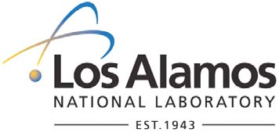
To/MS: Expanding Your Horizons Participants and Volunteers From/MS: Kimberly W. Thomas, M714 Phone/Fax: 7-7978/5-4092 Symbol: STBPO-07-059 Date: November 6, 2007

memorandum
Science & Technology Base Program Office
I am pleased, once again, to sponsor the Expanding Your Horizons Technical Career Workshop on April 2, 2008. LANL and LAWIS have co‐sponsored 28 of these technical workshops for 8th, 9th, and 10th grade girls from Northern New Mexico. The continued student participation in this workshop speaks to its value. In addition to ʺhands‐onʺ student workshops conducted by Laboratory and community women scientists, there will be a special session for adult sponsors.
Many young women have cited this workshop as instrumental in their decision to pursue studies in science. In years past, LAWIS has received endorsements from previous participants who credit EYH with sparking their interest in science, technology, engineering, and/or mathematics careers.
The workshop benefits the young women of Northern New Mexico, their teachers, our community, and the Laboratory. The workshop goals are:
- To provide young women with opportunities to meet and interact with positive women role models who are active in math, engineering, and science related careers;
- To involve young women with positive experiences in mathematics and science;
- To increase the interest of young women in math and science by providing exciting and fun hands‐on learning experiences;
- To encourage young women to study as much math and science as possible by showing them the benefits of education and its relevance to their lives;
- To foster awareness of career opportunities in science and math related careers.
As Eleanor Roosevelt said, ʺExample is the best lesson there is.ʺ I hope our participants and our volunteers alike have a stimulating and lasting experience at EYH 2008!
Kimberly Thomas STB Program Director
An Equal Opportunity Employer / Operated by Los Alamos National Security, LLC for the National Nuclear Security Administration of the U.S. Department of Energy

