Pathway to a Hydrogen Economy: What Pathway to Follow?
(And an expanded US MARKAL framework)

Lorna A. Greening
Los Alamos, NM

Hydrogen has been proposed as a solution to declining domestic resources of fossil fuels, and environmental problems such as climate change and air quality. However, as well explored by other analyses, technical and economic barriers exist to the wide-spread adoption of hydrogen as an energy carrier in the US. For those involved in developing policy in this area or developing an R&D program to address barriers to hydrogen penetration, the following questions need to be answered:

- Can the US transition to a hydrogen economy?
- At what cost and when?
- What trajectory must world oil prices follow in order to promote hydrogen penetration?
- Will we indeed have a more secure energy supply with lower emissions?
- What pathway out of all of those available should we follow?

During this presentation, we will focus on these questions and other fundamental questions for the development of the ‘hydrogen economy.’ We will examine the trade-offs between costs, environmental emissions, and security considerations for over forty (40) different hydrogen production/distribution/end-use pathways. Evaluation of several of these pathways requires the analysis of feed-back loops such as a complete nuclear fuel cycle (with spent nuclear fuel disposal options) and carbon sequestration. Some potential hydrogen production options offer net reductions in greenhouse gas emissions (e.g., CO₂, methane) and are more energy efficient; however, other options result in increased emissions and increased consumption of fossil fuels. Similarly, some options increase domestic energy security while others increase US vulnerabilities to disruptions of supply.

Using a commonly implemented energy system model of the US to facilitate this analysis, we will identify pathways for the potential development of the ‘hydrogen economy’ which simultaneously minimize costs, provide the greatest reductions in emissions, and increase our energy security through decreased dependence on foreign imports of hydrocarbons. Potential hydrogen production options include:
- Central production with distribution by pipeline, cryogenic tanker truck, or gas tube trailer to dispensing stations from
  - Gasification of biomass, petroleum coke, coal, and petroleum residue
  - Electrolysis
  - Steam methane reforming
  - Nuclear
    - HTGR-GT to electrolysis and plasma arc
    - HTGR-Process Heat to steam methane reforming
    - Sulfur-iodine
    - Modified HTGR-GT to steam methane reforming
    - Modified steam cycle HTGR to steam methane reforming, and
    - Steam electrolysis
  - Photo-biologic (e.g., algae)

- Forecourt (or de-centralized) production from
  - Steam reforming of natural gas, methanol, and gasoline
  - Electrolysis using grid-sourced electricity, and wind-specific or solar-specific sources.
  - Photo-biologic (e.g., algae)

Fuel cells in applications such as transportation and industrial, commercial and residential stationary uses complete the framework required for the analysis of the potential penetration of hydrogen into the US energy system. Embedding such detailed depictions in an energy system model allows the evaluation of the life-cycle costs and emissions of hydrogen in comparison to other alternatives. For example, in transportation, hydrogen fuel cells compete against conventional diesel, gasoline internal combustion engines, hybrids and advanced hybrids, and alternative fuels such as electricity, flex alcohol, bio-fuels and CNG.

Using this framework, a number of hypotheses can be tested concerning the conditions leading to a ‘hydrogen economy’. More optimistic assumptions for improvements in cost and hydrogen availability result in earlier commercial viability and market penetration. Coordination of environmental and energy policies in this area promote earlier introduction, while continued relatively low prices for various fossil fuels such as natural gas and gasoline, impede the market penetration of hydrogen. Some of the interesting initial conclusions from this framework include:
- At least initially, the paradigm for the fuel supply chain of central production/transportation/local distribution is probably not going to be part of the ‘pathway’. Distributed generation of hydrogen is less costly than central generation coupled with transmission and distribution. The cost difference, even with the economies of scale of central production, can be explained by fuel losses along the supply chain and the costs of the transmission segment.
- Small and/or local hydrogen production sources will probably initiate the hydrogen economy, i.e., forecourt generation with locally indigenous sources such as renewables (wind, solar, biomass, biochemical or waste), or by-product production in conjunction with electricity generation (either central generation or CHP/DG) will very likely ‘leap-frog’ other centralized production methods.
- Net reductions in emissions from a ‘hydrogen economy’ may not be as great as expected. Perceived net reductions are highly dependent upon the type of hydrogen production technology used, the type of feedstock, and the methods of accounting for emissions both initially and then after a production technology’s implementation. True reductions of emissions, particularly CO₂, are only going to be possible when hydrogen is produced with either renewable or ‘advanced nuclear’ technologies.
- Given that the EIA is already forecasting that the US will be importing over 20% of its natural gas supplies as LNG in 2025, increased consumption of natural gas for hydrogen through natural gas reformation won’t increase energy security. However, renewable and ‘advanced nuclear’ technologies do also offer the greatest energy security benefits of any of the potential options. Initial results from our modeling framework indicate that energy security benefits are a greater driver than environmental benefits.
- Given that hydrogen will be competing in the market-place with a very well established energy source (i.e., gasoline) with an entrenched production/distribution system, hydrogen-fuel cell vehicles will need to provide similar if not greater levels of service. Other alternative fuels, such as bio-diesel, are already competitive with gasoline and are closer substitutes. These substitutes provide an additional barrier to market penetration of hydrogen.
- With this view, assuming that the costs of hydrogen-fueled vehicles fall to current cost levels of hybrid vehicles, we might expect to start to see the development of a hydrogen segment in the transportation market as early as 2010 as an energy carrier in fleet applications. Expanded transportation applications to the personal vehicle segment might occur in the time-frame of 2020 to 2030 if other goals are included in the decision to adopt besides cost.
- Stationary uses of hydrogen probably won’t convert to centrally produced hydrogen (i.e., transported by pipeline and distributed) until well into the latter part of the century, if then.

Biographical sketch: Lorna A. Greening

Dr. Greening has over 25 years experience in the energy industry, including experience in consulting, research, academia, the public utility industry, and the petroleum industry (exploration geologist who found oil and gas). She is an energy and natural resource economist with expertise on domestic and international energy supply and demand, air and water quality, and regulation. Her experience includes projects for the US DOE, US EPA, EIA, USAID, the World Bank, the Asian Development Bank, several national laboratories, and private clients. From this work, she has published in various journals including Energy Economics, Journal of Regulatory Economics, Energy Policy, Applied Economics, Energy—The International Journal, Environmental Modeling and Assessment, Energy Sources, and Journal of Energy Resources Technology. In addition to archival journals, she has contributed to such publications as the Second Assessment of the International Panel on Climate Change. She is a member of the editorial board, and Associate Editor for Energy Economic. Currently, her research is focusing on energy system modeling of US energy policy and the role of new technologies or alternative forms of energy in reducing the consumption of fossil fuels. Part of this work involves real option valuation of Federal energy R&D.

Dr. Greening received her PhD from Colorado School of Mines in Mineral Economics with a minor in operations research (specialty in mathematical programming); and, she received a BS in geology (with a minor in mathematics/computer science) from the University of Michigan. She attended Oregon State University in Corvallis, Oregon where she received post-graduate training in oceanography, meteorology, mathematics, and computer science. While at CSM, she was concurrently enrolled in the MBA (corporate finance) program at University of Colorado, Denver. She now makes her home in Los Alamos, New Mexico.

Salient Features of the Expanded US MARKAL framework:

The modeling framework used in the analysis of hydrogen is a version of US MARKAL that has been undergoing development in Los Alamos, New Mexico. Other versions in the US include ones developed by Brookhaven National Laboratory (for EERE/USDOE), US EPA, and the EIA (in the form of SAGE). However, the version in Los Alamos is the most detailed of all of the US MARKAL models. Besides in the US, MARKAL is implemented in over 50 countries around the world (for a description of global activities check www.etsap.org).
MARKAL (MARKet Allocation model) is a technology-oriented energy system model, which utilizes a dynamic linear programming framework where all energy supplies and demands for energy services are depicted. For the hydrogen work, a goal programming formulation, a multi-criteria decision making support tool was utilized. Technologies within the modeling framework are described by initial investment and operating and maintenance (fixed and variable) costs, capacity utilization for demand technologies and availability for process and conversion (i.e., electrical generation technologies), and the efficiency (or heat rate in the case of electricity generation) of fuel use. As is typical of energy system models, energy flows are conserved, all demands are satisfied, previous investments in technologies are preserved, peak-load electricity requirements are honored, and capacity limits are observed along with similar traits of an energy system. Technologies are selected for inclusion in the solution based on comparison of life-cycle costs of alternative investments. In the standard variant, MARKAL minimizes energy system (capital, operating, and fuel) costs over the entire planning horizon. In addition, MARKAL provides an accounting mechanism for emissions by either the application of emissions coefficients on fuel consumption and/or on per unit output of a conversion, processing, or demand technology.

In addition to the expanded depiction of hydrogen, this version of US MARKAL (henceforth referred to as LA US-MARKAL) includes a number of features that assist in the analysis of a broad spectrum of energy-related issues. A tabular comparison of LA US-MARKAL with NEMS is available upon request. Some of the features of LA US-MARKAL include:

- Technology choice set of over 4500 technologies representing energy conversion (electricity generation), energy and materials processing, and energy service demand (e.g., heat pumps, refrigerators). Characterizations for the majority of these technologies have been taken from publicly available sources and are documented.
- Resource set including not only conventional fossil sources (e.g., coal, oil, natural gas), and renewables (e.g., wind, solar, biomass, land-fill methane recovery), but also longer-term unconventional resources (e.g., methane hydrates, oil shale).
- Nine different emissions types (CO₂, SO₂, NOx, CO, VOC, CH₄, particulates, and mercury) are tracked through the economy; and, several of the key emissions are by sector of emission, e.g., CO₂ from transportation energy consumption.
- Inclusion of a demand-specific response to prices and income, i.e., micro-level as opposed to macro-level. Incorporation of this response usually results in lower total energy demand.
- Time horizon for LA US-MARKAL extends from 1995 to 2100. This longer forecast horizon allows:
  - Evaluation of ‘new generation’ or advanced nuclear technologies and other longer-term technological solutions such as hydrogen.
  - Analysis of the effects of depletion of resources of conventional oil, natural gas, and coal on types of technologies used and their penetration rates.
  - Estimates of long-term growth in energy consumption and associated emissions, and the impacts of new energy sources (e.g., oil shale, methane hydrates).

Specifically during the development of LA US-MARKAL, three sectors received expanded emphasis: electricity generation, a complete nuclear fuel cycle, and the industrial sector. As a result of this type of effort, analyses such as those illustrated in Attachments A, B, and C may be undertaken with this framework.

Electricity Generation: Electricity generation in LA US-MARKAL is depicted as centrally dispatched and distributed generation (Figure 1). For centrally dispatched generation, over 150 generation technologies are characterized. The generation technology/fuel types represented include:
- Fossil (oil, natural gas, coal, biomass) steam;
- ‘Clean coal’ technologies including integrated coal gasification combined cycle, and atmospheric and pressurized fluidized bed;
- Combined cycle and advanced combined cycle (natural gas, oil, biomass);
- Conventional and advanced turbines (natural gas, diesel, coal, and methanol);
- Fuel cells (natural gas, coal, and methanol; MCFC and SOFC);
- Renewables including solar (power tower, central thermal, thermal dish Stirling, and photovoltaic concentrator), wind (three classes), biomass (as noted above), hydroelectric, geothermal (binary cycle and flashed steam), and MSW (mass burn, modular, RDF, and methane);
- Nuclear
  - Light water reactors (38 MWd/kg, 55 MWd/kg, and 6 types of MOX)
  - “Next generation” including
    - HTGR,
    - HTGR-MOX (6 types of mixed oxide fuel),
    - HTGR-TRU,
    - Fast-spectrum TRU, CR-1, and MOX burners,
    - Accelerator-driven TRU and MA burners.
Distributed generation (DG) and combined heat and power (CHP) are depicted with an end-use sectoral-specific (e.g., commercial, residential, and each industrial sector) electricity and steam or heat grid. The sector-specific electricity grids are also connected to the main electricity grid through a broker or “aggregation” function, and as a result the option exists for inter-sectoral trades of electricity from distributed sources. Where appropriate, it is assumed that technologies can produce either heat or power (based on the technical constraint of a minimum production of electricity), and that the heat to power ratio is flexible changing in response to the demand for each. In any event, DG and CHP are treated as the “marginal” producer to central generation sources. This configuration defines a limited, but expandable, market niche for DG and CHP. DG and CHP generation types include turbines (fossil-fueled and biomass for example in the paper and pulp industrial sector), microturbines, fuel cells, reciprocating engines, photovoltaic and wind sources. Attachment A illustrates the type of analysis that can be performed with this type of configuration and technology set.

Figure 1
Distributed Electricity Generation (DG) versus Central Electricity Generation (CG)
LA-US MARKAL
Distributed generators/CHP

Dispatched Central Generation
Distributed Generation Clearinghouse
Local-Use Distributed Generation Consumption
Consumption from Centrally Dispatched Generation
Consumption form Dispatched Aggregation Contracts
Total Consumption from Central Grid

To Grid
To Grid

Transmission Losses
Transmission Losses
Total Electricity Consumption in Energy System

Nuclear Fuel Cycle: For nuclear generation, LA US-MARKAL incorporates one of the more complete models of the nuclear fuel cycle, nuclear generation, and nuclear spent fuel reprocessing and/or disposal currently in existence that is embedded in a full energy system model. This model appears to have at least the detail or exceed the detail found in some earlier efforts (e.g., Joskow and Baughman, Bell Journal of Economics 7(1), 1976, pgs. 3-32). Figure 2 illustrates the components and flow diagram for the NFC depicted in LA US-MARKAL. The nuclear fuel cycle represented in this version of US MARKAL includes uranium enrichment by diffusion and centrifuge techniques, fuel fabrication processes for oxide and metal fuels, and aqueous and pyro-metallurgical SNF reprocessing. These facilities support a variety of current, evolutionary and next generation reactor types: advanced light water reactors, high temperature gas cooled reactors, fast-spectrum (“breeder”) reactors, and several systems (accelerator-driven systems) dedicated to efficient burning of actinide materials. These facilities are modeled upon those being considered in three Department of Energy programs: Nuclear Power 2010 (US DOE, 2001), the Advanced Fuel Cycle Initiative (US DOE, 2003), and the Generation-IV Program (US DOE, 2002).

Unique to this framework is the inclusion of advanced reprocessing and the implementation of several types of storage including cooling, interim dry storage, and permanent storage with the characterizations (i.e., costs) based on decay heat and radiotoxicity. As part of this depiction, we are able to track heavy metal tonnage throughout the system, and can estimate amounts of different materials (such as transuranics) in stockpiles, reprocessing, reactors, cooling and interim dry storage, and permanent geologic depositories. This approach allows the evaluation of
Figure 2. Flow Diagram for Complete Nuclear Fuel Cycle in LA US-MARKAL

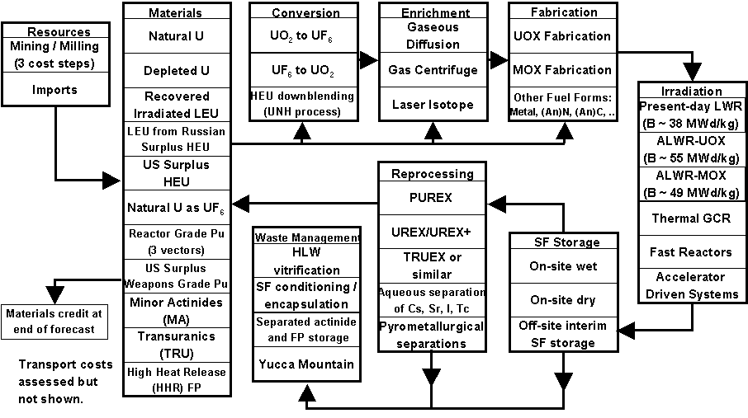

limitations on different types of storage, technological innovations in fabrication and reprocessing, strategies involving the use of the Nuclear Trust Fund for subsidizing different disposal strategies, and the impacts of market conditions including the availability and price of competing energy sources. Attachment B illustrates the type of analysis that can be performed with LA US-MARKAL on nuclear issues.

Industrial Energy Depiction: The industrial sector in LA US-MARKAL has been
disaggregated into ten distinct sub-sectors. Nine of the ten sub-sectors are characterized by a process train description utilizing approximately 2400 technologies. The industrial specification in LA US-MARKAL parallels the well-established industrial energy model, ITEMS (Industrial Technology and Energy Modeling System), and is calibrated to MECS 1994. Attachment C illustrates one potential line of investigation using this framework currently being conducted with Dr. Joe Roop at Pacific Northwest Laboratory.

Figure 3 provides an example or schematic flow diagram for one of the sectors currently depicted in LA US-MARKAL. The relationships are illustrated between various technology groups in the production of steel products. Within technology groups, individual technologies compete; for example within the group listed as integrated steel, twelve (12) different technologies compete in the production of molten steel. Technologies are distinguished by fuels used, costs, and other parameters. Some of the technology groupings use both energy and materials inputs, and output materials. Output from molten steel production feeds such operations as thin slab casting, slab pickling, galvanizing, cold rolling, annealing, plating and similar operations for the production of finished and semi-finished steel products. Demands for this sector are specified as tons of slabs and slab products, heavy structural steel, tubes, bars, rods, and light structural shapes. As a result of this disaggregation of sectoral demand into categories of final products, structural shifts or changes in patterns of product demand can affect the over-all energy consumption in the sector, and the specific types of energy consumed. Constraints are used between technologies within groups to control capacity and activity. For example, a constraint provides for the trade-off between integrated steel production and recycled steel. Since sizes of motors, for example, vary by sector, sector-specific capacity by size and type are defined by proportionality constraints; this technique is used for pumps, compressors, conveyors, and fans and blowers.

The industrial specification in LA US-MARKAL offers a number of benefits for the analysis of industrial energy. This specification of industrial energy consumption conforms to the intent of the original MARKAL developers (Hamilton, et al., BNL 48377, 1992, pg. 5); and, has been previously implemented in other national MARKAL frameworks such as the Japanese model (Sato, et al., Progress in Nuclear Energy, 37 (1-4), 2000, pgs. 95-100). The advantages from this approach include:

- Use of this specification results in a more realistic depiction of the derived demand for industrial energy (e.g., mechanical drive).
- More points where industrial energy consumption is reduced by technological improvements and the interactions between different technologies are captured.
- The platform can be readily used to test for the effects of increases in the energy efficiency of specific industrial technologies, new technologies, or process improvements.
- As part of the ‘process train’ specification, energy service demands are expressed in terms of physical units of product output or GDP where appropriate. Use of physical output as a measure of energy services provides for a ready linkage to other economic frameworks such as an input/output (I/O) or computable general equilibrium (CGE) framework.
- Disaggregated demands within each sector by product type allow for the investigation of the effects of economic structural change on the demands from some sectors.
- Endogenous estimates of motor drive, conveyor, compressor, fan, and pump usage, and process heat or steam are generated based on the demand for a physical output.
- Output from combined heat and power (CHP) is determined by the requirements for electricity and heat for the production of materials to meet a specified demand. For electricity, CHP competes with grid sourced electricity; for steam and process heat, CHP competes with standard boilers fueled by natural gas, coal, and distillate fuels.
- Fuel sources for a technology are selected on the basis of the life-cycle costs of the entire process train and not a single technology.
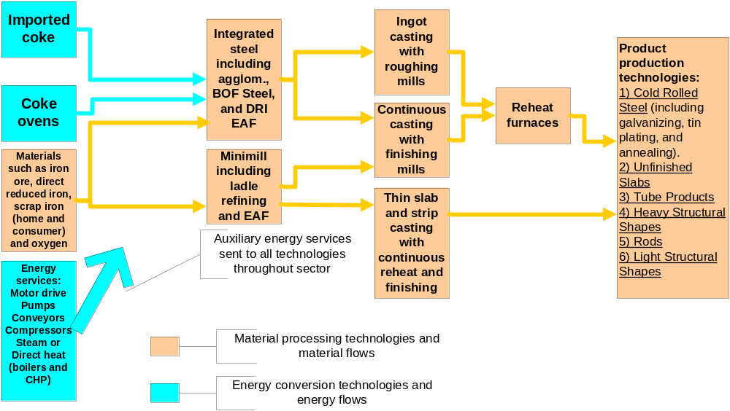Figure 3. Example Industrial Process Flow: Iron and Steel Industry

Attachment A: Example of Analysis of Potential Market Penetration of Fuel Cells in Stationary Applications

Distributed Generation: Increased Penetration of Fuel Cells Fulfills the Promise of Increased Energy Efficiency and Greater Emissions Reductions*

Lorna A. Greening, Consultant

*Journal paper in progress.

Once thought to be a “technology of the future,” fuel cells are now commercially available, and gaining in share in the distributed generation market. Fuel cells currently offer a 10 to a more than 25% improvement in generation efficiency over centrally dispatched electricity with the associated transmission and distribution losses. Similarly, natural gas-fueled cells in comparison to natural gas combined cycle emit approximately 25% less CO₂ and SO₂, 98% less NOx, and no particulates. Therefore, fuel cells in a distributed generation context produce electricity more efficiently with much lower levels of emissions. However, even with these attributes, the effects of increased penetration of fuel cells on the US energy system are highly uncertain.

Within the framework of a US energy system model (MARKAL calibrated to AEO 2005), where all sources of energy supply and demand are depicted, the role of fuel cells in meeting the potential promise of distributed generation is evaluated. Detailed depictions of four different fuel cell technologies (phosphoric acid, PEM, MCFC, and SOFC) using natural gas, coal, petroleum products and waste materials in residential, commercial, and industrial distributed generation applications have been implemented; and, this allows the evaluation of the life-cycle costs of fuel cells in comparison to other distributed generation technologies, and to centrally generated electricity with transmission and distribution losses. This evaluation also includes comparison of total levels of eight (8) emissions species, and the points of emission in the life-cycle among competing technologies.

Analysis performed with this framework indicates that depending upon fuel costs, and the initial costs of fuel cells in comparison to competing technologies, the capacity of fuel cells in distributed generation applications could increase by more than 100 fold in as little as fifteen years (2015 to 2020). US DOE has targeted initial costs for fuel cells at $400 per KW; however, this target cost could be missed by as much as a factor of two (or around $800 per KW) and penetration rates for this technology would still be substantial in stationary applications. Market penetration includes stationary applications in the residential sector where distributed generation has not been expected on a major scale with other types of technologies; measurable increases in electricity generation efficiency attributable to consumption in the sector and corresponding declines in emissions occur from this increased penetration. In the industrial sector, where heat production or CHP already plays a substantial role, the role of fuel cells is less clear-cut.

Attachment B: Example of Modeling the Complete Nuclear Fuel Cycle in an Energy Systems Model

Expanding and Preserving the Nuclear Infrastructure
Under Conditions of Limited Waste Disposal*

Erich Schneider, Los Alamos National Laboratory
Lorna Greening, Consultant

*Journal paper in progress; preliminary versions of this work appeared in IAEE newsletter, 4th quarter 2003, pages 12 to 19 (www.iaee.org) and were presented at WEA conference, July, 2003, USAEE/IAEE meetings in Mexico City, October, 2003, and at Resources for the Future, Washington, DC, October, 2003.

Nuclear power currently accounts for roughly 20% of electricity generated in the US. Following recent operating successes (>90% plant availability, lower production costs), nuclear generation is gaining attention as an option that maintains reliability and security of supply while mitigating emissions of greenhouse gases and other pollutants. Proponents are increasingly speaking of a ‘nuclear renaissance’- and indeed license extensions for existing nuclear generation capacity are being pursued and addition of new capacity is being considered. However, before increased nuclear generation becomes a feasible option in the US, the issues surrounding the disposal of spent nuclear fuel need to be addressed. Within the framework of a widely-used US energy system model (MARKAL), the market viability of the nuclear option is assessed under hypotheses tied to the availability nuclear waste disposal facilities. The nuclear demand scenarios arrived at by the energy system model are explored in detail using a nuclear fuel cycle simulation model (NFCSim). This model allows detailed tracking of the flow of nuclear materials and the prevalence of isotopes relevant to the heat load and radiotoxicity of nuclear waste.

The hypotheses tested vary the rate at which waste long-term storage and disposal capacity is brought online as well as the costs associated with the nuclear fuel cycle. It is seen that the once-through fuel cycle as currently practiced could continue to support nuclear generation at or above its current market share by mid-century only when an optimistic set of assumptions (i.e., addition of a second Yucca Mountain or storage facility of equivalent capacity) tied to waste disposal is imposed. Under more stringent disposal supply scenarios, nuclear can only gain market share in the long term if a closed fuel cycle entailing transmutation of plutonium and other actinides is adopted. It is shown that the transmuting nuclear economy could reduce the long-term heat load borne by a repository by orders of magnitude, increasing the effective capacity of a repository to store nuclear wastes, and bound the mass of plutonium and other hazardous actinides present in nuclear fuel. Earlier deployment of the requisite infrastructure – a nuclear fuel reprocessing facility – maximizes this benefit. This earlier deployment also fosters symbiosis with the development and implementation of advanced nuclear generation in the US.
Attachment C: Example of Industrial Energy Modeling

Industrial Energy Use in the Future: Does the Modeling Framework Make a Difference?*

Joseph M. Roop, Pacific Northwest National Laboratory
Lorna Greening, Consultant

*Presented at the 25th Annual North American Conference of the USAEE/IAEE “Fueling the Future: Prices, Productivity, Politics, and Prophecies,” September 18-21, 2005, Denver, CO (see www.iaee.org); journal paper in progress.

In previous comparisons of the output of energy system models, model structure has been shown to be extremely important in predicting output and model behaviors. Previous efforts quantifying those differences have indicated that optimization models produce cost estimates for meeting environmental policies such as the Kyoto Protocol that are substantially lower than behavioral simulation models. In the work presented here, we have had the opportunity to perform a comparison between an optimization model with perfect foresight and a simulation model which is myopic and behaviorally based. Further, we have been able to perform this comparison on industrial energy consumption in the US, one of the more complicated end-uses sectors in terms of the number and types of technologies. For this comparison, we forecast industrial energy consumption to 2025 using the Department of Energy’s Annual Energy Outlook, 2005 assumptions, and the U. S. version of CIMS and a detailed MARKAL model of the U. S. Comparing these forecasts we are able to perform a systematic comparison of the structure and other characteristics of the two frameworks for the industrial sector.

After a long period of development in Canada, CIMS (in the U. S., the Consolidated Impacts Modeling System), a behaviorally-based simulation model of energy use, has been adapted to the U. S. This modeling framework has a modular structure, not unlike NEMS (US EIA), but with high levels of technology detail. The industrial portion of the predecessor to CIMS-US has been used by one of the authors under the name ITEMS (Industrial Technology and Energy Modeling System) (Roop, 1997, Roop, 1998, and Roop and Dahowski, 2000).

The version of MARKAL (LA US-MARKAL) used here has been refined and expanded over the last several years by Greening. LA US-MARKAL includes well over 4500 technologies with a time horizon beyond 2050 (Greening and Schneider, 2003). We focus on industry in this paper because the basic data and structure used to construct the industrial sector of both models is largely the same (there have been some refinements in the petroleum refining sector of LA US-MARKAL which we exclude from this comparison; refining falls within the energy transformation sector of CIMS-US). Using the same assumptions, this provides an opportunity to compare forecasts to see what difference the structure of the models makes to the industrial forecasts. The objective of this paper, then, is to simulate both models under essentially the same set of assumptions, compare the results, and explore the causes of differences in forecast results.

As an example of the differences we explore, MARKAL and CIMS-US segment markets for new technologies differently. We find that the “reasonable” set of restrictions placed on the market penetration of new technologies in MARKAL is different from the calculated market shares that are outcomes of the CIMS-US simulation, therefore leading to some differences in the energy consumption of the two models. Further, unlike past analyses, where price response has been disabled, we have conducted this analysis to include that factor. We find that inclusion of a price response in both models reduces the differences in output. As a result, this is an important factor that probably should be included in all types of modeling efforts.

References

Greening, Lorna A. and Erich Schneider. 2003. "The U.S. Spent Nuclear Fuel Legacy and the Sustainability of Nuclear Power." IAEE Newsletter, Vol. 12:pp. 12-19 www.iaee.org.

Roop, J. M. 1997. "Energy Efficiency in the Steel Industry: Simulations of New Technology Adoption with ITEMS." Proceedings. ACEEE Summer Study on Energy Efficiency in Industry, Saratoga Springs, NY, July 8-11, 1997

Roop, Joseph M. 1998. “Energy Efficiency in the Pulp and Paper Industry: Simulations of Steam Challenge and CHP Incentives with ITEMS,” Proceedings, 20th National Industrial Energy Technology Conference, April 22 & 23, Houston, Texas, pp. 115-124.

Roop, Joseph M. and Robert T. Dahowski. 2000. “Comparison of Bottom-up and Top-down Forecasts: Vision Industry Energy Forecasts with ITEMS and NEMS.” Proceedings, 22nd National Industrial Energy Technology Conference, May 5 & 6, Houston, Texas.

