▼▼▼▼▼▼▼▼▼▼▼▼▼▼▼▼▼

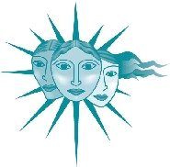
- Networking & Mentoring
We encourage and help women enter
and succeed in non-traditional careers.
We nominate network members for awards. In 2007 we initiated the
annual
to recognize New Mexico women
who further the goals of the Network.
IMPACT!
Award
Created in
cooperation
with the NM
Commission on
the Status of Women.

- Professional Conference
Our Annual fall meeting and Technical Symposium provides an opportunity to present technical papers in a supportive environment. It also provides professional development and networking opportunities.
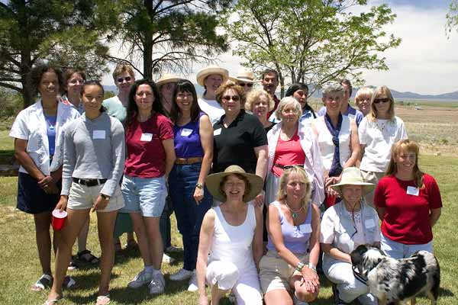
Current and former members gathered in 2004
to celebrate 25 Years of Networking.

- Chapters
Local chapters promote networking and communication among members by providing regularly scheduled meetings, talks, and other local activities.
▼▼▼▼▼▼▼▼▼▼▼▼▼▼▼▼▼
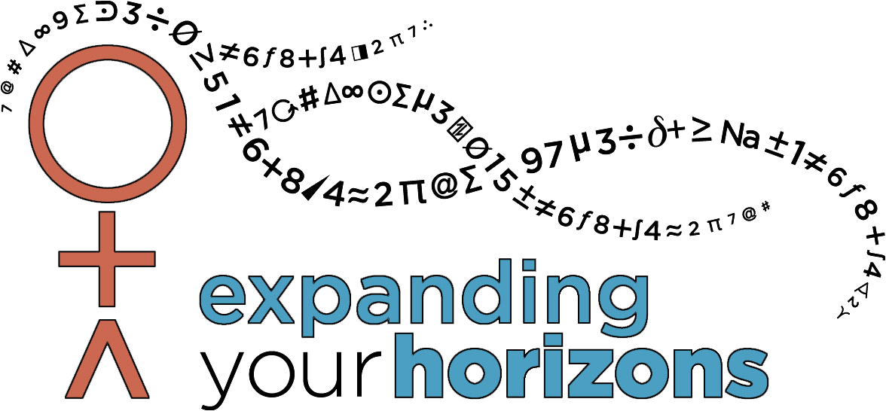



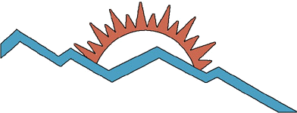
- Expanding Your HorizonsTM (EYH)
Licensed by NMNWSE from the EYH Network.
We encourage young women to enter the fast-growing high-technology professions by sponsoring EYH. These conferences are designed to provide career information to 5-12th grade students and their parents, teachers, and counselors. The emphasis of EYH conferences is communicating the excitement and challenge we experience in our work through "hands-on" career workshops, panel discussions, and interaction with professional role models who share their experiences and give practical advice. Check our website for conference dates, locations, and grades served.

- Career Information Booklet
Careers: Exploring the Possibilities acquaints young women and their parents, advisors, and teachers with non-traditional career opportunities. Available on-line at http://nmnwse.org/careers/.

- Science Fair Awards
NMNWSE special awards are given to encourage young women to continue their interests in math, science, engineering, technology, and allied professions.

"Winning the Prize [1963 Nobel Prize in Physics]
wasn't half as exciting as doing the work itself"
-- Maria Goeppert Mayer

NMNWSE
PO Box 51926
Albuquerque, NM 87181
▼▼▼▼▼▼▼▼▼▼▼▼▼▼▼▼▼

Membership categories:
Professional $40.00
Donor-Match $40.00
Affiliate $0, 1st Year
Volunteer member
Student / Teacher $10.00
Retired / Not Employed $10.00
If you would like to join, you may also download a full membership form:
http://nmnwse.org
If you do not have access to the web, just add your information below send it in!

date: 

name: ___________________________________________

address: _________________________________________

________________________________________________

phone/
fax: _____________________________________________

email: _____

___ Please send me a membership form.

Please contact me about:
___ Donating money to the network for use in
___ general fund
___ EYH conferences
___ Annual meeting & Technical Symposium
___ scholarships or awards
___ Volunteering to help with
___ board or chapter activities
___ Annual Meeting & Technical Symposium
___ EYH conference
___ speakers
___ administrative or editorial help
___ one-time support tasks
___ Updating/adding chapter to careers book
▼▼▼▼▼▼▼▼▼▼▼▼▼▼▼▼▼

- We are a group of women scientists, mathematicians, engineers, educators, managers, community leaders, and parents, most of who live and work in New Mexico.
- Members in local chapters around the state are dedicated to encouraging young women to enter science-based fields and to providing supportive activities for women professionals in non-traditional careers.
- Members get together to share common interests, to celebrate our successes, and learn about each other’s work.

- Meet other women in technical areas
- Network for career development and support
- Mentor/Role Model - Find one; Be one
- Share common interests
- Broaden horizons
- Develop skills
- Add to resume
- Reduce sense of isolation
- Make great friends in the process!

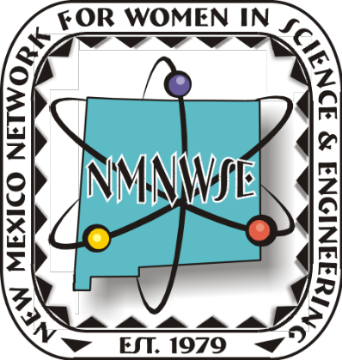

NMNWSE
PO Box 51926
Albuquerque, NM 87181
http://nmnwse.org

- Scientists, engineers, educators, managers, community leaders, parents
- 37-Year Statewide Legacy
- Local chapters
- Not-for-profit
- Professional conferences
- Mentoring and networking
- Outreach and Empowerment
- Expanding Your Horizons Conferences

